Physics 1st Tri Exam Review (2012/13)
Forces
- What is a vector quantity and name some examples?
- What is a scalar quantity and name some examples?
- How do you find the minimum resultant of a pair of parallel forces?
- How do you find the net force when 2 forces act in opposite directions
- How do you find the maximum resultant of a pair of parallel forces?
- How do you find the net force when 2 forces act in the same direction?
- What is the definition of equilibrium?
- How do you calculate the tension in a rope or ropes when an object with a certain weight is hanging from it?
- How is a vector drawn for a person’s weight?
- What is special about the tension in a pair of ropes that is 120 degrees apart from one another?
- How do you find the components of a vector?
- What is the parallelogram rule and how do you construct one?
- What is static equilibrium?
- What is dynamic equilibrium?
- What is the definition of friction and in which direction does it act?
Newton’s 1st law
- What is another name for Newton’s 1st law?
- What are some of Copernicus’s contributions to physics?
- What are some of Galileo’s contributions to physics?
- What are some of Aristotle’s contributions to physics?
- How does doubling the mass affect the inertia?
- How does weight change as you move from the Earth to the Moon?
- How does mass change as you move from the Earth to the Moon?
- How much force is needed to keep an object moving?
- How do you convert from kg to Newtons?
- How do you convert form Newtons to kg?

Linear Motion
- What is the definition of speed?
- What are the possible units of speed?
- What is the difference between average speed and instantaneous speed?
- What is the definition acceleration?
- What is needed to happen to an object for it to be considered accelerating?
- It doesn’t matter if something is dropped, thrown, shot out, or jumping, everything will accelerate at what rate?
Projectile Motion
- What does an object have to be doing to be considered a projectile?
- What is the biggest difference between the vertical and horizontal components of a projectile?
- What are the different angles that a projectile can be launched at and still hit the same target on the ground?
- Is gravity responsible for slowing down a projectile fired horizontally? If not, what is responsible for it?
- How do you find the resultant of a pair of vectors at right angles to each other?
Falling objects
- What stays constant as an object falls?
- What increases as an object falls?
- How do you determine the distance and object falls?
- What letter symbolizes the acceleration due to gravity?
- What is the numerical value given to gravity?
- What is the rate of acceleration due to gravity on an object that is dropped from rest?
- What is the rate of acceleration due to gravity on an object that is shot out horizontally?
- What is the rate of acceleration due to gravity on an object that is shot out at an upward angle?
- What is the rate of acceleration due to gravity on an object that is shot out at a downward angle?
- In what direction does gravity always act?
- The speed of a falling object will increase by how much each second?
Hang time
- How do you calculate the vertical height of a person with a certain hang time?
- What is the hang time for most athletes?
Newton’s 2nd Law
- What causes and acceleration and how is it proportional to acceleration?
- How do you calculate acceleration using Newton’s 2nd law?
- How do you calculate the mass of an object using Newton’s 2nd law?
- How do you calculate the force of an object using Newton’s 2nd law?
Terminal Velocity
- What is the acceleration of an object once it hits it’s terminal velocity?
- What are the terminal speeds for an average person parachuting before and after the shoot is open?
Pressure
- What is the definition and what unit is it measured in?

Graphing
Match the letter and the description that goes with it to the correct graph.
- Stopped
- Constant Velocity toward the origin
- Speeding up
- Slowing down
- Constant Velocity away from the origin

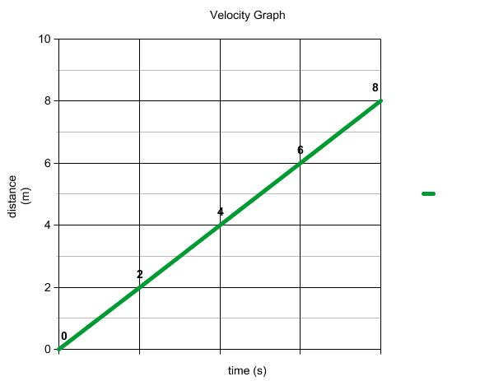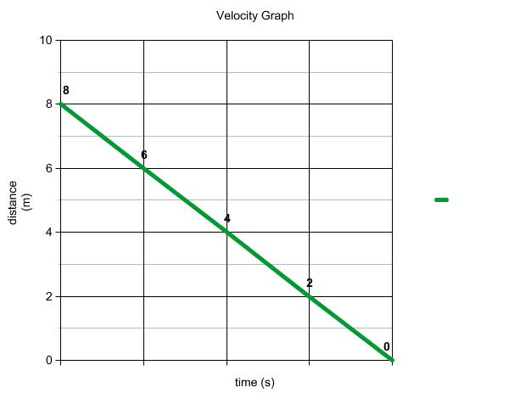
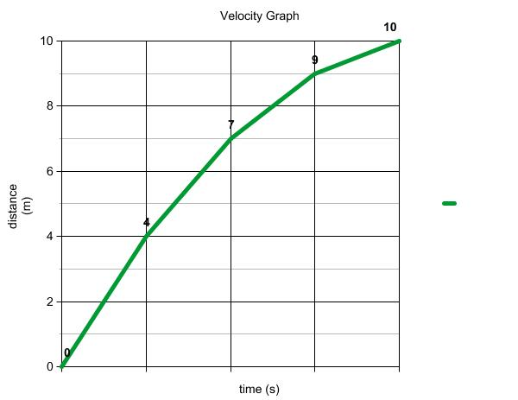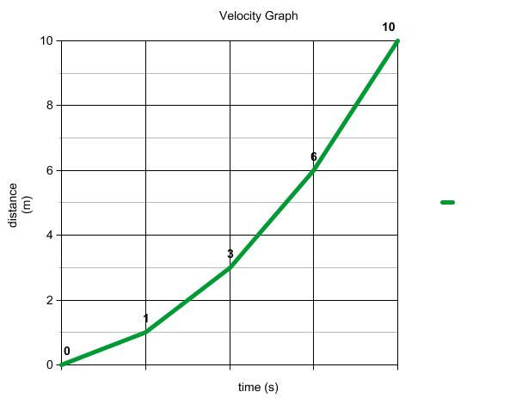
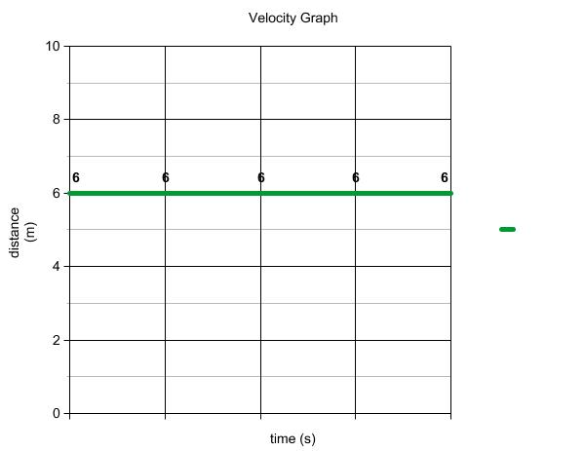

Match the letter and the description that goes with it to the correct graph.
- Negative acceleration
- Constant - acceleration
- Constant + acceleration
- Constant non zero velocity
- Positive acceleration

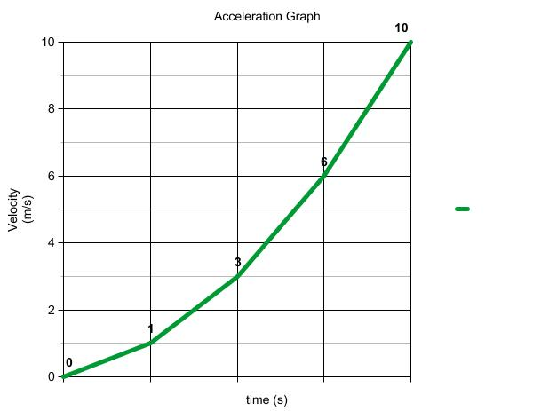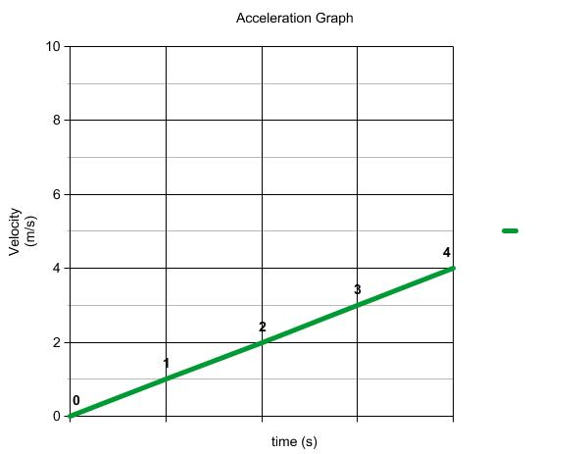
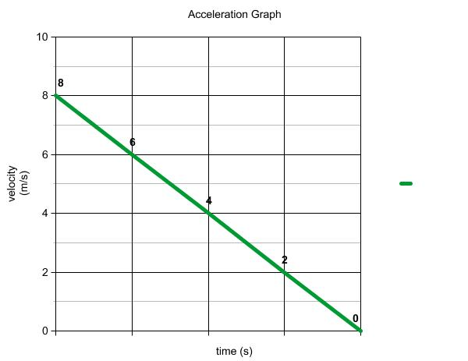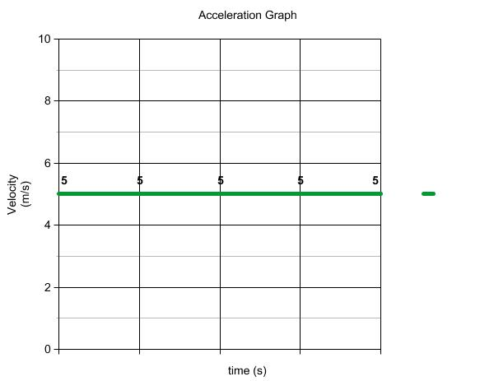

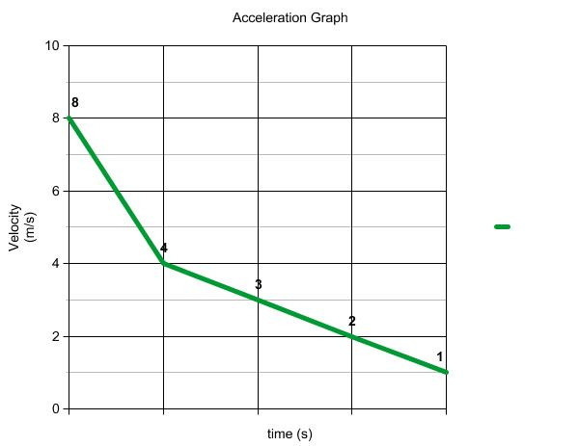
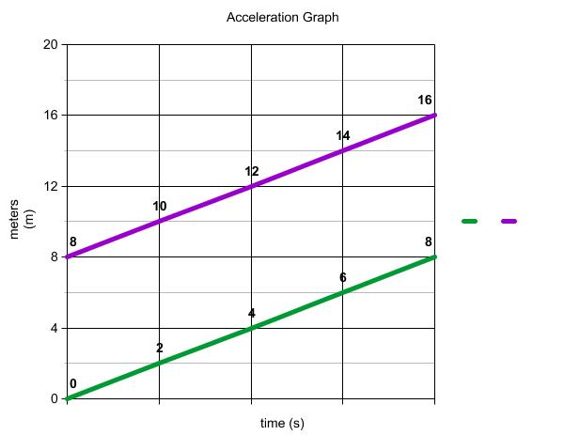
According to the graph above,
- How far did the two runners start apart from one another ?
- Are they going at the same velocity or a different velocity ?
- How can you tell ?

