Chapter 8 Vocab and Review
8 REVIEW
Concept Summary
••••••
REVIEW
For: Self-Assessment
Visit: PHSchool.com
Web Code: csa – 0800
Teaching Resources
• TeacherEXPRESS
• Virtual Physics Lab 11
• Conceptual Physics Alive!
DVDs Momentum
think! Answers
8.1
The roller skate and truck can have the
same momentum if the speed of the roller
skate is much greater than the speed of the
truck. How much greater? As many times
greater as the truck’s mass is greater than
the roller skate’s mass. Get it? For example,
a 1000-kg truck backing out of a drive-
way at 0.01 m/s has the same momentum
as a 1-kg skate going 10 m/s. Both have
momentum = 10 kg m/s.
No. The impulse would be the same for
either surface because the same momen-
tum change occurs for each. It is the force
that is less for the impulse on the carpet
because of the greater time of momentum
change.
Since the time of impact increases five
times, the force of impact will be reduced
five times.
Yes, because no acceleration means that no
change occurs in velocity or in momentum
(mass velocity). Another line of reason-
ing is simply that no net force means there
is no net impulse and thus no change in
momentum.
The mass of the stuck-together gliders is
four times that of the unloaded glider.
Thus, the postcollision velocity of the
stuck-together gliders is one-fourth of the
unloaded glider’s velocity before collision.
This velocity is in the same direction as
before, since the direction as well as the
amount of momentum is conserved.
•
•
•
•
•
•
A moving object can have a large mo-
mentum if it has a large mass, a high
speed, or both.
The change in momentum depends on
the force that acts and the length of time
it acts.
The impulse required to bring an ob-
ject to a stop and then to “throw it back
again” is greater than the impulse re-
quired merely to bring the object to a
stop.
The law of conservation of momentum
states that in the absence of an external
force, the momentum of a system re-
mains unchanged.
Whenever objects collide in the absence
of external forces, the net momentum of
both objects before collision equals the
net momentum of both objects after col-
lision.
The vector sum of the momenta is the
same before and after a collision.
•••••
8.2.1
8.2.2
8.4
Key Terms
momentum (p. 125)
impulse (p. 126)
law of conservation
of momentum (p. 131)
elastic
collision (p. 132)
inelastic
collision (p. 133)
8.5
CHAPTER 8
MOMENTUM
137
137

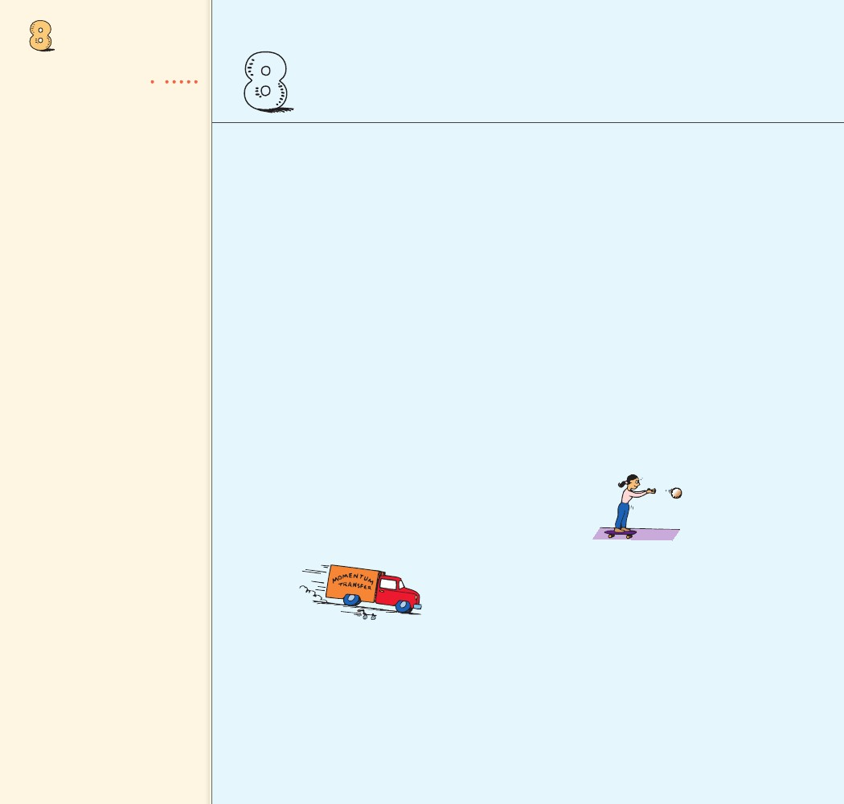
ASSESS
Check Concepts
8 ASSESS
Check Concepts
Section 8.1
••••••
9. In a car crash, why is it advantageous for an
occupant to extend the time during which
the collision takes place?
10. If the time of impact in a collision is extend-
ed by four times, how much does the force
of impact change?
11. Why is it advantageous for a boxer to ride
with the punch? Why should he avoid mov-
ing into an oncoming punch?
Section 8.3
1. Distinguish between mass and momentum.
Which is inertia and which is inertia in
motion?
2. a. Which has the greater mass, a heavy truck
at rest or a rolling skateboard?
b. Which has greater momentum?
3. Distinguish between force and impulse.
Section 8.2
4. Distinguish between impact and impulse.
Which designates a force and which is force
multiplied by time?
5. When the force of impact on an object is
extended in time, does the impulse increase
or decrease?
6. Distinguish between impulse and momen-
tum. Which is force time and which is
inertia in motion?
7. Does impulse equal momentum, or a change
in momentum?
12. Visualize yourself on a skateboard.
a. When you throw a ball, do you experi-
ence an impulse?
b. Do you experience an impulse when you
catch a ball of the same speed?
c. Do you experience an impulse when you
catch it and then throw it out again?
d. Which impulse is greatest?
13. Why is more impulse delivered during a
collision when bouncing occurs than during
one when it doesn’t?
14. Why is the Pelton Wheel an improvement
over paddle wheels with flat blades?
8. For a constant force, suppose the duration
of impact on an object is doubled.
a. How much is the impulse increased?
b. How much is the resulting change in
momentum increased?
Section 8.4
15. In terms of momentum conservation, why
does a cannon recoil when fired?
16. What does it mean to say that momentum is
conserved?
138
138

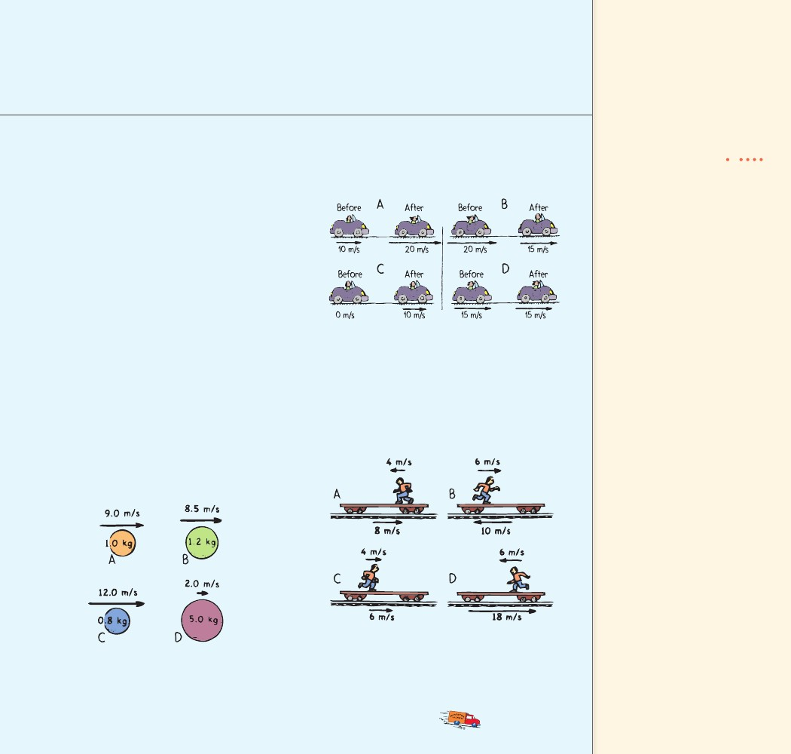
8 ASSESS
Section 8.5Concept
17. Distinguish between an elastic and an in-
elastic collision.
18. Imagine that you are hovering next to the
space shuttle in an Earth orbit. Your buddy
of equal mass, who is moving at 4 km/h
with respect to the shuttle, bumps into you.
If he holds onto you, how fast do you both
move with respect to the ship?
Summary
••••••
21. Below are before-and-after pictures of a
car’s speed. The mass of the car doesn’t
change.
Think and Rank
Section 8.6
19. Is momentum conserved for colliding
objects that are moving at angles to one
another? Explain.
Think and Rank
••••••
Rank the following from greatest to least.
a. the magnitude of momentum change
b. the magnitude of the impulse producing
the momentum change
22. Jogging Jake runs along a train flatcar that
moves at the velocities shown. In each case,
Jake’s velocity is given relative to the car.
Rank each of the following sets of scenarios in
order of the quantity or property involved. List
them from left to right. If scenarios have equal
rankings, then separate them with an equal sign.
(e.g., A = B)
20. The balls have different masses and speeds.
Rank the following from greatest to least.
a. momentum
b. the impulse needed to stop them
Rank the following from greatest to least.
a. the magnitude of Jake’s momentum rela-
tive to the car
b. Jake’s momentum to the right relative to
an observer at rest on the ground
CHAPTER 8
MOMENTUM
139
139

Plug and Chug
8 ASSESS
ASSESS
(continued)
23. Rick pushes crates starting at ••••••Concept Summary rest across
a floor for 3 seconds with a net force as
shown.
Think and Explain
28. A lunar vehicle is tested on Earth at a
speed of 10 km/h. When it travels as fast
on the moon, is its momentum more, less,
or the same?
29. When you ride a bicycle at full speed and
the bike stops suddenly, why do you have
to push hard on the handlebars to keep
from flying forward?
30. Can Andrew produce a net impulse on an
automobile by sitting inside and pushing
on the dashboard? Can the internal forces
within a soccer ball produce an impulse
on the soccer ball that will change its
momentum?
31. Brian tries to jump from his canoe to the
dock. He lands in the water, delighting his
companions. What’s your explanation for
his mishap?
32. Jason throws a ball horizontally while
standing on roller skates. He rolls back-
ward with a momentum that matches that
of the ball. Will he end up rolling back-
ward if he goes through the motions of
throwing the ball, but does not let go of
it? Explain.
33. The example in the previous question
can be explained in terms of momentum
conservation and in terms of Newton’s
third law. Assuming you’ve answered it in
terms of momentum conservation, an-
swer it also in terms of Newton’s third law
(or vice versa if you answered already via
Newton’s third law).
For each crate, rank the following from
greatest to least.
a. change in momentum
b. final speed
c. momentum in 3 seconds
Plug and Chug
••••••
The key equations of the chapter are shown below
in bold type.
Momentum
m
v
24. Calculate the momentum of a 10-kg bowl-
ing ball rolling at 2 m/s.
25. Calculate the momentum of a 50-kg carton
that slides at 4 m/s across an icy surface.
Impulse
Ft
26. Calculate the impulse when an average
force of 10 N is exerted on a cart for 2.5 s.
27. Calculate the impulse when an average
force of 10 N acts on a cart for 5.0 s.
Think and Explain
••••••
For answers to Think and Explains and Think
and Solves, you may express momentum with the
symbol p. Then p mv.
140
140

8 ASSESS
Concept Summary ••••••34. In the previous chapter, rocket propulsion
was explained in terms of Newton’s third
law. That is, the force that propels a rocket
is from the exhaust gases pushing against
the rocket, the reaction to the force the
rocket exerts on the exhaust gases. Explain
rocket propulsion in terms of momentum
conservation.
35. In terms of impulse and momentum, why
are air bags in automobiles a good idea?
42. Many years ago, automobiles were manufac-
tured to be as rigid as possible. Today’s autos
are designed to crumple upon impact. Why?
43. Why is it difficult for a firefighter to hold a
hose that ejects large amounts of water at
high speed?
44. You can’t throw a raw egg against a wall
without breaking the shell, but you can
throw it at the same speed into a sagging
sheet without breaking it. Explain.
45. Why can Muhammad exert a greater punch-
ing force with his bare fist than he can while
wearing a boxing glove?
36. Why do gymnasts use floor mats that are
very thick?
37. When jumping from a significant
height, why is it advantageous to land with
your knees slightly bent?
38. In terms of impulse and momentum, why
are nylon ropes, which stretch consider-
ably under tension, favored by mountain
climbers?
39. Would it be a dangerous mistake for a
bungee jumper to use a steel cable rather
than an elastic cord?
40. When catching a foul ball at a baseball
game, why is it important to extend your
bare hands upward so they can move down-
ward as the ball is being caught?
41. Why would it be a poor idea to have the
back of your hand up against the outfield
wall when you catch a long fly ball?
46. Why do 6-ounce boxing gloves hit harder
than 16-ounce gloves?
47. Suppose you roll a bowling ball into a pillow
and the ball stops. Now suppose you roll it
against a spring and it bounces back with an
equal and opposite momentum.
a. Which object exerts a greater impulse, the
pillow or the spring?
b. If the time it takes the pillow to stop the
ball is the same as the time of contact of
the ball with the spring, how do the aver-
age forces exerted on the ball compare?
141
CHAPTER 8
MOMENTUM
141

(continued)
48. If you topple from your treehouse, you’ll
continuously gain momentum as you fall to
the ground below. Doesn’t this violate the
law of conservation of momentum? Defend
your answer.
Think and Solve
49. If a fully loaded shopping cart and an
empty one traveling at the same speed have
a head-on collision, which cart will experi-
ence the greater force of impact? The greater Think and Solve ••••••
impulse? The greater change in momentum?
54. Using units, show that kg.m/s is equiva-
The greater acceleration?
lent to N.s.
50. A bug and the windshield of a fast-moving
car collide. Indicate whether each of the fol- 55. A 1000-kg car moving at 20 m/s slams into
a building and comes to a halt. Which of the
lowing statements is true or false.
following questions can be answered using
a. The forces of impact on the bug and on
the given information, and which one can-
the car are the same size.
not be answered? Explain.
b. The impulses on the bug and on the car
a. What impulse acts on the car?
are the same size.
b. What is the force of impact on the car?
c. The changes in speed of the bug and of
the car are the same.56. A car with a mass of 1000 kg moves at
d. The changes in momentum of the bug20 m/s. What braking force is needed to
and of the car are the same size.bring the car to a halt in 10 s?
51. What difference in recoil would you expect
in firing a solid ball versus firing a hollow
ball from the same cannon? Explain.
57. A 2-kg blob of putty moving at 3 m/s slams
into a 2-kg blob of putty at rest.
a. Calculate the speed of the two stuck-
together blobs of putty immediately
after colliding.
b. Calculate the speed of the two blobs if
the one at rest was 4 kg.
58. A 1-kg dart moving horizontally at 10 m/s
strikes and sticks to a wood block of mass
9 kg, which slides across a friction-free level
surface. What is the speed of the block and
the dart after the collision?
53. A proton from an accelerator strikes an
atom. An electron is observed flying for-
ward in the same direction the proton was
moving and at a speed much greater than
the speed of the proton. What conclusion
can you draw about the relative mass of a
proton and an electron?
52. A group of playful astronauts, each with a
bag full of balls, form a circle as they free-
fall in space. Describe what happens when
they begin tossing balls simultaneously to
one another.
142
142
8 ASSESS
59. Assume an 8-kg bowling ball moving atConcept Summary ••••••
2 m/s bounces off a spring at the same
speed that it had before bouncing.
a. What is its momentum of recoil?
b. What is its change in momentum?
(Hint: What is the change in temperature
when something goes from 1° to –1°?)
c. If the interaction with the spring occurs
in 0.5 s, calculate the average force the
spring exerts on it.
65. A 5-kg fish swimming 1 m/s swallows an
absent-minded 1-kg fish at rest. What is the
speed of the large fish immediately after
lunch? What would its speed be if the small
fish were swimming toward it at 4 m/s?
60. Brakes are applied in bringing a 1200-kg
car moving at 25 m/s to rest in 20.0 s. Show
that the amount of braking force is 1500 N.
61. A 20.0-kg mass moving at a speed of
3.0 m/s is stopped by a constant force of
15.0 N. Show that the stopping time re-
quired is 4.0 s.
62. A 1-kg ostrich egg is thrown at 2 m/s at
a bed sheet and is brought to rest in 0.2 s.
Show that the average amount of force on
the egg is 10 N.
63. A railroad diesel engine weighs four times
as much as a freight car. If the diesel engine
coasts at 5 km/h into a freight car that is
at rest, how fast do the two coast after they
couple?
64. A comic-strip superhero meets an
asteroid in outer space and hurls it at
100 m/s. The asteroid is a thousand times
more massive than the superhero is. In the
strip, the superhero is seen at rest after the
throw. Taking physics into account, what
would be his recoil speed? What is this in
miles per hour?
Activity
••••••
66. Visit your local pool or billiards parlor and
bone up on momentum conservation. Note
that no matter how complicated the colli-
sion of balls, the momentum along the line
of action of the cue ball before impact is the
same as the combined momentum of all the
balls along this direction after impact. Also,
the components of momenta perpendicu-
lar to this line of action add to zero after
impact, the same value as before impact in
this direction. When rotational skidding,
English, is imparted by striking the cue ball
off center, rotational momentum, which is
also conserved, somewhat complicates the
analysis. But regardless of how the cue ball
is struck, in the absence of external forces,
both linear and rotational momentum are
always conserved. Pool or billiards offers a
first-rate exhibition of momentum conser-
vation in action.
Activity
Teaching Resources
More Problem-Solving Practice
Appendix F
CHAPTER 8
MOMENTUM
• Computer Test Bank
• Chapter and Unit Tests
143
143

