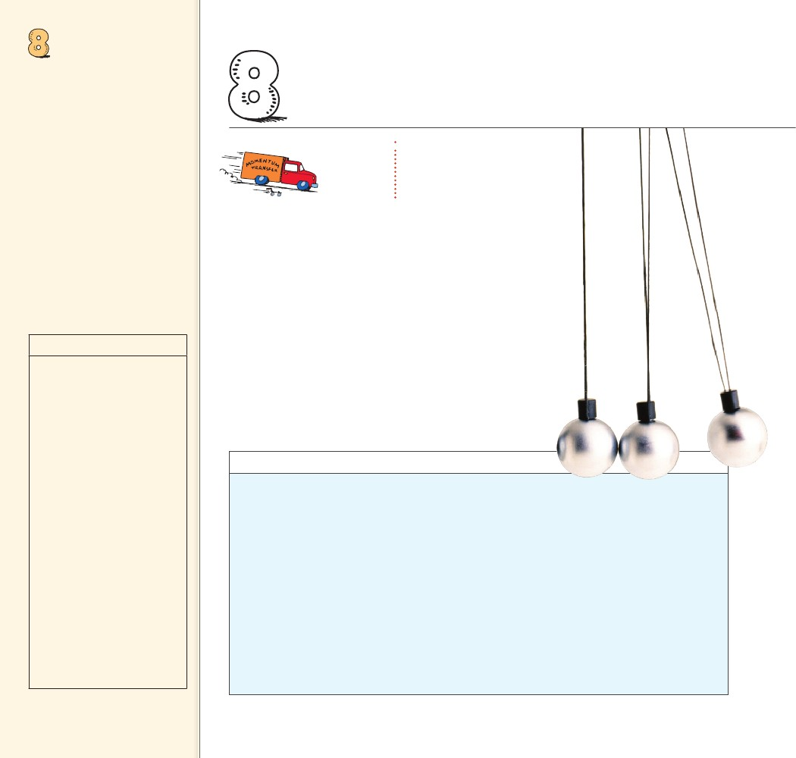
MOMENTUM
Objectives
• Define momentum. (8.1)
• Define impulse and describe
how it affects changes in
momentum. (8.2)
• Explain why an impulse is
greater when an object bounces
than when the same object
comes to a sudden stop. (8.3)
• State the law of conservation
of momentum. (8.4)
• Describe how the conservation
of momentum applies to
collisions. (8.5)
• Describe how the vector nature
of momentum affects the law
of conservation of momentum.
(8.6)
8 MOMENTUM
THE BIG
IDEA
Momentum is conserved
for all collisions as long
as external forces don’t
interfere.
discover!
MATERIALS
five marbles, ruler
When a
marble or marbles collide
with the marbles at rest, the
momentum is the same before
and after the collision. As a
result, the same number of
marbles emerges at the same
speed on the other side.
EXPECTED OUTCOME
ANALYZE AND CONCLUDE
ave you ever wondered how a tae kwon do expert
can break a stack of cement bricks with the blow
of a bare hand? Or why falling on a wooden floor
hurts less than falling on a cement floor? Or why follow-
through is important in golf, baseball, and boxing? To
understand these things, you need to recall the concept
of inertia introduced and developed when we discussed
Newton’s laws of motion. Inertia was discussed both in
terms of objects at rest and objects in motion. In this chap-
ter we are concerned only with the concept of inertia in
motion—momentum.
H
discover!
How Does a Collision Affect the Motion
of Marbles?
1. Place five marbles, all identical in size and
shape, in the center groove of a ruler. Launch
a sixth marble toward the five stationary
marbles. Note any changes in the marbles’
motion.
2. Now launch two marbles at four stationary
marbles. Then launch three marbles at three
stationary marbles, and so on. Note any
changes in the marbles’ motion.
3. Remove all but two marbles from the groove.
Roll these two marbles at each other with
equal speeds. Note any changes in the
marbles’ motion.
1. When one marble collides
with 5 marbles, the colliding
marble stops and one
marble emerges at the same
speed on the other side.
When 2 marbles collide
with 4 marbles, 2 marbles
emerge at the same speed.
The pattern continues with
more marbles.
2. The speed and number of
marbles
3. Three marbles move to the
right and two marbles move
to the left.
Analyze and Conclude
1. Observing How did the approximate speed
of the marbles before each collision compare
to after each collision?
2. Drawing Conclusions What factors determine
how the speed of the marbles changes in a
collision?
3. Predicting What do you think would hap-
pen if three marbles rolling to the right and
two marbles rolling to the left with the same
speed were to collide?
124
124

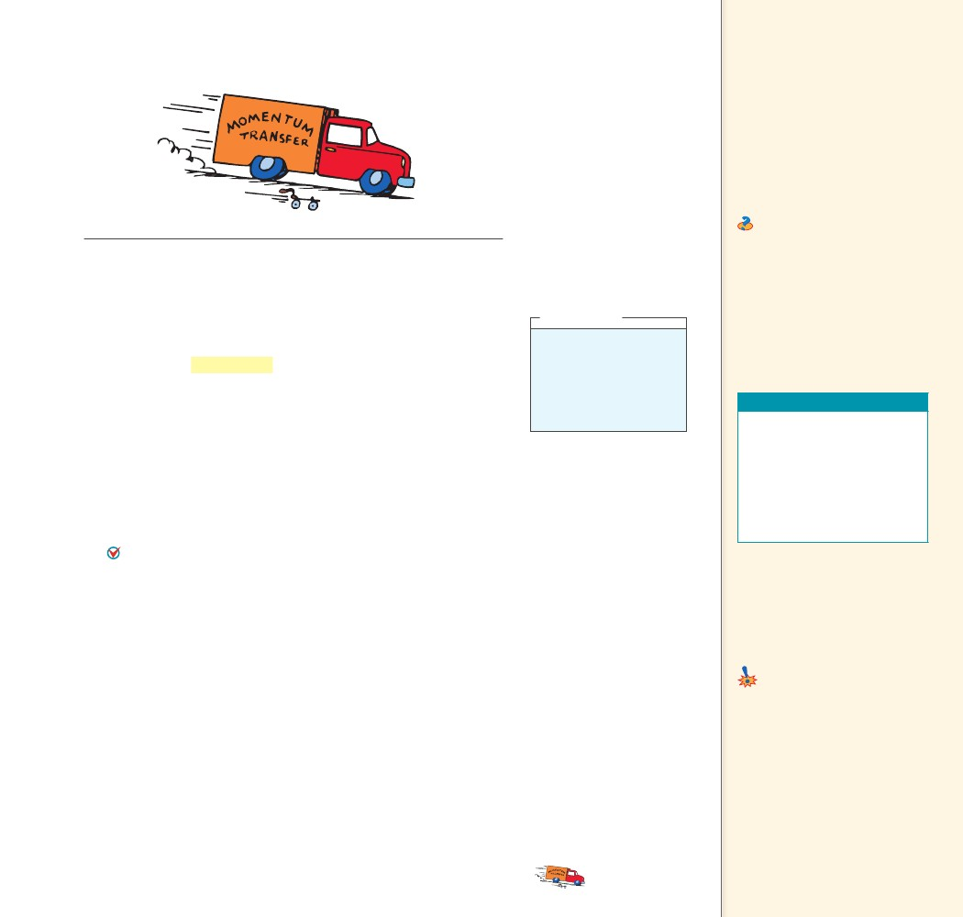
8.1 Momentum
FIGURE 8.1
A truck rolling down a
hill has more momentum
than a roller skate with
the same speed. But if
the truck is at rest and
the roller skate moves,
then the skate has more
momentum.
Key Term
momentum
Teaching Tip State that just
as a large truck and a roller skate
have different masses, a moving
large truck and a moving roller
skate have different momenta.
Define and discuss momentum as
moving mass—inertia in motion.
Ask Will a large truck always
have more momentum than a
roller skate? No, a large truck at
rest has no momentum. A moving
roller skate has momentum.
A moving object
CHECK can have a large
momentum if it has a large mass,
a high speed, or both.
CONCEPT
8.1 Momentum
We know that it’s harder to stop a large truck than a small car when
both are moving at the same speed. We say the truck has more
momentum than the car. By momentum, we mean inertia in motion.
More specifically, momentum is the mass of an object multiplied by
its velocity.
momentum
or, in abbreviated notation,
momentum
momentum
mass
mv
speed
When direction is not an important factor, we can say
which we still abbreviate mv.
A moving object can have a large momentum if it has a large
mass, a high speed, or both. A moving truck has more momentum
than a car moving at the same speed because the truck has more
mass. But a fast car can have more momentum than a slow truck.
And a truck at rest has no momentum at all. Figure 8.1 compares the
momentum of a truck to that of a roller skate.
CONCEPT
mass
velocity
Can you think of a case
where the roller skate and
the truck shown in Figure
8.1 would have the same
momentum?
Answer: 8.1
Teaching Resources
• Reading and Study
Workbook
• PresentationEXPRESS
• Interactive Textbook
• Next-Time Question 8-1
• Conceptual Physics Alive!
DVDs Momentum
8.2 Impulse Changes
Momentum
Key Term
impulse
Common Misconceptions
Impulse equals momentum.
Impulse equals change in
momentum.
FACT
......
CHECK
What factors affect an object’s momentum?
8.2 Impulse Changes Momentum
If the momentum of an object changes, either the mass or the veloc-
ity or both change. If the mass remains unchanged, as is most often
the case, then the velocity changes and acceleration occurs. What pro-
duces acceleration? We know the answer is force. The greater the force
acting on an object, the greater its change in velocity, and hence, the
greater its change in momentum.
CHAPTER 8
MOMENTUM
Teaching Tip Derive the
impulse–momentum relationship.
Equate the two definitions of
acceleration: F/m 5 Dv/t. A simple
algebraic rearrangement yields
Ft 5 D(mv).
......
think!
125
125

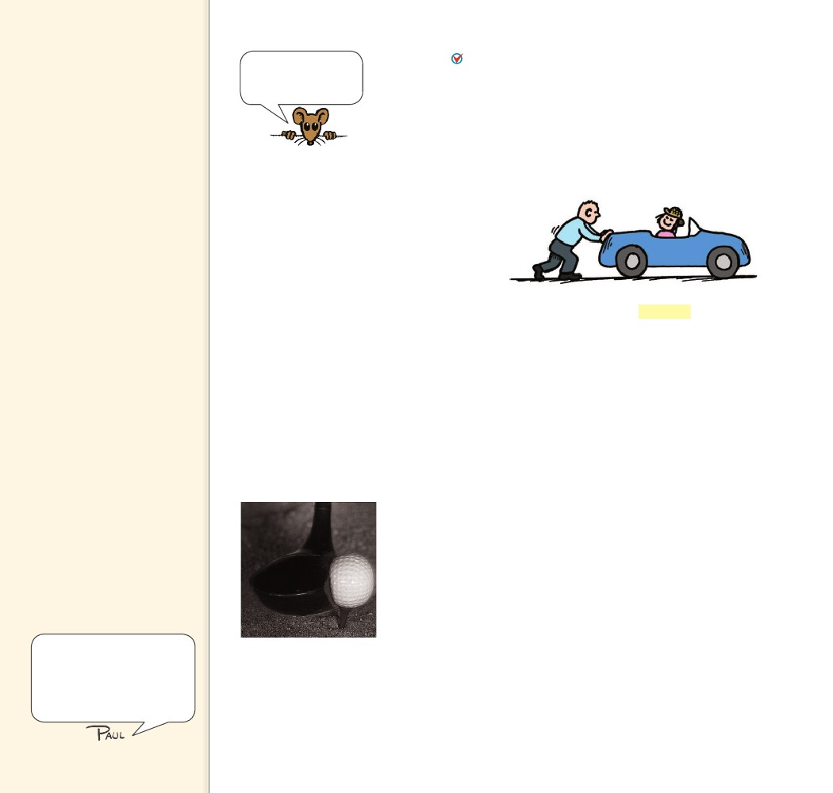
Teaching Tip Choose
your examples of changing
momentum in careful sequence.
First, describe those where
the objective is to increase
momentum (e.g., pulling a sling
shot or arrow in a bow all the
way back, the effect of a long
cannon for maximum range,
and driving a golf ball). Second,
describe cases in which the
objective is to minimize a force
when decreasing momentum
(e.g., pulling your hand backward
when catching a ball, driving into
a haystack vs. into a concrete
wall, and falling on a spongy
surface rather than on a rigid
one). Last, describe examples
where the objective is to
maximize forces when decreasing
momentum (e.g., karate chops).
The derivation of
Ft(mv) is given in
Appendix G, Note 8.2.
ImpulseThe change in momentum depends on the force that
acts and the length of time it acts. As Figure 8.2 shows, apply a
brief force to a stalled automobile, and you produce a change in its
momentum. Apply the same force over an extended period of time
and you produce a greater change in the automobile’s momentum. A
force sustained for a long time produces more change in momentum
than does the same force applied briefly. So both force and time are
important in changing an object’s momentum.
FIGURE 8.2
When you push with the
same force for twice the
time, you impart twice
the impulse and produce
twice the change in
momentum.
The quantity force
hand notation,
time interval is called impulse. In short-
impulse
Ft
The greater the impulse exerted on something, the greater will be the
change in momentum. The exact relationship8.2 is
impulse
change in momentum
or
Ft(mv)
The impulse–momentum relationship helps us to analyze a
variety of situations where the momentum changes. Consider the
familiar examples of impulse in the following cases of increasing and
decreasing momentum.
Increasing Momentum To increase the momentum of an object,
it makes sense to apply the greatest force possible for as long as pos-
sible. A golfer teeing off and a baseball player trying for a home run
do both of these things when they swing as hard as possible and fol-
low through with their swing.
The forces involved in impulses usually vary from instant to
instant. Look at Figure 8.3. A golf club that strikes a golf ball exerts
zero force on the ball until it comes in contact with it; then the force
increases rapidly as the ball becomes distorted. The force then
diminishes as the ball comes up to speed and returns to its original
shape. So when we speak of such forces in this chapter, we mean the
average force.
Many interactions that are
explainable by Newton’s third
law can also be explained
by momentum conservation.
Newton’s laws flow nicely into
momentum and its conservation.
FIGURE 8.3
The force of impact on a
golf ball varies throughout
the duration of impact.
126
126

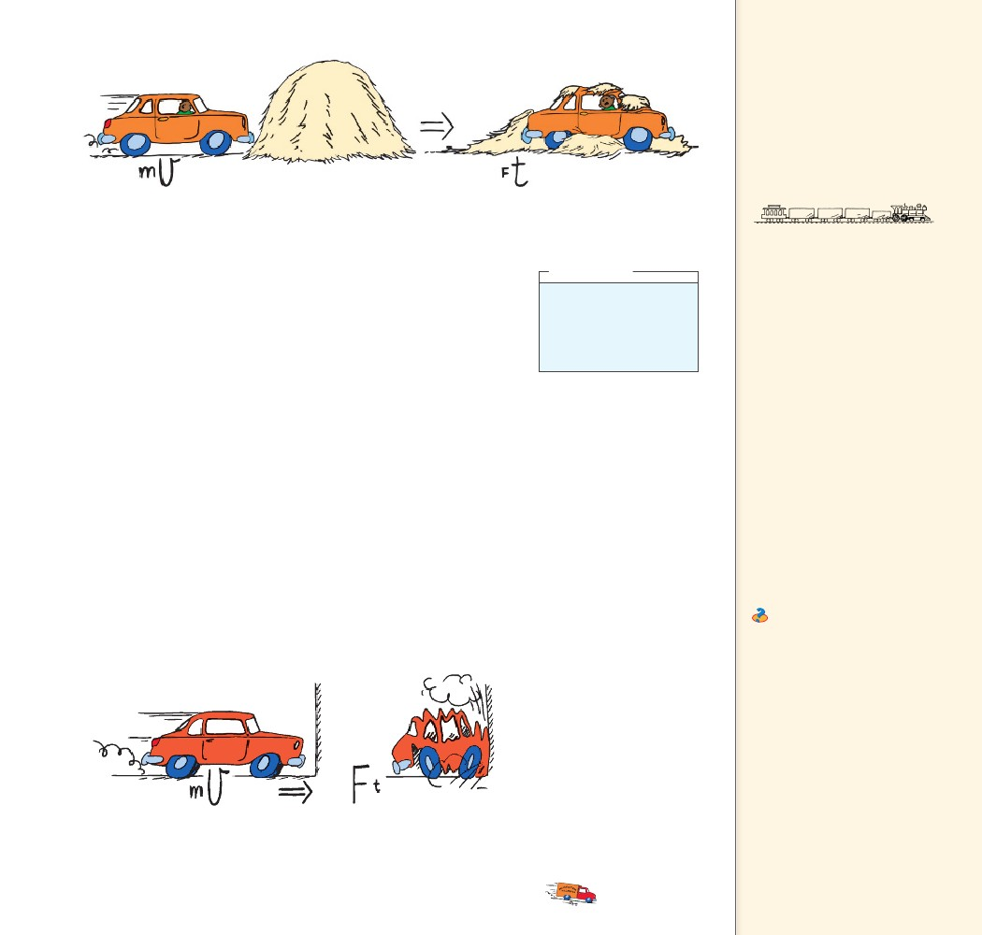
FIGURE 8.4
If the change in momentum occurs over
a long time, the force of impact is small.
Teaching Tip Use the loose
coupling between railroad cars
as a very good example of the
impulse–momentum relationship.
The slack in the coupling of
railroad cars is evident when a
locomotive either brings a long
train from rest into motion, or
when it brings a moving train
to rest.
Decreasing Momentum If you were in a car that was out of
control and had to choose between hitting a haystack, as in Figure
8.4 or a concrete wall as in Figure 8.5, you wouldn’t have to call on
your knowledge of physics to make up your mind. Common sense
tells you to choose the haystack. But knowing the physics helps you to
understand why hitting a soft object is entirely different from hitting
a hard one.
In the case of hitting either the wall or the haystack and coming
to a stop, your momentum is decreased by the same impulse. The
same impulse does not mean the same amount of force or the same
amount of time; rather it means the same product of force and time.
By hitting the haystack instead of the wall, you extend the contact
time—the time during which your momentum is brought to zero. A
longer contact time reduces the force and decreases the resulting
deceleration. For example, if the time is extended 100 times, the force
of impact is reduced 100 times. Whenever we wish the force to be
small, we extend the time.
We know that a padded dashboard in a car is safer than a rigid
metal one and that airbags save lives. You also know that to catch a
fast-moving ball safely with your bare hand—you extend your hand
forward so there’s plenty of room for it to move backward after mak-
ing contact with the ball. When you extend the time of contact, you
reduce the force of the catch.
think!
When a dish falls, will the
impulse be less if it lands
on a carpet than if it lands
on a hard floor?
Answer: 8.2.1
In both cases a cascade of clanks
is heard as each car in turn is
engaged. Without the loose
coupling, a locomotive might
simply sit still and spin its wheels.
The friction force between the
wheels and the track is simply
inadequate to set the entire mass
of the train in motion. There is,
however, enough friction to set
one car in motion so the slack
allows the locomotive to get
one car going. Then, when the
coupling is tight, the next car is
set in motion. When the coupling
for two cars is tight, the third
car is set in motion, and so on
until the whole train is given
momentum. The slack allows the
required impulse to be broken
into a series of smaller impulses,
so that the friction between the
locomotive wheels and the track
can do the job.
Ask Why is falling on a floor
with more give less dangerous
than falling on a floor with less
give? Because the floor with
more give allows a greater time
for the impulse that reduces
the momentum of fall to zero.
A greater time for a change in
momentum results in less force.
FIGURE 8.5
If the change in momentum occurs over a
short time, the force of impact is large.
CHAPTER 8
MOMENTUM
127
127

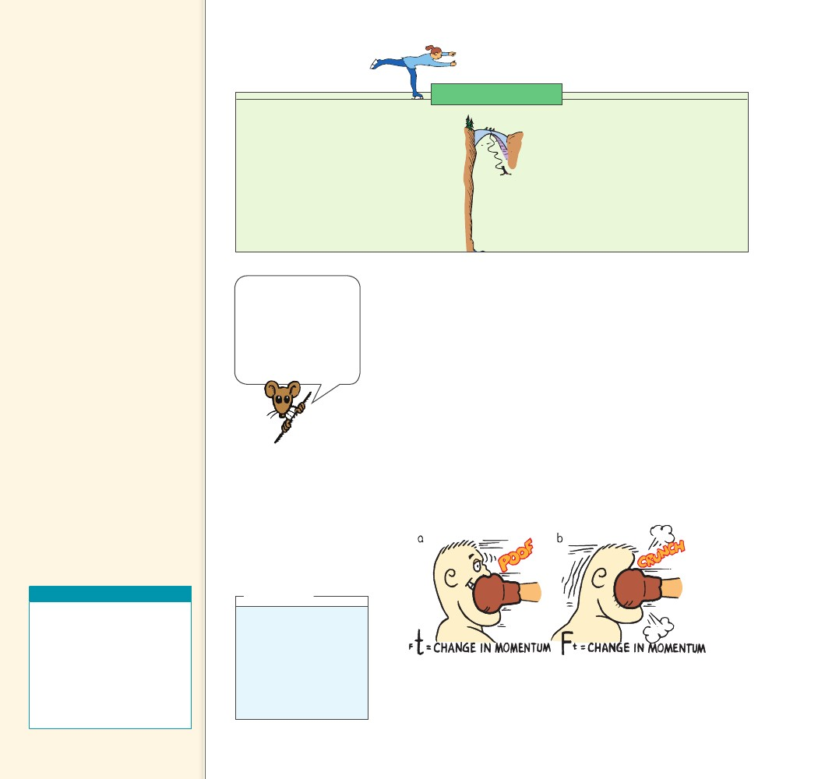
Teaching Tip Have your
students design and construct a
case to hold an egg that is to be
dropped from a three- or four-
story building without breaking.
Be sure students see that the
key consideration is maximizing
the time of impact in order to
minimize the force of impact.
The design cannot include means
to increase air resistance, so all
cases should strike the ground
with about the same speed. By
requiring the masses of all cases
to be the same, the impulses
of all will be the same upon
impact. The force of impact, of
course, should be minimized by
maximizing the time of impact.
Physics of Sports
Bungee Jumping
The impulse–momentum relationship is put
to a thrilling test during bungee jumping.
Be glad the rubber cord stretches when
the jumper’s fall is brought to a halt,
because the cord has to apply an impulse
equal to the jumper’s momentum in order
to stop the jumper—hopefully above
ground level.
Note how Ft(mv) applies here. The
momentum, mv, we wish to change is the
amount gained before the cord begins
stretching. Ft is the impulse the cord
supplies to reduce the momentum to zero.
Because the rubber cord stretches for a
long time, a large time interval t ensures
that a small average force F acts on the
jumper. Elastic cords typically stretch to
twice their original length during the fall.
Whether body A acts
on body B, or body
B acts on body A,
in accordance with
Newton’s third law,
both have the same
amount of impulse Ft.
When jumping from an elevated position down to the ground,
you should bend your knees when your feet make contact with the
ground. By doing so you extend the time during which your momen-
tum decreases by 10 to 20 times that of a stiff-legged, abrupt land-
ing. The resulting force on your bones is reduced by 10 to 20 times.
A wrestler thrown to the floor tries to extend his time of hitting the
mat by relaxing his muscles and spreading the impulse into a series of
smaller ones as his foot, knee, hip, ribs, and shoulder successively hit
the mat. Of course, falling on a mat is preferable to falling on a solid
floor because the mat also increases the stopping time.
When a boxer gets punched, the impulse provided by the boxer’s
jaw must counteract the momentum of the punch. As Figure 8.6a
shows, when the boxer moves away from the punch, he increases the
time of contact and reduces the force. When the boxer moves toward
the punch, as in Figure 8.6b, the time of contact is reduced and the
force is increased.
The change in
CHECK momentum depends
on the force that acts and the
length of time it acts.
CONCEPT
......
Teaching Resources
• Reading and Study
Workbook
• Problem-Solving Exercises in
Physics 5-1
• Laboratory Manual 23
• Transparency 11
• PresentationEXPRESS
• Interactive Textbook
think!
If the boxer in Figure 8.6
is able to make the con-
tact time five times lon-
ger by “riding” with the
punch, how much will the
force of the punch impact
be reduced?
Answer: 8.2.2
FIGURE 8.6
The impulse provided by a boxer’s jaw counteracts
the momentum of the punch. a. The boxer moves
away from the punch. b. The boxer moves toward
the punch. Ouch!
128
128

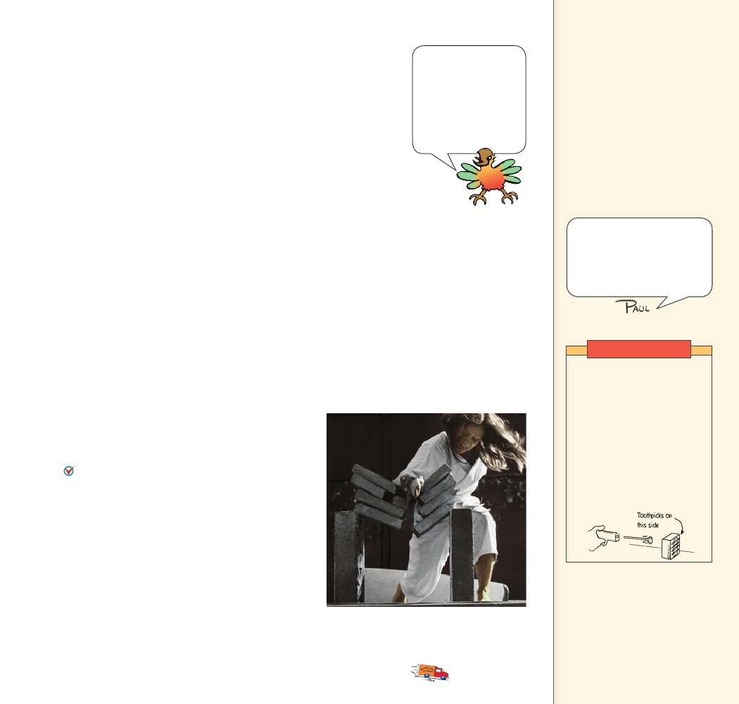
8.3 Bouncing
We know a glass dish is more likely to survive if it is dropped on
a carpet rather than a sidewalk because the carpet has more “give”
than the sidewalk. Ask why a surface with more give makes for a safer
fall and you will get a puzzled response from most people. They may
simply say, “Because it gives more.” However, your question is, “Why
is a surface with more give safer for the dish?” In this case, a common
explanation isn’t enough. A deeper explanation is needed.
To bring the dish or its fragments to rest, the carpet or the side-
walk must provide an impulse, which you know involves two vari-
ables—force and time. Since time is longer hitting the carpet than
hitting the sidewalk, a smaller force results. The shorter time hitting
the sidewalk results in a greater stopping force. The safety net used
by circus acrobats is a good example of how to achieve the impulse
needed for a safe landing. The safety net reduces the stopping force
on a fallen acrobat by substantially increasing the time interval of the
contact.
Sometimes a difference in time is important even if you can’t
notice the give in a surface. For example, a wooden floor and a
concrete floor may both seem rigid, but the wooden floor can have
enough give to make quite a difference in the forces that these two
surfaces exert.
A flower pot dropped
onto your head
bounces quickly. Ouch!
If bouncing took a
longer time, as with
a safety net, then the
force of the bounce
would be much smaller.
Teaching Tip Explain that the
magnitude of an impact force
when bouncing occurs depends
on impact time. For an elastic
collision where momentum is
reversed, and D(mv) is twice
that of merely halting, impulse
is doubled. Although impulse is
greater for bouncing, impact may
or may not depend on time.
Teaching Tip Explain that if
the impulse is over a short time,
impact force is large.
A karate expert does not pull
back upon striking his target.
He strikes in such a way that
his hand is made to bounce
back, yielding up to twice the
impulse to his target.
......
CONCEPT What factors affect how much an object’s
CHECK
momentum changes?
Demonstration
Tape some toothpicks to one
side of a floppy disk box. Fire
a dart from a dart gun against
the smooth side of the box.
The dart sticks and the box
slides an observed distance
across the table. Then repeat,
but with the box turned
around so the dart hits the
toothpick side. When the
dart hits, it bounces. Note the
appreciably greater distance
the box slides!
8.3 Bouncing
If a flower pot falls from a shelf onto your head, you
may be in trouble. If it bounces from your head,
you may be in more serious trouble. Why? Because
impulses are greater when an object bounces.
The impulse required to bring an object to a stop
and then to “throw it back again” is greater than
the impulse required merely to bring the object to
a stop. Suppose, for example, that you catch the fall-
ing pot with your hands. You provide an impulse
to reduce its momentum to zero. If you throw the
pot upward again, you have to provide additional
impulse. It takes a greater impulse to catch the pot
and throw it back up than merely to catch it. This
increased amount of impulse is supplied by your
head if the pot bounces from it. The karate expert in
Figure 8.7 strikes the bricks in such a way that her
hand is made to bounce back, yielding as much as
twice the impulse to the bricks.
FIGURE 8.7
Cassy imparts a large impulse to the bricks in
a short time and produces considerable force.
The impulse required
CHECK to bring an object to
a stop and then to ”throw it back
again” is greater than the impulse
required merely to bring the
object to a stop.
CONCEPT
......
CHAPTER 8
MOMENTUM
129
129

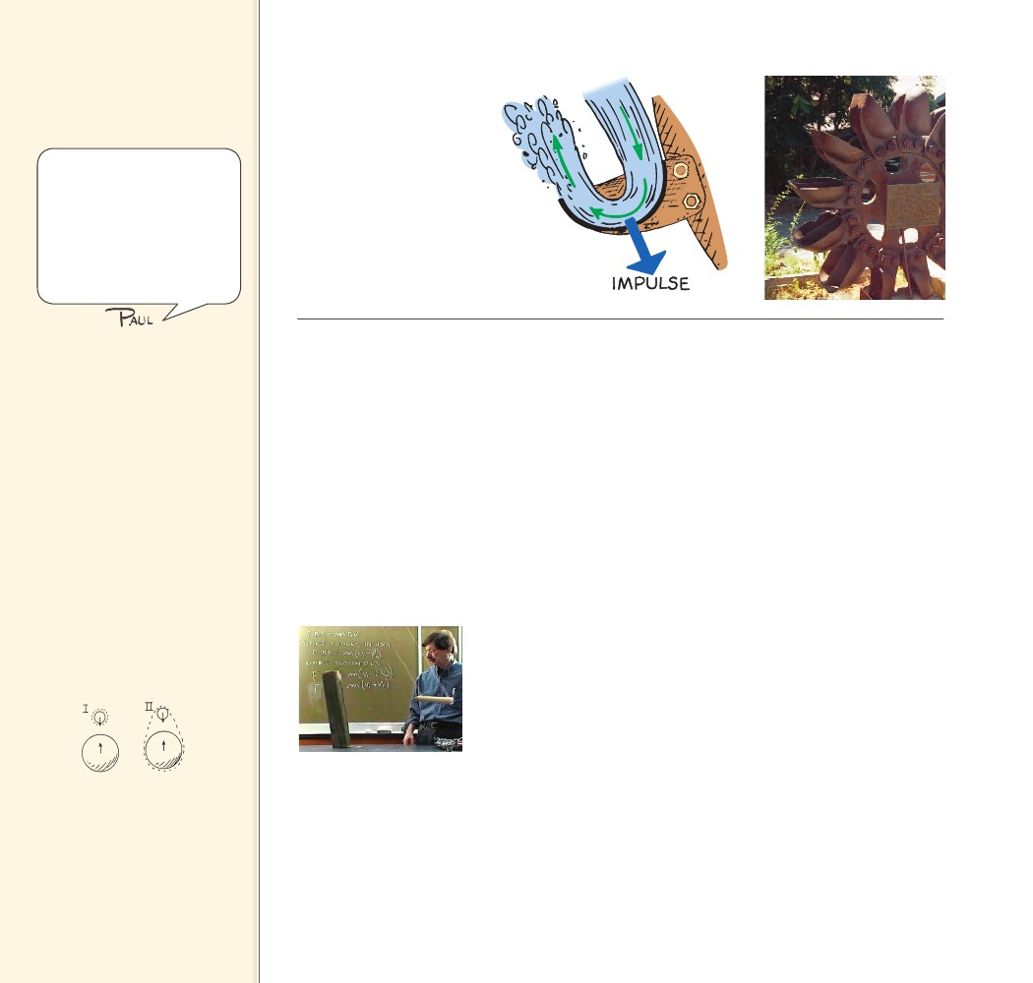
8.4 Conservation of
Momentum
Key Term
law of conservation of momentum
Either Newton’s third law or
momentum conservation can be
considered fundamental. That
is, momentum conservation can
be a consequence of Newton’s
third law, or just as well,
Newton’s third law can be a
consequence of momentum
conservation.
FIGURE 8.8
The curved blades of the
Pelton Wheel cause water to
bounce and make a U-turn,
producing a large impulse
that turns the wheel.
Teaching Tip Distinguish
between external forces
and internal forces (e.g., the
difference between sitting
inside a car and pushing on the
dashboard and standing outside
and pushing against the outside
of the car). Point out that only
an external force will produce a
change in the momentum of the
car. When F 5 0, D(mv) 5 0.
Teaching Tip Discuss the
idea of isolating a system when
applying the conservation of
momentum. We isolate a system
in space by imagining a dotted
boundary line around the
perimeter of the system, and
we isolate a system in time by
considering only the duration of
the interaction.
The fact that impulses are greater when bouncing takes place was
used with great success during the California Gold Rush. The water-
wheels used in gold mining operations were not very effective. A man
named Lester A. Pelton saw that the problem had to do with the flat
paddles on the waterwheel. He designed the curve-shaped paddle
that is shown in Figure 8.8. This paddle caused the incoming water
to make a U-turn upon impact with the paddle. Because the water
“bounced,” the impulse exerted on the waterwheel was increased.
Pelton patented his idea and probably made more money from his
invention, the Pelton Wheel, than any of the gold miners earned.
Physics can indeed make you rich!
CHECK
......
CONCEPT How does the impulse of a bounce compare to
stopping only?
8.4 Conservation of Momentum
From Newton’s second law you know that to accelerate an object,
a net force must be applied to it. This chapter says much the same
thing, but in different language. If you wish to change the momen-
tum of an object, exert an impulse on it.
In either case, the force or impulse must be exerted on the object
by something outside the object. Internal forces won’t work. For
example, the molecular forces within a basketball have no effect on
the momentum of the basketball, just as a push against the dash-
board of a car you’re sitting in does not affect the momentum of the
car. Molecular forces within the basketball and a push on the dash-
board are internal forces. They come in balanced pairs that cancel
within the object. To change the momentum of the basketball or the
car, an outside push or pull is required. If no outside force is present,
no change in momentum is possible.
FIGURE 8.9
Show that where momentum
may be conserved for a particular
system, it may not be conserved
for part of the system.
Teacher Howie Brand
shows that the block
topples when the swing-
ing dart bounces from
it. When he removes the
rubber head of the dart
so it doesn’t bounce
when it hits the block, no
toppling occurs.
130
130

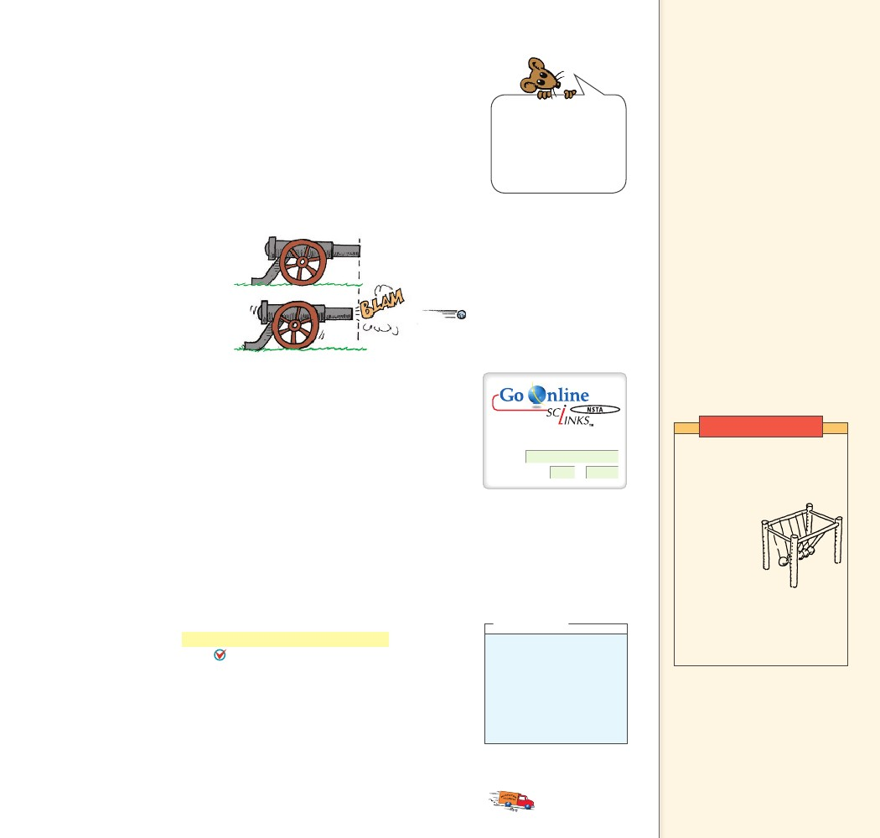
Consider the cannon being fired in Figure 8.10. The force on
the cannonball inside the cannon barrel is equal and opposite to the
force causing the cannon to recoil. Recall Newton’s third law about
action and reaction forces. These forces are internal to the system
comprising the cannon and the cannonball, so they don’t change
the momentum of the cannon–cannonball system. Before the firing,
the system is at rest and the momentum is zero. After the firing the
net momentum, or total momentum, is still zero. Net momentum
is neither gained nor lost. Let’s consider the effects of internal and
external forces carefully.
FIGURE 8.10
The momentum before fir-
ing is zero. After firing, the
net momentum is still zero
because the momentum
of the cannon is equal and
opposite to the momentum
of the cannonball.
Most of the cannon-
ball’s momentum is
in speed; most of the
recoiling cannon’s
momentum is in mass.
mv .So mv
Momentum, like the quantities velocity and force, has both direc-
tion and magnitude. It is a vector quantity. Like velocity and force,
momentum can be canceled. So, although the cannonball in the
preceding example gains momentum when fired and the recoiling
cannon gains momentum in the opposite direction, the cannon–can-
nonball system gains none. The momenta (plural form of momen-
tum) of the cannonball and the cannon are equal in magnitude and
opposite in direction. Therefore, these momenta cancel each other
out for the system as a whole. No external force acted on the system
before or during firing. Since no net force acts on the system, there
is no net impulse on the system and there is no net change in the
momentum.
In every case, the momentum of a system cannot change unless it
is acted on by external forces. A system will have the same momentum
before some internal interaction as it has after the interaction occurs.
When momentum, or any quantity in physics, does not change, we say
it is conserved. The law of conservation of momentum describes the
momentum of a system. The law of conservation of momentum
states that, in the absence of an external force, the momentum of a
system remains unchanged. If a system undergoes changes wherein
all forces are internal as for example in atomic nuclei undergoing
radioactive decay, cars colliding, or stars exploding, the net momen-
tum of the system before and after the event is the same.
Teaching Tip Consider a
dropped rock in free fall. If the
system is taken to be the rock,
then momentum is not conserved
as it falls because an external
force acts on the system (its
vector is seen to penetrate the
dotted border of the system).
This external force, gravity,
produces an impulse on the rock
that changes its momentum. If
the system is instead considered
to be the rock and Earth, then
the interaction between the
rock and Earth is internal to the
system (there is no penetrating
vector). For this larger system,
momentum is conserved. That
is, the momentum of Earth as it
“races up” to meet the falling
rock is equal and opposite to
the momentum of the rock as it
drops to meet Earth (at its center
of mass). The momentum of any
interaction is always conserved
if you make your system big
enough.
Demonstration
For: Links on momentum
Visit: www.SciLinks.org
Web Code: csn – 0804
think!
Newton’s second law
states that if no net force
is exerted on a system, no
acceleration occurs. Does
it follow that no change in
momentum occurs?
Answer: 8.4
Use the popular swinging balls
apparatus to demonstrate
momentum conservation.
Show students that when the
balls on one
side are lifted
and released
so they make
contact with
the others, the
momentum
of balls is the
same before and after the
collision—the same number
of balls emerge at the same
speed on the other side.
CHECK
......
CONCEPT What does the law of conservation of
momentum state?
CHAPTER 8
MOMENTUM
The law of
CHECK conservation of
momentum states that, in the
absence of an external force,
the momentum of a system
remains unchanged.
CONCEPT
......
131
131

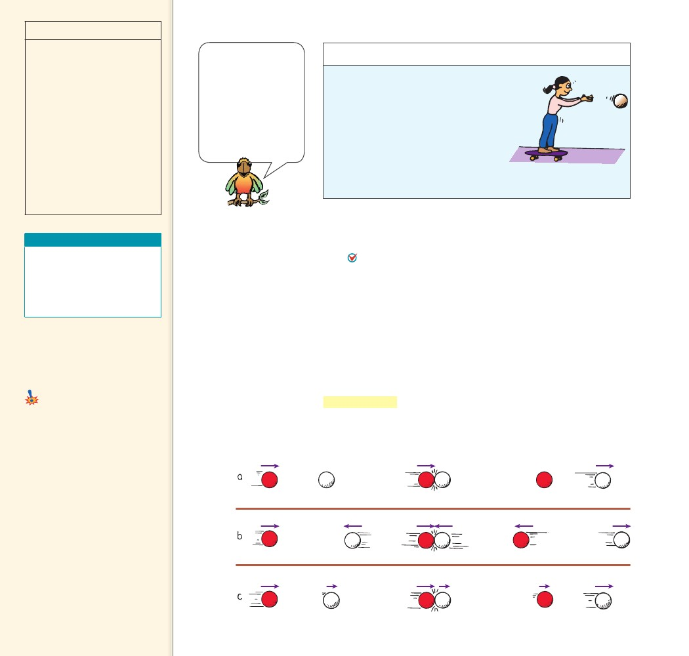
discover!
MATERIALS
skateboard, heavy
object
You only
move when you release the
object.
EXPECTED OUTCOME
In both Steps 1 and 2,
the total momentum is zero.
In order for momentum to be
conserved in Step 1, you must
move in the opposite direc-
tion that the object moves. In
order for the total momentum
to be conserved in Step 2, you
must stay at rest because the
object does not move away.
THINK
A conservation law
is constancy during
change. Conservation
laws are a source of
deep insights into the
simple regularity of
nature and are often
considered the most
fundamental of physical
laws.
discover!
How Are Motion and Conservation
of Momentum Related?
1. Stand at rest on a skateboard and
throw a massive object forward or
backward. What do you notice?
2. Repeat the throwing motion in Step
1, but this time don’t let go of the
object. What do you notice?
3. Think How is the difference in your motion in Steps 1 and 2 related
to conservation of momentum?
8.5 Collisions
Teaching Resources
• Reading and Study
Workbook
• Probeware Lab Manual 6
• PresentationEXPRESS
• Interactive Textbook
The collision of objects clearly shows the conservation of momen-
tum. Whenever objects collide in the absence of external forces,
the net momentum of both objects before the collision equals the
net momentum of both objects after the collision.
net momentum before collision
net momentum after collision
8.5 Collisions
Key Terms
elastic collision, inelastic collision
Common Misconceptions
Momentum is conserved only when
collisions are perfectly elastic.
Even in an inelastic collision,
the net momentum before the
collision is equal to the net
momentum after the collision.
FACT
FIGURE 8.11
Colliding objects bounce
perfectly in elastic collisions.
a. A moving ball strikes a
ball at rest. b. Two moving
balls collide head-on.
c. Two balls moving in the
same direction collide.
Elastic Collisions When a moving billiard ball collides head-on
with a ball at rest, the first ball comes to rest and the second ball
moves away with a velocity equal to the initial velocity of the first
ball. We see that momentum is transferred from the first ball to
the second ball. When objects collide without being permanently
deformed and without generating heat, the collision is said to be an
elastic collision. Colliding objects bounce perfectly in perfect elastic
collisions, as shown in Figure 8.11. Note that the sum of the momen-
tum vectors is the same before and after each collision.
Collision
After Collision
Before Collision
132
132

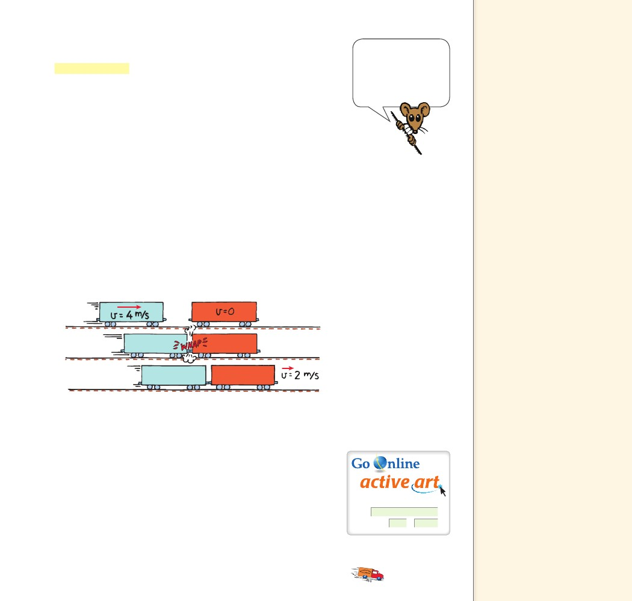
Inelastic Collisions A collision in which the colliding objects
become distorted and generate heat during the collision is an
inelastic collision. Momentum conservation holds true even in inelas-
tic collisions. Whenever colliding objects become tangled or couple
together, a totally inelastic collision occurs. The freight train cars in
Figure 8.12 provide an example. Suppose the freight cars are of equal
mass m, and that one car moves at 4 m/s toward the other car that is
at rest. Can you predict the velocity of the coupled cars after impact?
From the conservation of momentum,
Momentum is con-
served for all collisions,
elastic and inelastic
(when there are no
external forces to
provide net impulse).
Teaching Tip Distinguish
between elastic (bouncy) and
inelastic (sticky) collisions. Point
out that when no external forces
act on a system, no change in the
total momentum of that system
occurs.
Teaching Tip For the case of
equal-mass carts in an inelastic
collision (Figure 8.12), go over
the equation in the middle of
the page in detail. Write similar
equations for the collisions you
demonstrate on the air track so
students will relate the equations
to visual examples. Have your
students write the equations
for other examples you show. In
writing the equations for head-
on collisions, be careful to show
velocities in one direction as
positive and oppositely-directed
velocities as negative. For
example, the equation for Figure
8.11b is [mv 1 m(2v)]before 5
[m(2v) 1 mv]after. In both the
before and after cases, the net
momentum is zero.
net momentum before collision
or, in equation form,
(net mv)before
(m)(4 m/s)
net momentum after collision
(net mv)after
(2m)(vafter)
(m)(0 m/s)
Since twice as much mass is moving after the collision, can you
see that the velocity, vafter, must be one half of 4 m/s? Solving for the
velocity after the collision, we find vafter 2 m/s in the same direction
as the velocity before the collision, vbefore. The initial momentum is
shared by both cars without loss or gain. Momentum is conserved.
FIGURE 8.12
In an inelastic collision
between two freight cars,
the momentum of the
freight car on the left is
shared with the freight car
on the right.
Most collisions usually involve some external force. Billiard balls
do not continue indefinitely with the momentum imparted to them.
The moving balls encounter friction with the table and the air. These
external forces are usually negligible during the collision, so the net
momentum does not change during collision. The net momentum of
two colliding trucks is the same before and just after the collision. As
the combined wreck slides along the pavement, friction provides an
impulse to decrease its momentum. Similarly, a pair of space vehicles
docking in orbit have the same net momentum just before and just
after contact. Since there is no air resistance in space, the combined
momentum of the space vehicles after docking is then changed only
by gravity.
For: Momentum activity
Visit: PHSchool.com
Web Code: csp – 1085
CHAPTER 8
MOMENTUM
133
133

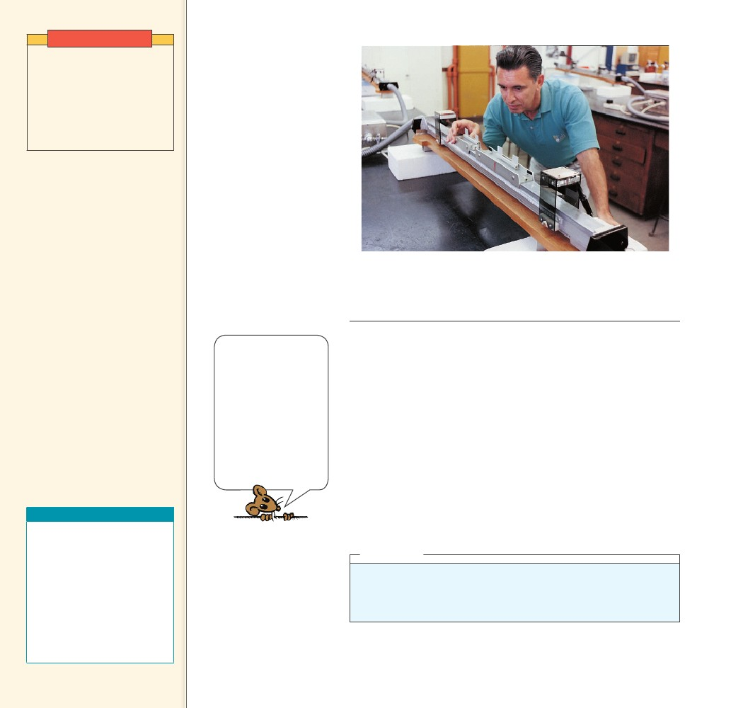
Demonstration
Show examples of momentum
conservation in both elastic
and inelastic collisions using
carts on an air track. If you
represent the collisions on the
board, use the exaggerated
symbol technique (big m,
little v, and vice versa).
FIGURE 8.13
An air track nicely demonstrates conservation of
momentum. Many small air jets provide a nearly fric-
tionless cushion of air for the gliders to slide on.
Whenever objects
CHECK collide in the absence
of external forces, the net
momentum of both objects
before the collision equals the
net momentum of both objects
after the collision.
CONCEPT
Pucks and carts ride
nearly free of friction
on cushions of air on
air tracks like the one
shown in Figure 8.13.
Galileo worked hard
to produce smooth
surfaces to minimize
friction. How he would
have loved to experi-
ment with today’s air
tracks!
Perfectly elastic collisions are not common in the everyday world.
We find in practice that some heat is generated during collisions.
Drop a ball and after it bounces from the floor, both the ball and the
floor are a bit warmer. Even a dropped superball will not bounce to
its initial height. At the microscopic level, however, perfectly elastic
collisions are commonplace. For example, electrically charged par-
ticles bounce off one another without generating heat; they don’t
even touch in the classic sense of the word. Later chapters will show
that the concept of touching needs to be considered differently at the
atomic level.
CONCEPT
......
Teaching Resources
• Reading and Study
Workbook
• Laboratory Manual 24, 25
• Concept-Development
Practice Book 8-1
• Problem-Solving Exercises in
Physics 5-2
• Transparency 12
• PresentationEXPRESS
• Interactive Textbook
CHECK
How does conservation of momentum
apply to collisions?
think!
Suppose one of the gliders in Figure 8.13 is loaded so it has three times the
mass of the other glider. The loaded glider is initially at rest. The unloaded
glider collides with the loaded glider and the two gliders stick together.
Describe the motion of the gliders after the collision. Answer: 8.5
134
134
......

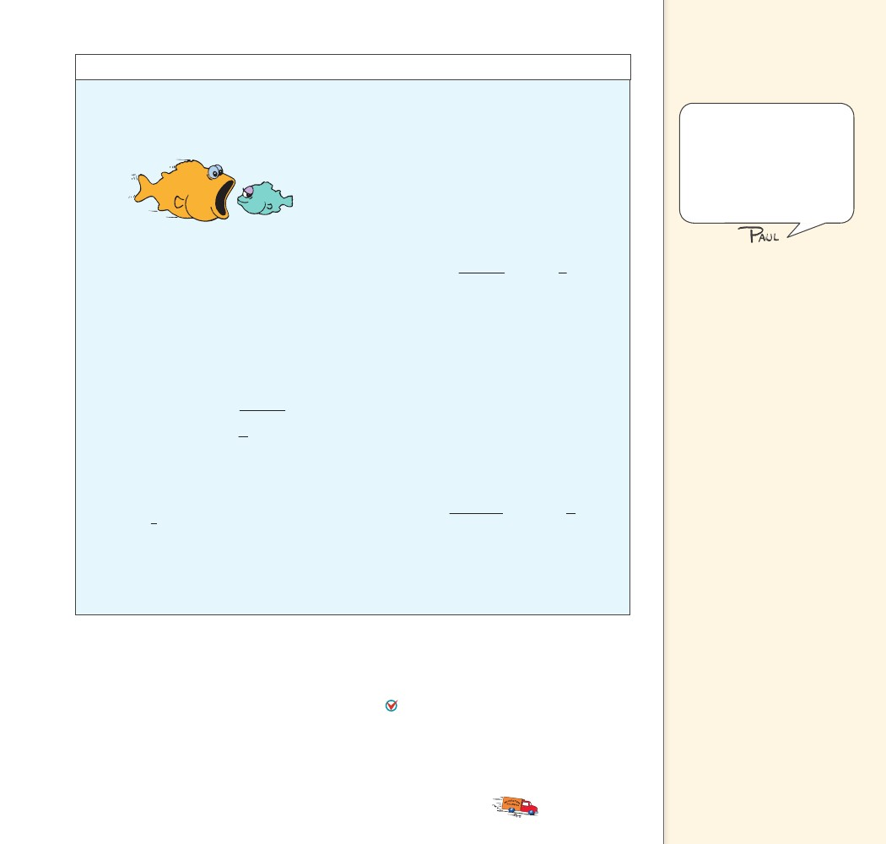
8.6 Momentum
do the math!
Consider a 6-kg fish that swims toward and
swallows a 2-kg fish that is at rest. If the
larger fish swims at 1 m/s, what is its velocity
immediately after lunch?
Suppose the small fish is not at rest but is
swimming toward the large fish at 2 m/s.
What is the velocity of the larger fish
immediately after lunch?
If we consider the direction of the large fish
as positive, then the velocity of the small fish
is –2 m/s.
(net mv) before
(6 kg)(1 m/s)
(2 kg)( 2 m/s)
( 4 kg m/s)
2 kg m/s
8 kg
(net mv) after
(6 kg
2 kg)(vafter)
Vectors
Resist making a big deal out
of this section unless you have
ample time on your hands and
your class is anxious for you to
set your academic plow deeper.
I think it is enough for students
to be exposed to the general
idea here and then move on.
Momentum is conserved from the instant before
lunch until the instant after (in so brief an inter-
val, water resistance does not have time to
change the momentum), so we can write
net momentum before lunch
(net mv) before
(6 kg)(1 m/s)
(2 kg)(0 m/s)
6 kg m/s
vafter
vafter
net momentum after lunch
(net mv) after
(6 kg
2 kg)(vafter)
(6 kg m/s)
(8 kg)(vafter)
vafter
1
m/s
4
(8 kg)(vafter)
6 kg m/s
8 kg
3
m/s
4
The negative momentum of the small fish is very
effective in slowing the large fish. If the small
fish were swimming at –3 m/s, then both fish
would have equal and opposite momenta. Zero
momentum before lunch would equal zero
momentum after lunch, and both fish would
come to a halt.
More interestingly, suppose the small fish
swims at –4 m/s.
(net mv) before
(6 kg)(1 m/s)
(6 kg m/s)
(2 kg)( 4 m/s)
( 8 kg m/s)
2 kg m/s
8 kg
(net mv) after
(6 kg
2 kg)(vafter)
We see that the small fish has no momentum
before lunch because its velocity is zero. Using
simple algebra we see that after lunch the com-
bined mass of the two-fish system is 8 kg and
3its speed is 4 m/s in the same direction as the
large fish’s direction before lunch.
(8 kg)(vafter)
vafter
1
m/s
4
The minus sign tells us that after lunch the two-
fish system moves in a direction opposite to the
large fish’s direction before lunch.
8.6 Momentum Vectors
Momentum is conserved even when interacting objects don’t move
along the same straight line. To analyze momentum in any direction,
we use the vector techniques we’ve previously learned. The vector
sum of the momenta is the same before and after a collision. We’ll
look at momentum conservation involving angles by briefly
considering the three following examples.
CHAPTER 8
MOMENTUM
135
135

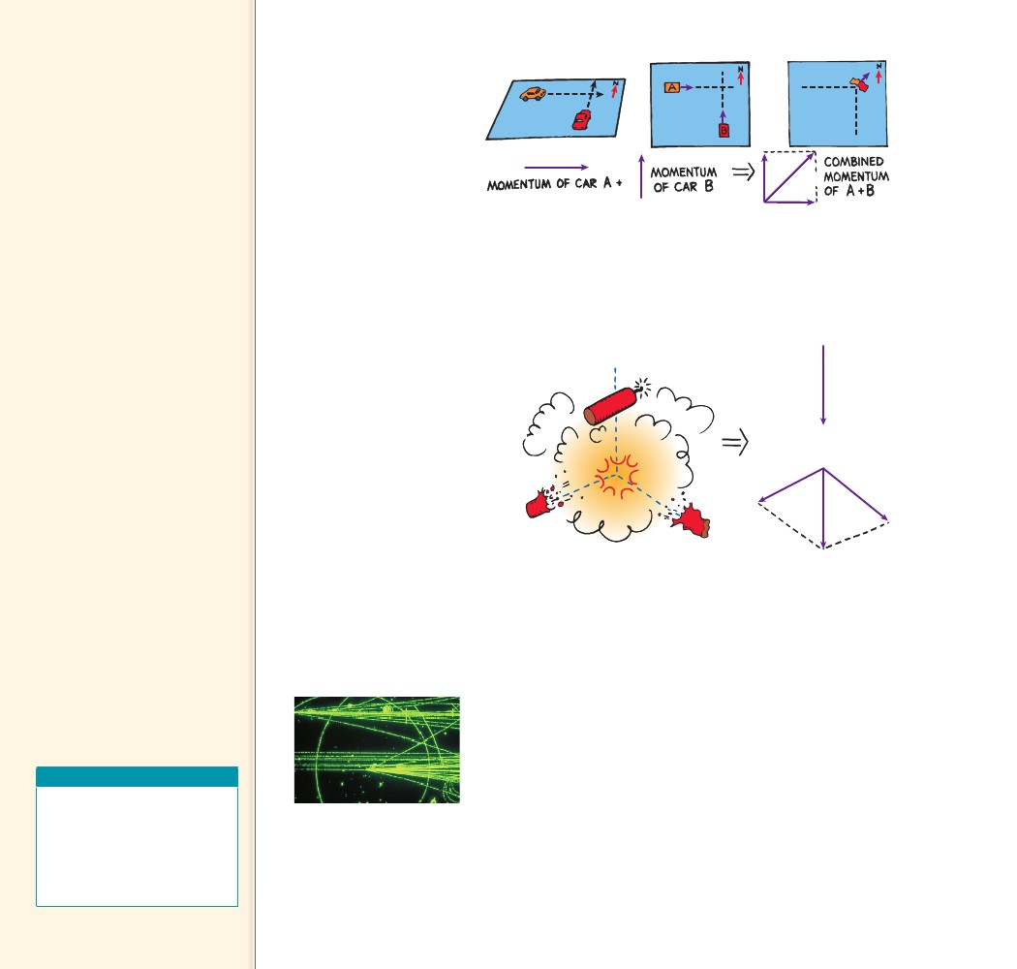
Teaching Tip You may find
it helpful to review the rules of
vectors here.
Teaching Tip Illustrate the
vector nature of momentum by
discussing Figures 8.14, 8.15, and
8.16.
Teaching Tip When
discussing Figure 8.15, explain
that for collisions involving x and
y directions,
S(mvx)before 5 S(mvx)after and
S(mvy)before 5 S(mvy)after.
For the falling firecracker,
S(mvx)before 5 S(mvx)after 5 0,
so mvx of the piece that flies off
to the right equals 2mvx of the
piece that flies off to the left.
FIGURE 8.14
Momentum is a vector
quantity. The momentum
of the wreck is equal to the
vector sum of the momenta
of car A and car B before
the collision.
Notice in Figure 8.14 that the momentum of car A is directed
due east and that of car B is directed due north. If their momenta are
equal in magnitude, after colliding their combined momentum will
be in a northeast direction with a magnitude 2 times the momen-
tum either vehicle had before the collision (just as the diagonal of a
square is 2 times the length of a side).
FIGURE 8.15
When the firecracker bursts,
the vector sum of the
momenta of its fragments add
up to the firecracker’s momen-
tum just before bursting.
mv
mv
The vector sum of
CHECK the momenta is the
same before and after a collision.
CONCEPT
Teaching Resources
• Concept-Development
Practice Book 8-2
• Reading and Study
Workbook
• PresentationEXPRESS
• Interactive Textbook
FIGURE 8.16
Momentum is conserved for
the high-speed elementary
particles, as shown by the
tracks they leave in a bubble
chamber.
Figure 8.15 shows a falling firecracker that explodes into two
pieces. The momenta of the fragments combine by vector rules to
equal the original momentum of the falling firecracker.
Figure 8.16 shows tracks made by subatomic particles in a bubble
chamber. The mass of these particles can be computed by applying
both the conservation of momentum and conservation of energy
laws—the conservation of energy law will be discussed in the next
chapter. The conservation laws are extremely useful to experimenters
in the atomic and subatomic realms. A very important feature of their
usefulness is that forces do not show up in the equations. Forces in
collisions, however complicated, are not a concern.
Conservation of momentum and, as the next chapter will discuss,
conservation of energy are the two most powerful tools of mechanics.
Their application yields detailed information that ranges from under-
standing the interactions of subatomic particles to entire galaxies.
CONCEPT
......
CHECK
What is true about the vector sum of
momenta in a collision?
136
136
......

