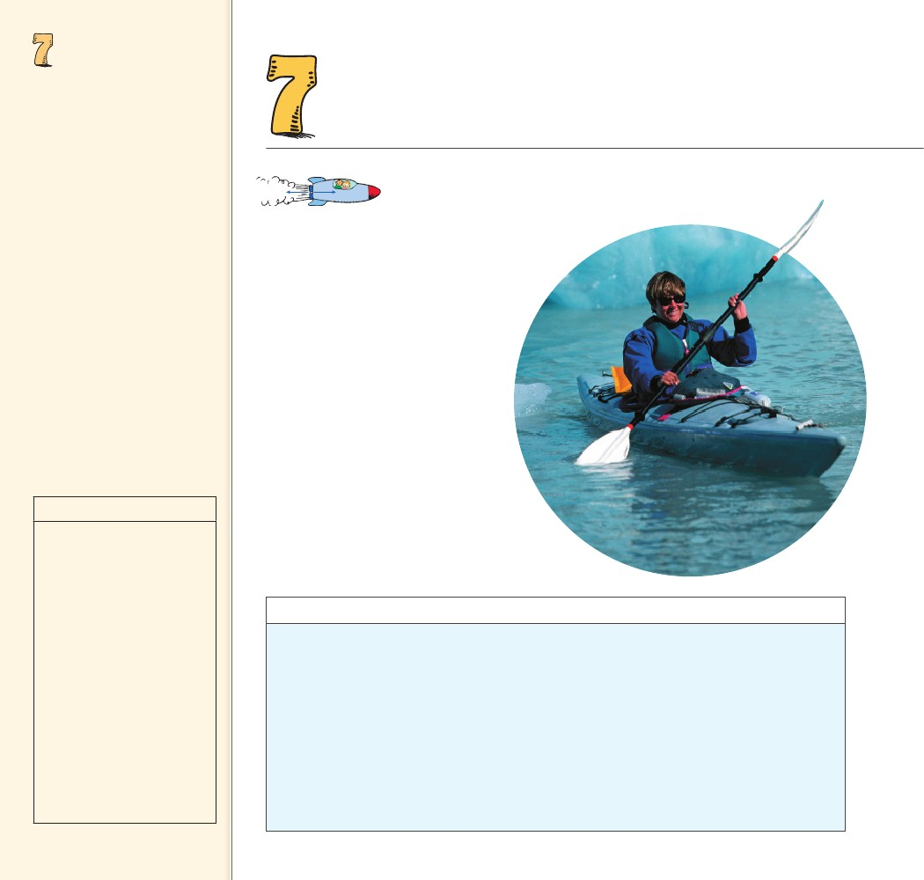
NEWTON’S
THIRD LAW
OF MOTION—
ACTION AND
REACTION
Objectives
• Define force as part of an
interaction. (7.1)
• State Newton’s third law of
motion. (7.2)
• Describe how to identify a pair
of action–reaction forces. (7.3)
• Explain why the accelerations
caused by an action force and
by a reaction force do not have
to be equal. (7.4)
• Explain why an action force is
not cancelled by the reaction
force. (7.5)
• Explain how a horse-cart
system accelerates. (7.6)
• Explain what must occur in
every interaction between
things. (7.7)
NEWTON’S THIRD LAW OF
MOTION—ACTION AND REACTION
THE BIG
........
IDEA
For every force, there is an equal
and opposite force.
discover!
MATERIALS
two spring
balances, two bathroom scales
f you lean over too far, you’ll fall. But
if you lean over with your hand out-
stretched and make contact with a
wall, you can do so without falling.
When you push against the wall, it
pushes back on you. That’s why you
are supported. Ask your friends
why you don’t topple over. How
many will answer, “Because the
wall is pushing on you and hold-
ing you in place”? Probably not
very many people, unless they’re
physics types, realize that walls
can push on us every bit as much as
we push on them.7.0 Similarly, kayak
paddles that push water backward
are pushed forward by the water.
I
In the
interaction between two
spring balances or two
bathroom scales, the spring
balances and the bathroom
scales always have the same
reading.
EXPECTED OUTCOME
ANALYZE AND CONCLUDE
discover!
Can There Be Only One Force In an
Interaction?
1. Connect the hooks of two spring balances.
Have a tug of war with a classmate. Observe
the reading on the scales during the tug of
war. (Caution: Don’t pull too hard!)
2. Try to have one person pull harder than the
other. Note the scale readings again.
3. With your classmate, hold two bathroom
scales back to back. Now push on the scales
and share scale readings.
Analyze and Conclude
1. Observing How did readings on the spring
balances compare throughout your
tug of war?
2. Predicting Is there some way for one person
to exert a force without causing the other
person to interact? Explain.
3. Making Generalizations Why do we say
forces occur only in pairs?
1. They were the same.
2. No. If one person pulls
harder, the other person
must pull harder back in
order for there still to be an
interaction.
3. A force is always part of an
interaction that involves
another force.
106
106

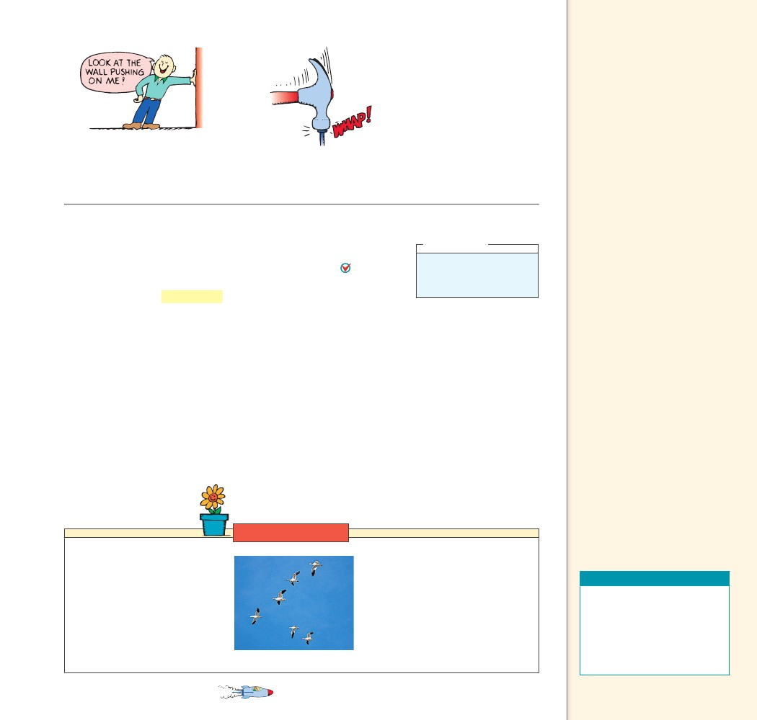
7.1 Forces and
Interactions
Key Term
interaction
Teaching Tip Touch your
desk and state, “I can’t touch this
desk without the desk touching
me; I can’t exert a force on a
body without that body exerting
a force on me. In all cases of
contact there is a twoness—
contact requires two objects.”
FIGURE 7.1
When you push on the wall,
the wall pushes on you.
FIGURE 7.2
The interaction that drives the nail is the
same as the one that halts the hammer.
7.1 Forces and Interactions
In the simplest sense, a force is a push or a pull. Looking closer, how-
A forceever, Newton realized that a force is not a thing in itself.
is always part of a mutual action that involves another force. A
mutual action is an interaction between one thing and another. For
example, consider the interaction between a hammer and a nail, as
shown in Figure 7.2. A hammer exerts a force on the nail and drives
it into a board. But this force is only half the story, for there must
also be a force exerted on the hammer to halt it in the process. What
exerts this force? The nail does! Newton reasoned that while the ham-
mer exerts a force on the nail, the nail exerts a force on the hammer.
So, in the interaction between the hammer and the nail, there are
a pair of forces, one acting on the nail and the other acting on the
hammer. Such observations led Newton to his third law: the law of
action and reaction.
CONCEPT
think!
Does a stick of dynamite
contain force? Explain.
Answer: 7.1
......
CHECK
Why do forces always occur in pairs?
Link to BIOLOGY
Action–Reaction in Action Why
do migrating birds, such as geese,
fly in a V formation? The answer is
simple, physics! The bird’s wings
deflect air downward and the
air pushes the bird upward. But
the story doesn’t end there. The
downward-moving air meets the
air below and swirls upward.
CHAPTER 7
A force is always part
CHECK of a mutual action
that involves another force.
CONCEPT
This upward-swirling air creates an
updraft, which is strongest off to
the side of the bird. A trailing bird
positions itself to get added lift
from the updraft, thus conserving its
energy. This bird, in turn, creates an
updraft for a following bird, and so
on. The result is a flock flying in a
V formation.
NEWTON’S THIRD LAW OF MOTION— ACTION AND REACTION
Teaching Resources
• Reading and Study
Workbook
• PresentationEXPRESS
• Interactive Textbook
• Conceptual Physics Alive!
DVDs Newton’s Third Law
......
107
107

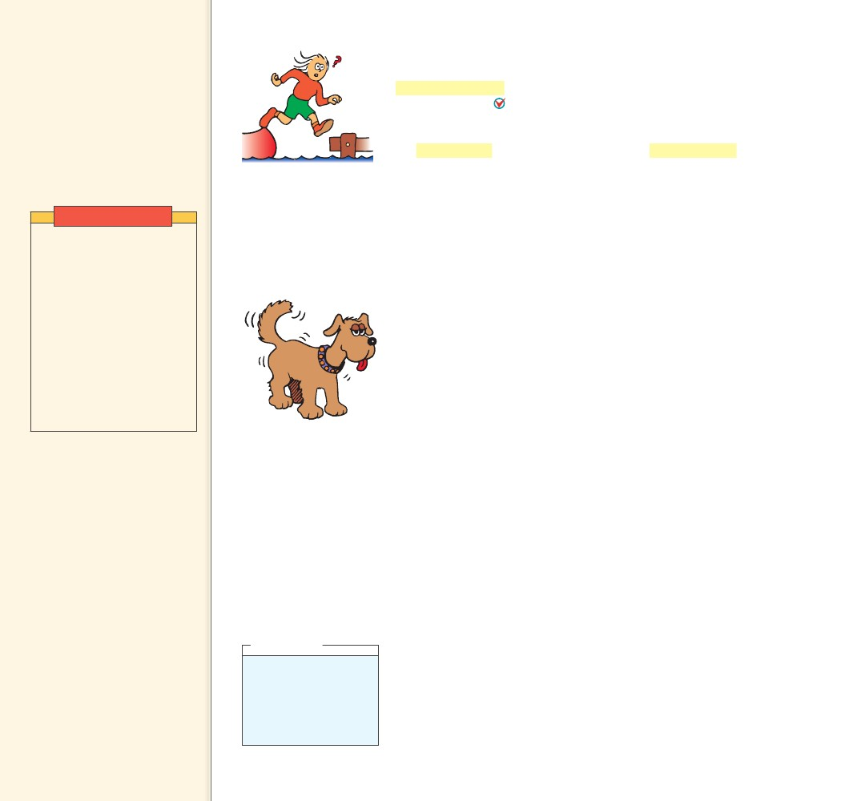
7.2 Newton’s Third
Law
Key Terms
Newton’s third law, action force,
reaction force
Teaching Tip Stress that
forces always occur in pairs and,
like the sound of one hand
clapping, the action of one force
alone is physically impossible.
7.2 Newton’s Third Law
Newton’s third law describes the relationship between two forces
in an interaction. Newton’s third law states that whenever one
object exerts a force on a second object, the second object exerts
an equal and opposite force on the first object. One force is called
the action force. The other force is called the reaction force. It
doesn’t matter which force we call action and which we call reaction.
The important thing is that they are partners in a single interac-
tion and that neither force exists without the other. They are equal
in strength and opposite in direction. Newton’s third law is often
stated: “To every action there is always an equal opposing reaction.”
Look at Figures 7.3 and 7.4. In every interaction, the forces always
occur in pairs. For example, you interact with the floor when you
walk on it. You push against the floor, and the floor simultaneously
pushes against you. Likewise, the tires of a car interact with the road
to produce the car’s motion. The tires push against the road, and the
road simultaneously pushes back on the tires. When swimming, you
interact with the water. You push the water backward, and the water
pushes you forward. Notice that the interactions in these examples
depend on friction. For example, a person trying to walk on ice,
where friction is minimal, may not be able to exert an action force
against the ice. Without the action force there cannot be a reaction
force, and thus there is no resulting forward motion.
CONCEPT
FIGURE 7.3
When the girl jumps to shore,
the boat moves backward.
Demonstration
Extend your hand and show
your class that you can bend
your fingers backward only
very little. Show that if you
push with your other hand,
and thereby apply a force
to them, they will bend
appreciably more. Then show
that an inanimate wall does
the same (as you push against
the wall). State that the wall is
simultaneously pushing
on you as you push on it—
as evidenced by your bent
fingers.
FIGURE 7.4
Teaching Tip Explain that in
walking, you interact with the
ﬂoor; that is, you push back on
the ﬂoor and the ﬂoor pushes
forward on you. In swimming,
you interact with the water;
that is, you push backward on
the water and the water pushes
forward on you. A balloon pushes
escaping air backward and the
escaping air in turn pushes the
balloon forward, just as a jet
engine works. A car pushes
backward on the road, and the
road pushes forward on the car.
The dog wags the tail and
the tail wags the dog.
CHECK
What happens when an object exerts a force on
another object?
7.3 Identifying Action and Reaction
Sometimes the identity of the pair of action and reaction forces in
an interaction is not immediately obvious. For example, what are the
action and reaction forces in the case of a falling boulder? You might
say that Earth’s gravitational force on the boulder is the action force,
but can you identify the reaction force? Is it the weight of the boul-
der? No, weight is simply another name for the force of gravity. Is it
caused by the ground where the boulder lands? No, the ground does
not act on the boulder until the boulder hits it.
There is a simple recipe for treating action and reaction forces.
First identify the interaction. Let’s say one object, A, interacts with
another object, B. The action and reaction forces are stated in this
form:
Action: Object A exerts a force on object B.
Reaction: Object B exerts a force on object A.
think!
We know that Earth
pulls on the moon. Does
the moon also pull on
Earth? If so, which pull
is stronger?
Answer: 7.3
Newton’s third law
CHECK states that whenever
one object exerts a force on a
second object, the second object
exerts an equal and opposite
force on the first object.
CONCEPT
108
......
108
......

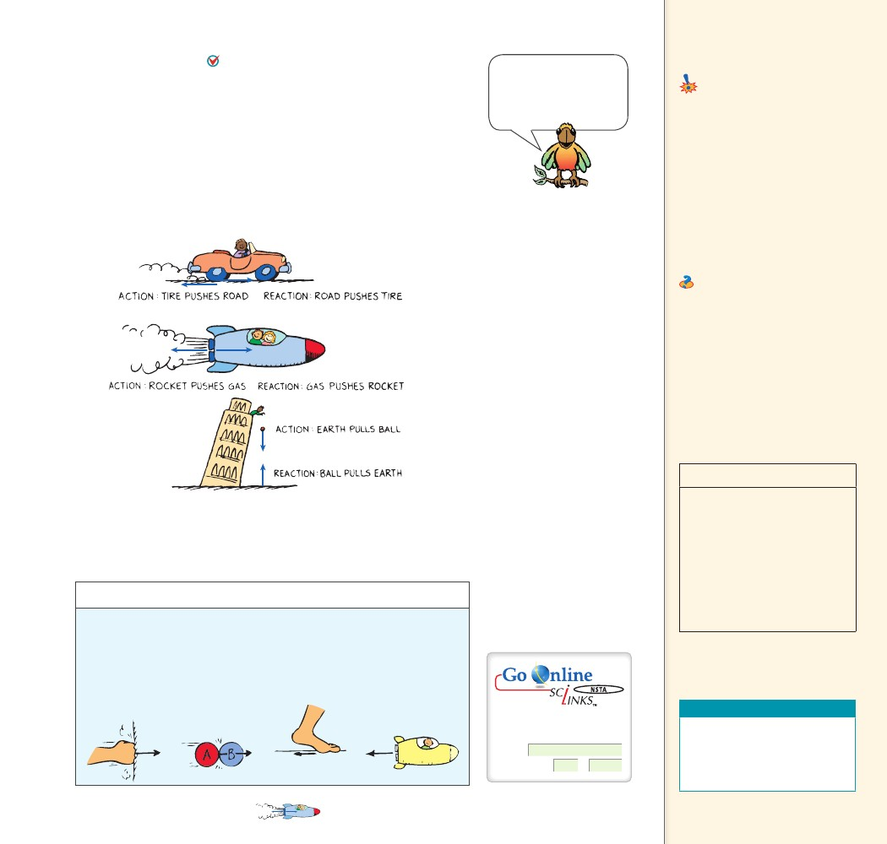
7.3 Identifying
Look at Figure 7.5. To identify a pair of action–reaction
forces, first identify the interacting objects A and B, and if the
action is A on B, the reaction is B on A. So, in the case of the falling
boulder, the interaction during the fall is the gravitational attraction
between the boulder and Earth. If we call the action Earth exerting a
force on the boulder, then the reaction is the boulder simultaneously
exerting a force on Earth.
CONCEPT
You can’t pull on some-
thing unless that some-
thing simultaneously pulls
on you. That’s the law!
Action and Reaction
Common Misconceptions
Reaction forces occur slightly after
the action force is applied.
Action and reaction forces
act simultaneously.
FACT
CHECK
How do you identify the acton–reaction forces
in an interaction?
Teaching Tip Call attention
to the examples in Figure 7.5 and
relate these to the interaction
rule: Object A exerts a force on
object B. Object B exerts a force
on object A. Point out that action
and reaction forces always act on
different objects.
Ask Identify the action and
reaction pair of forces for the
case of a bat interacting with a
ball. The bat pushes on the ball
and the ball pushes on the bat.
To identify a pair of
CHECK action–reaction
forces, first identify the
interacting objects A and B, and
if action is A on B, the reaction is
B on A.
CONCEPT
......
discover!
MATERIALS
......
paper and pencil
FIGURE 7.5
In the force-pair between object A and object B, note
that when action is A exerts force on B, the reaction is
simply B exerts force on A.
Students
will identify the action–
reaction forces.
EXPECTED OUTCOME
THINK
discover!
What are the action–reaction pairs?
1. Each of the drawings below shows the action force on an object.
Recopy each of the drawings in your notebook.
2. Draw the appropriate vectors showing the reaction forces.
3. Think Specify the action–reaction pairs in each example.
In each of the four
cases, the reaction arrow
should be equal in size but
opposite in direction to the
action arrow.
Teaching Resources
For: Links on
action and reaction
Visit: www.SciLinks.org
Web Code: csn – 0703
• Concept-Development
Practice Book 7-1
• Transparency 10
• Next-Time Question 7-1
CHAPTER 7
NEWTON’S THIRD LAW OF MOTION— ACTION AND REACTION
109
109

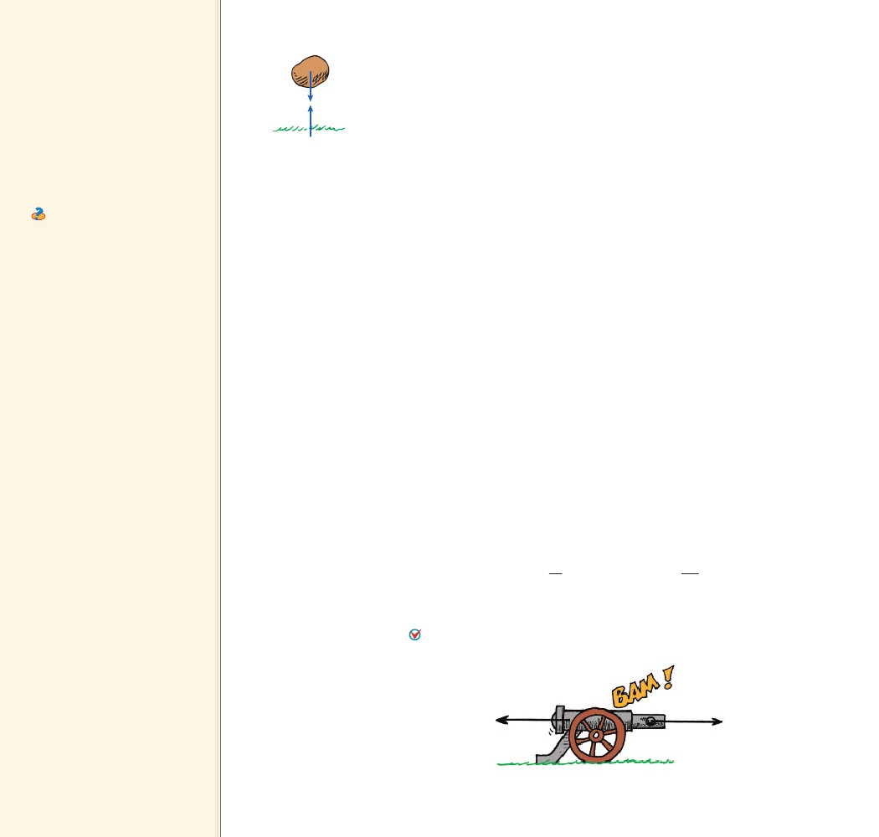
7.4 Action and
Reaction on
Different Masses
Teaching Tip Discuss the
action and reaction forces when
a cannonball is fired from a
cannon. Use the exaggerated
symbol technique to show how
equal forces produce unequal
accelerations when different
masses are involved.
Ask Apply Newton’s third
law to a tug-of-war. If the action
is you pulling on the rope, is
the reaction force the ground
pushing back on you or your
opponent pulling back on the
rope? Neither; reaction is the
rope pulling back on you—A on B;
B on A!
7.4 Action and Reaction on
Different Masses
Interestingly enough, in the interaction between the boulder and
Earth, shown in Figure 7.6, the boulder pulls up on Earth with as
much force as Earth pulls down on the boulder. The forces are equal
in strength and opposite in direction. We say the boulder falls to
Earth. Could we also say Earth falls to the boulder? The answer is yes,
but the distance Earth falls is much less. Although the pair of forces
between the boulder and Earth are the same, the masses are quite
unequal. Recall that Newton’s second law states that acceleration is
not only proportional to the net force, but it is also inversely propor-
tional to the mass. Because Earth has a huge mass, we don’t sense its
infinitesimally small acceleration. Although Earth’s acceleration is
negligible, strictly speaking it does move up toward the falling boul-
der. So when you step off a curb, the street actually comes up a tiny
bit to meet you!
Force and Mass A similar example occurs during the firing of a
cannon, as shown in Figure 7.7. When the cannon is fired, there is an
interaction between the cannon and the cannonball. The force the
cannon exerts on the cannonball is exactly equal and opposite to the
force the cannonball exerts on the cannon, so the cannon “kicks.” On
first consideration, you might expect the cannon to kick more than
it does, or you might wonder why the cannonball moves so fast com-
pared with the cannon. According to Newton’s second law, we must
also consider the masses.
, the massLet F represent both the action and reaction forces;
of the cannon; and m, the mass of the cannonball. Different-sized
symbols indicate the differences in masses and the accelerations. The
acceleration of the cannonball and cannon are
FIGURE 7.6
Earth is pulled up by the
boulder with just as much
force as the boulder is
pulled down by Earth.
m
Cannonball:
F
m
a
Cannon:
m
F
a
FIGURE 7.7
The cannonball undergoes
more acceleration than the
cannon because its mass is
much smaller.
Do you see why the change in the velocity of the cannonball is
great compared with the change in velocity of the cannon?
A given force exerted on a small mass produces a greater
acceleration than the same force exerted on a large mass.
110
110

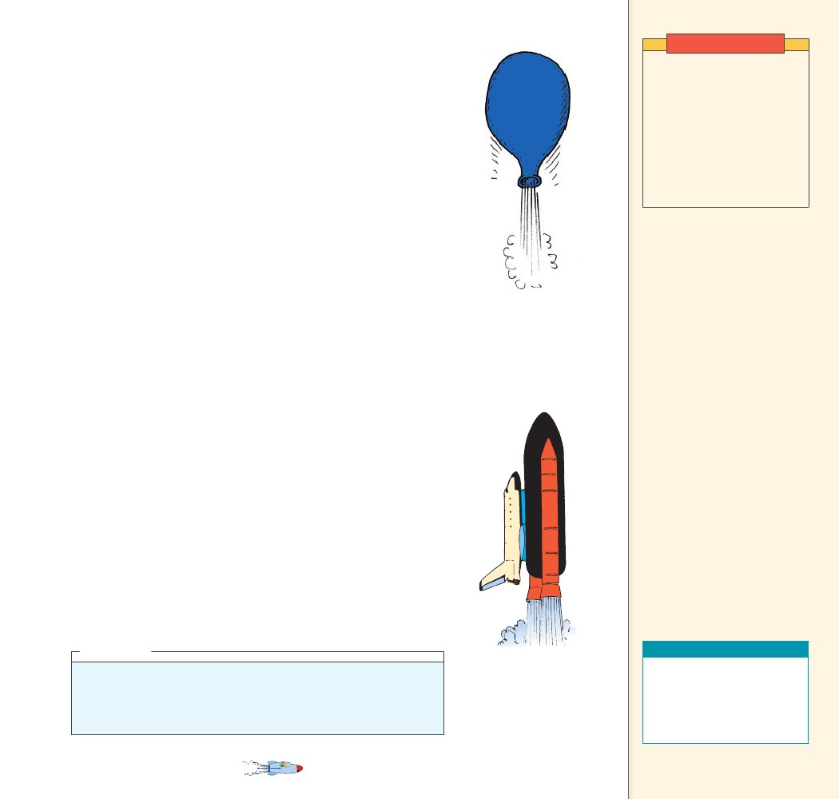
Demonstration
If we extend the basic idea of a cannon recoiling from the can-
nonball it launches, we can understand rocket propulsion. Consider
air escaping from an untied, blown-up balloon. If the balloon is
released and allowed to move as shown in Figure 7.8, it accelerates
as the air comes out. A rocket accelerates in much the same way—it
continually recoils from the exhaust gases ejected from its engine.
Each molecule of exhaust gas acts like a tiny molecular cannonball
shot downward from the rocket.
A common misconception is that a rocket, like the one shown
in Figure 7.9, is propelled by the impact of exhaust gases against the
atmosphere. In fact, before the advent of rockets, it was commonly
thought that sending a rocket to the moon was impossible because of
the absence of an atmosphere for the rocket to push against. This is
like saying a cannon won’t recoil unless the cannonball has air to push
against. This is not true! Both the rocket and recoiling cannon acceler-
ate because of the reaction forces created by the “cannonballs” they
fire—air or no air. In fact, rockets work better above the atmosphere
where there is no air resistance.
Lift Using Newton’s third law, we can understand how a helicop-
ter gets its lifting force. The whirling blades are shaped to force air
particles downward (action), and the air forces the blades upward
(reaction). This upward reaction force is called lift. When lift equals
the weight of the craft, the helicopter hovers in midair. When lift is
greater, the helicopter climbs upward.
Birds and airplanes also fly because of action and reaction forces.
When a bird is soaring, the shape of its wings deflects air downward.
The air in turn pushes the bird up. The slightly tilted wings of an air-
plane also deflect oncoming air downward and produce lift. Airplanes
must continuously push air downward to maintain lift and remain
airborne. This continuous supply of air is produced by the forward
motion of the aircraft, which results from jets or propellers that push
air backward. When the engines push air back, the air in turn pushes
the engines and the plane forward. We will learn later how the curved
surface of an airplane wing enhances the lifting force.
Have a tug of war between
boys and girls in your
classroom. Have the boys
remove their shoes (they
should wear socks) and have
the girls wear rubber-soled
shoes. The fact that the girls
win aptly demonstrates that
the team that wins is the one
that exerts more force against
the floor.
FIGURE 7.8
The balloon recoils from
the escaping air and climbs
upward.
CHECK
......
CONCEPT Why do objects that experience the same amount of
force accelerate at different rates?
A given force exerted
CHECK on a small mass
produces a greater acceleration
than the same force exerted on a
large mass.
CONCEPT
think!
A tug of war occurs between boys and girls on a polished floor that’s
somewhat slippery. If the boys are wearing socks and the girls are wearing
rubber-soled shoes, who will surely win, and why?
Answer: 7.4
FIGURE 7.9
The rocket recoils from
the “molecular cannon-
balls” it fires and climbs
upward.
Teaching Resources
• Reading and Study
Workbook
• PresentationEXPRESS
• Interactive Textbook
• Next-Time Question 7-2
......
CHAPTER 7
NEWTON’S THIRD LAW OF MOTION— ACTION AND REACTION
111
111

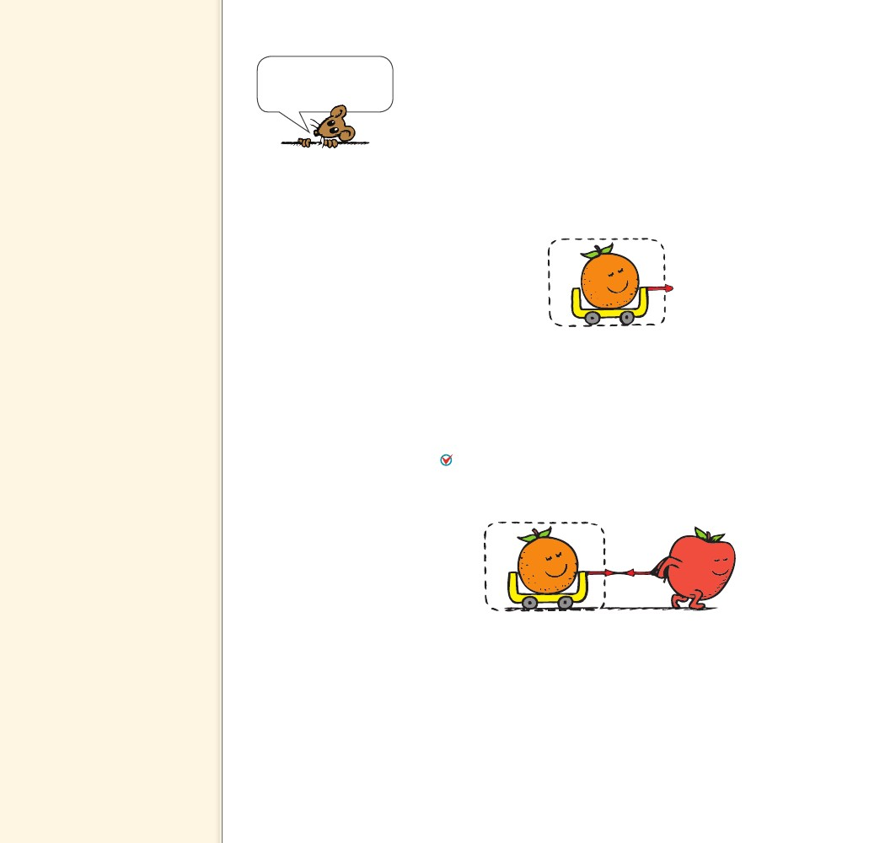
7.5 Defining Systems
Teaching Tip Call attention
to Figure 7.12. Action and
reaction forces are like apples
and oranges in that they act
on different objects. You can’t
cancel a force on an orange with
a force on an apple. This is the
essence of the horse-and-cart
problem.
A system may be as tiny
as an atom or as large as
the universe
7.5 Defining Systems
An interesting question often arises: since action and reaction forces
are equal and opposite, why don’t they cancel to zero? To answer
this question, we must consider the system involved. Consider, for
example, a system consisting of a single orange, as in Figure 7.10. The
dashed line surrounding the orange encloses and defines the system.
The vector that pokes outside the dashed line represents an external
force on the system. The system (that is, the orange) accelerates in
accord with Newton’s second law.
FIGURE 7.10
A force acts on the orange,
and the orange accelerates
to the right.
In Figure 7.11 we see that this force is provided by an apple,
which doesn’t change our analysis. The apple is outside the system.
The fact that the orange simultaneously exerts a force on the apple,
which is external to the system, may affect the apple (another system),
but not the orange. You can’t cancel a force on the orange with a force
on the apple. So in this case the action and reaction forces don’t can-
cel. Action and reaction forces do not cancel each other when
either of the forces is external to the system being considered.
FIGURE 7.11
The force on the orange,
provided by the apple,
is not cancelled by the
reaction force on the apple.
The orange still accelerates.
Now let’s consider a larger system, enclosing both the orange and
the apple. We see the system bounded by the dashed line in Figure
7.12a. Notice that the force pair is internal to the orange–apple sys-
tem. Therefore these forces do cancel each other. They play no role
in accelerating the system. A force external to the system is needed
for acceleration. That’s where friction with the floor comes in, as
in Figure 7.12b. When the apple pushes against the floor, the floor
simultaneously pushes on the apple—an external force on the system.
The system accelerates to the right.
112
112

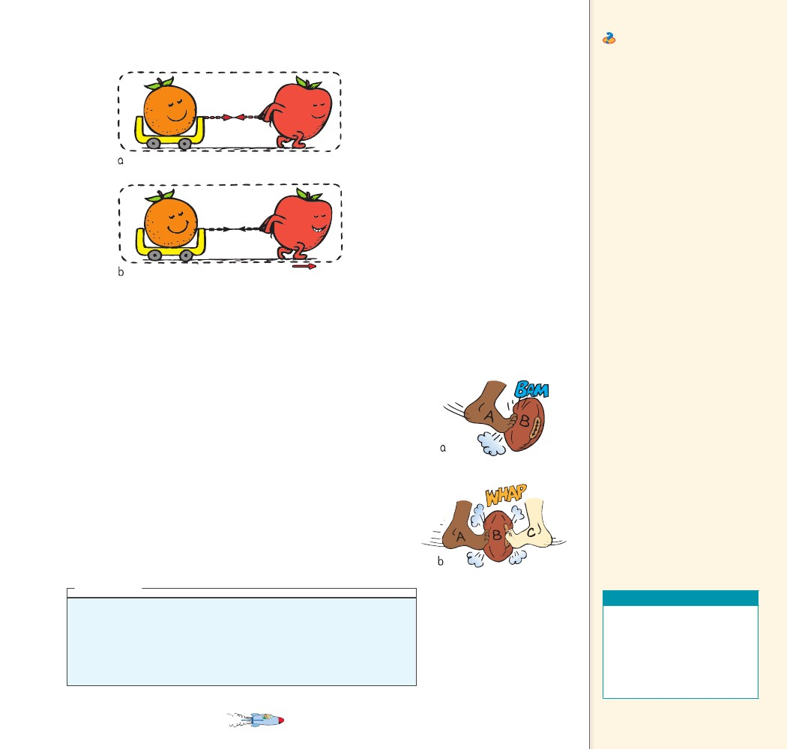
FIGURE 7.12
Consider the larger system of orange
+ apple. a. Action and reaction forces
cancel. b. When the floor pushes on
the apple (reaction to the apple’s push
on the floor), the orange–apple
system accelerates.
Ask Describe the relative
motions of two people of equal
mass who push off from each
other on slippery ice. Both
people will move at the same
speed, but in opposite directions.
Describe the relative motions of
two people of different masses
who push off each other on the
ice. The more massive person
will move more slowly than the
less massive person. They will,
however, still move in opposite
directions.
CONCEPT
CONCEPT
......
CHECK
Why don’t action–reaction forces cancel each other?
think!
Suppose a friend who hears about Newton’s third law says that you can’t
move a football by kicking it because the reaction force by the kicked ball
would be equal and opposite to your kicking force. The net force would be
zero, so no matter how hard you kick, the ball won’t move! What do you say
to your friend?
Answer: 7.5
FIGURE 7.13
A football is kicked. a. A acts
on B and B accelerates.
b. Both A and C act on B.
They can cancel each other
so B does not accelerate.
Teaching Resources
• Reading and Study
Workbook
• PresentationEXPRESS
• Interactive Textbook
• Next-Time Questions 7-3,
7-4, 7-5, 7-6
......
Inside a baseball are trillions and trillions of interatomic forces
at play. They hold the ball together but play no role in accelerating
the ball. Although every one of the interatomic forces is part of an
action–reaction pair within the ball, they combine to zero, no matter
how many of them there are. A force external to the ball, such as a
swinging bat provides, is needed to accelerate the ball. If the action–
reaction forces are internal to the system, then they cancel and the
system does not accelerate.
Consider the football in Figure 7.13a. There is one interaction
between the foot and the football, and the ball accelerates. But when
two kicks act on the ball as in Figure 7.13b, no acceleration occurs. In
this case there are two interactions occurring. If the two kicks on the
ball are simultaneous, equal, and opposite, then the net force on the
ball is zero. It is important to notice that the opposing forces act on
the same object, not on different objects, so they do not make up an
action–reaction pair.7.5
Action and reaction
CHECK forces do not cancel
each other when either of the
forces is external to the system
being considered.
CHAPTER 7
NEWTON’S THIRD LAW OF MOTION— ACTION AND REACTION
113
113

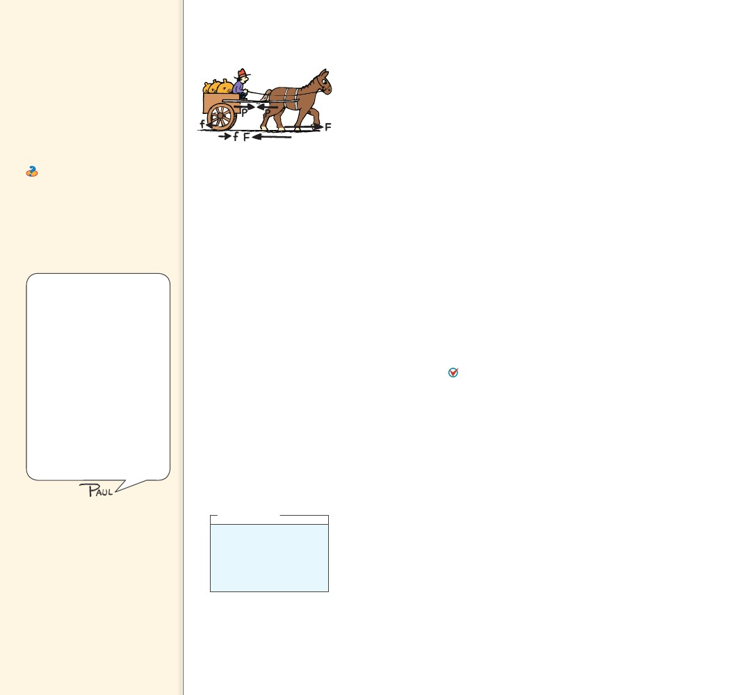
7.6 The Horse–Cart
Problem
Teaching Tip Discuss action
and reaction in terms of the
horse and cart situation. Point
out that the action force on
the cart is not cancelled by
the reaction force because the
reaction acts on the horse. You
can’t cancel a force on the cart
with a force on something else.
Ask Consider a tug-of-war
where scales are at opposite
ends of the rope. Is it possible
for the scales to have different
readings when participants pull?
No. Both scales will have the
same reading at any time, no
matter how the rope is pulled.
7.6 The Horse–Cart Problem
A situation similar to the kicked football is shown in the comic strip
“Horse Sense.” Look at Figure 7.14. Here we think of the horse as
believing its pull on the cart will be canceled by the opposite and
equal pull by the cart on the horse, thus making acceleration impos-
sible. This is a classic problem that stumps many college students. By
thinking carefully, you can understand it.
The horse–cart problem can be looked at from three different
points of view. First, consider the point of view of the farmer, who
is concerned with getting his cart (the cart system) to market. Then,
there is the point of view of the horse (the horse system). Finally,
there is the point of view of the horse and cart together (the horse–
cart system).
From the farmer’s point of view, the only concern is with the
force that is exerted on the cart system. The net force on the cart,
divided by the mass of the cart, will produce a very real acceleration.
The farmer doesn’t care about the reaction on the horse.
Now look at the horse system. It’s true that the opposite reac-
tion force by the cart on the horse restrains the horse. Without this
force, the horse could freely gallop to the market. This force tends
to hold the horse back. So how does the horse move forward? The
horse moves forward by interacting with the ground. When the horse
pushes backward on the ground, the ground simultaneously pushes
forward on the horse. If the horse in the horse–cart system
pushes the ground with a greater force than it pulls on the cart,
there is a net force on the horse, and the horse–cart system acceler-
ates. When the cart is up to speed, the horse need only push against
the ground with enough force to offset the friction between the cart
wheels and the ground.
Finally, look at the horse–cart system as a whole. From this view-
point, the pull of the horse on the cart and the reaction of the cart
on the horse are internal forces, or forces that act and react within
the system. They contribute nothing to the acceleration of the horse–
cart system. They cancel and can be neglected. To move across the
ground, there must be an interaction between the horse–cart system
and the ground. For example, if your car is stalled, you can’t get it
moving by sitting inside and pushing on the dashboard. You must
interact with the ground outside. You must get outside and make the
ground push the car. The horse–cart system is similar. It is the out-
side reaction by the ground that pushes the system.
CONCEPT
FIGURE 7.14
All the pairs of forces that
act on the horse and cart
are shown. The acceleration
of the horse–cart system is
due to the net force F – f.
Difficulties that occur with
action–reaction situations
usually stem from failing to
clearly identify the system in
question. Basically, if you want
to know the effect of a force
or forces on something, call
that something your system.
Define your system by a real
or imaginary dotted line around
that something. Restrict
your attention to the external
forces that originate outside
the dotted line and act on the
system, and not to the forces
that the system may exert on
things external to the dotted
line.
think!
What is the net force that
acts on the cart in Figure
7.14? On the horse? On
the ground?
Answer: 7.6
If the horse in the
CHECK horse–cart system
pushes the ground with a greater
force than it pulls on the cart,
there is a net force on the horse,
and the horse, and the horse–cart
system accelerates.
CONCEPT
......
CHECK
114
114
......
How does a horse–cart system accelerate?

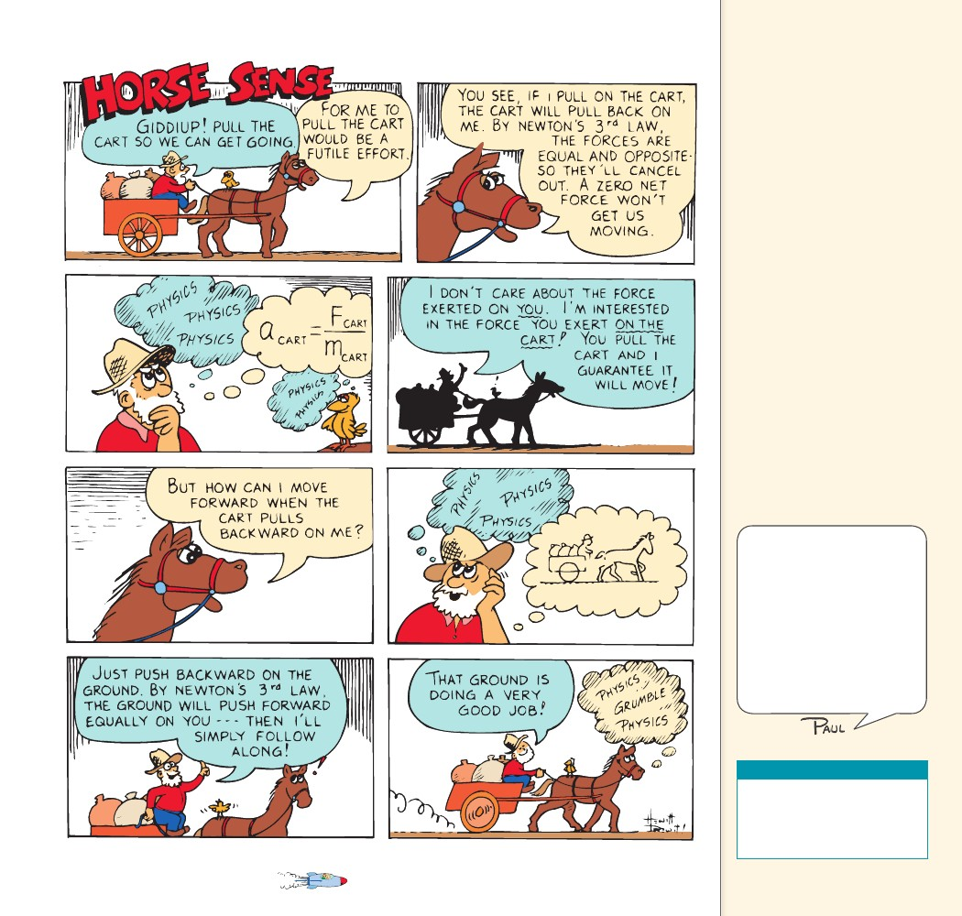
Teaching Tip Distinguish
between forces on a system,
and forces by the system on
other objects. In the horse–cart
problem, if the system is the cart,
then the only horizontal force
that acts on the cart is the pull
of the horse (ignoring friction)!
So there is a net force on the
cart and acceleration occurs. If
the system is the horse, draw a
dotted line around the horse.
Two horizontal external forces
act on this system: the reaction
by the cart, and the reaction
by the ground (friction) due to
the horse’s push against the
ground. If the ground’s push is
greater than the cart’s pull, the
horse accelerates (just as much
as the attached cart!). If the
system is both the horse and the
cart, then only one horizontal
external force acts on this system:
the same push of the ground.
Divide this push by the mass of
the horse and cart, and you have
the acceleration of both (the
same as before). Action and
reaction forces do cancel if they
both are within the system being
considered.
Interestingly, if there were
a wind blowing in the same
direction and at the same speed
as the horse and the cart are
moving, there would be no air
resistance. If the wind blew
just enough faster to provide
a force to counteract friction,
the horse could wear roller
skates and simply coast along
with the cart all the way to the
market.
Teaching Resources
• Reading and Study
Workbook
• PresentationEXPRESS
• Interactive Textbook
CHAPTER 7
NEWTON’S THIRD LAW OF MOTION— ACTION AND REACTION
115
115

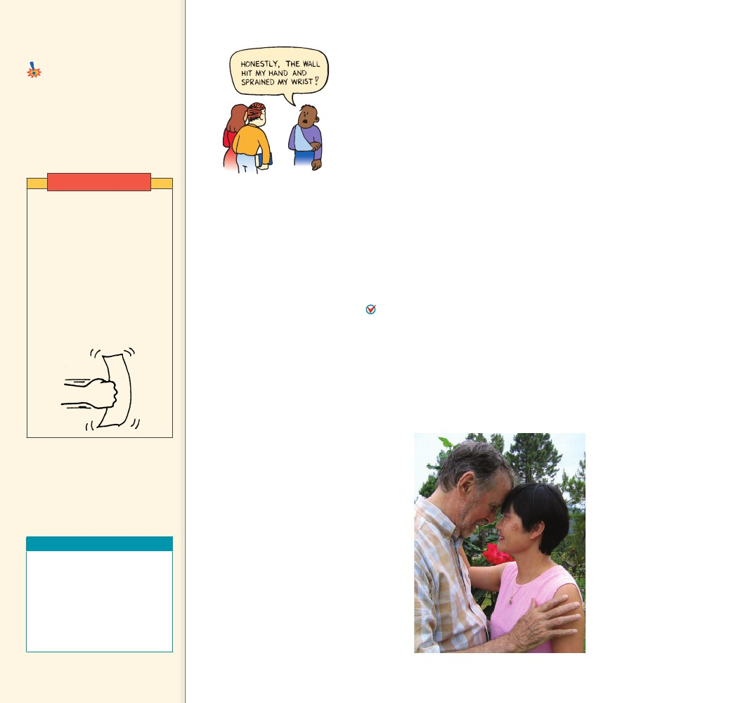
7.7 Action Equals
Reaction
Common Misconception
Action and reaction forces are equal
and opposite only under certain
conditions.
For every interaction
between things, there is always a
pair of oppositely directed forces
that are equal in strength.
FACT
7.7 Action Equals Reaction
This chapter began with a discussion of how a wall pushes back on
you when you push against it. Suppose that for some reason, you
punch the wall. Bam! Your hand is hurt. Look at the cartoon in
Figure 7.15. Your friends see your damaged hand and ask what hap-
pened. What can you say truthfully? You can say that the wall hit your
hand. How hard did the wall hit your hand? It hit just as hard as you
hit the wall. You cannot hit the wall any harder than the wall can hit
you back.
Hold a sheet of paper in midair and tell your friends that the
heavyweight champion of the world could not strike the paper with a
force of 200 N (45 pounds). You are correct, because a 200-N interac-
tion between the champ’s fist and the sheet of paper in midair isn’t
possible. The paper is not capable of exerting a reaction force of 200
N, and you cannot have an action force without a reaction force.
Now, if you hold the paper against the wall, that’s a different story.
The wall will easily assist the paper in providing 200 N of reaction
force, and more if needed!
For every interaction between things, there is always a pair
of oppositely directed forces that are equal in strength. If you push
hard on the world, for example, the world pushes hard on you. If you
touch the world gently, the world will touch you gently in return.
The way you touch others is the way others touch you, as shown in
Figure 7.16.
Demonstration
Drop a sheet of paper and
then punch it in midair. State
that even the heavyweight
boxing champion of the world
couldn’t hit the paper with
a force of 50 pounds. This
is because the paper is not
capable of “hitting back” with
the same amount of force.
A 50-lb interaction between
his fist and the paper is not
possible.
FIGURE 7.15
If you hit the wall, it will hit
you equally hard.
CHECK
FIGURE 7.16
For every interaction
CHECK between things,
there is always a pair of
oppositely directed forces that
are equal in strength.
CONCEPT
The author and his wife
demonstrate that you can-
not touch without being
touched—Newton’s third law.
Teaching Resources
• Lab Manual 21, 22
• Concept-Development
Practice Book 7-2
• Reading and Study
Workbook
• PresentationEXPRESS
• Interactive Textbook
116
......
116
......
CONCEPT What must occur in every interaction
between things?

