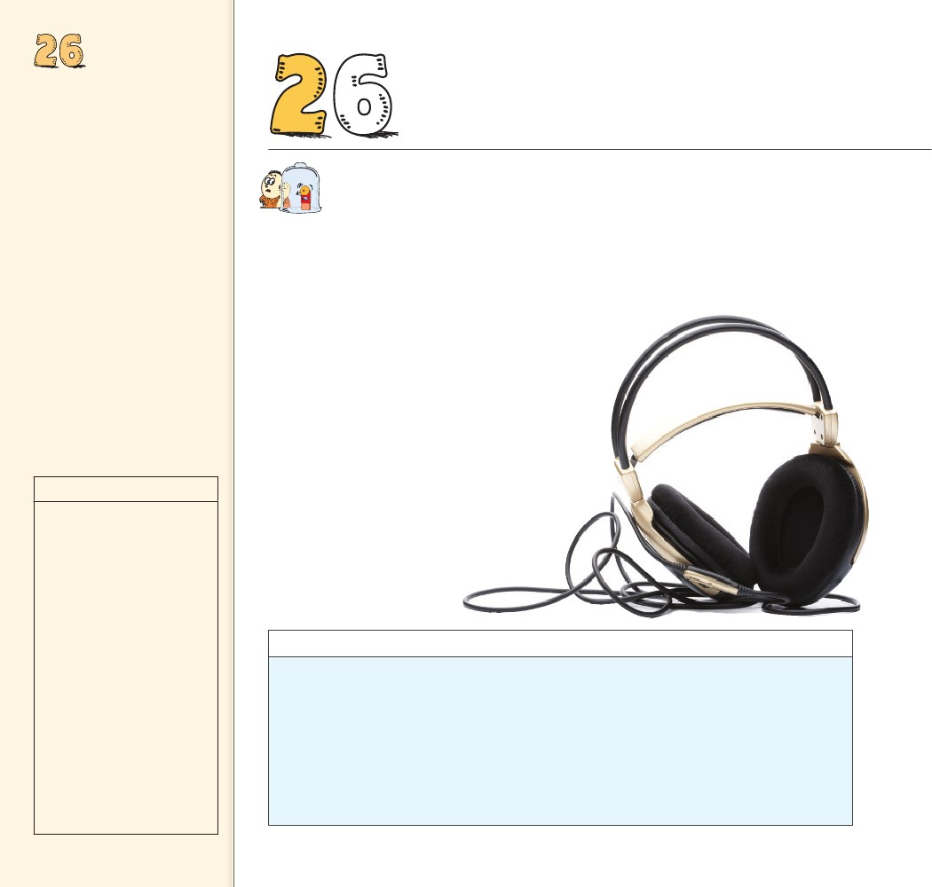
SOUND
Objectives
• State what the source of sound
is. (26.1)
• Describe the movement of
sound through air. (26.2)
• Compare the transmission of
sound through air with that
through solids, liquids, and a
vacuum. (26.3)
• Describe factors that affect the
speed of sound. (26.4)
• Describe loudness and sound
intensity. (26.5)
• Describe natural frequency.
(26.6)
• Describe the purpose of a
sounding board in a stringed
musical instrument. (26.7)
• Describe resonance. (26.8)
• Describe how sound waves
interfere with one another.
(26.9)
• Describe beats. (26.10)
6 SOUND
THE BIG
........
IDEA
Sound is a form of energy that
spreads out through space.
W
discover!
MATERIALS
tuning forks
Students
will hear a change in sound
intensity as they rotate a
vibrating tuning fork.
EXPECTED OUTCOME
ANALYZE AND CONCLUDE
hen a singer sings, the vocal chords in the singer’s
throat vibrate to and fro, causing adjacent air mol-
ecules to vibrate. This air, in turn, vibrates against
neighboring air molecules. A series of ripples in the form of
a longitudinal wave travels through the air. The frequency
of the ripples matches the frequency of the singer’s
vibrating vocal chords. When the ripples hit your
eardrum, the eardrum is pushed and then pulled
with the same frequency as the singer’s vibrat-
ing vocal chords. Vibrations in the eardrum send
rhythmic electrical impulses into your brain. And
you hear the voice of the singer.
Molecules of air behave like tiny table-tennis
balls. If you place a tuning fork in the middle of
a room and then strike the tuning fork with a
rubber hammer, the prongs of the vibrating
tuning fork set the surrounding air mol-
ecules into motion in the same way that
the moving paddle sets the table-tennis
balls into motion.
1. The intensity of the sound
varies.
2. Alternating loud and
soft sounds occur more
frequently with a tuning
fork with a higher
frequency.
3. Each of the tuning fork’s
tines has a front and a
back surface. Sounds from
these surfaces interfere
with each other in the
area surrounding the tines,
producing an audible
interference pattern.
discover!
What Is Acoustical Interference?
1. Strike a tuning fork with a rubber hammer or
on the heel of your shoe. (Do not strike the
tuning fork on the edge of the table.)
2. Place the vibrating tuning fork near your ear.
3. Slowly rotate the vibrating tuning fork.
Make certain that you rotate the tuning fork
through 360 degrees.
Analyze and Conclude
1. Observing What do you hear as you rotate
the tuning fork?
2. Predicting What do you think you would hear
if you were to use a tuning fork with a higher
pitch? A lower pitch?
3. Making Generalizations What causes the
changes in sound intensity produced by rotat-
ing a tuning fork?
514
514

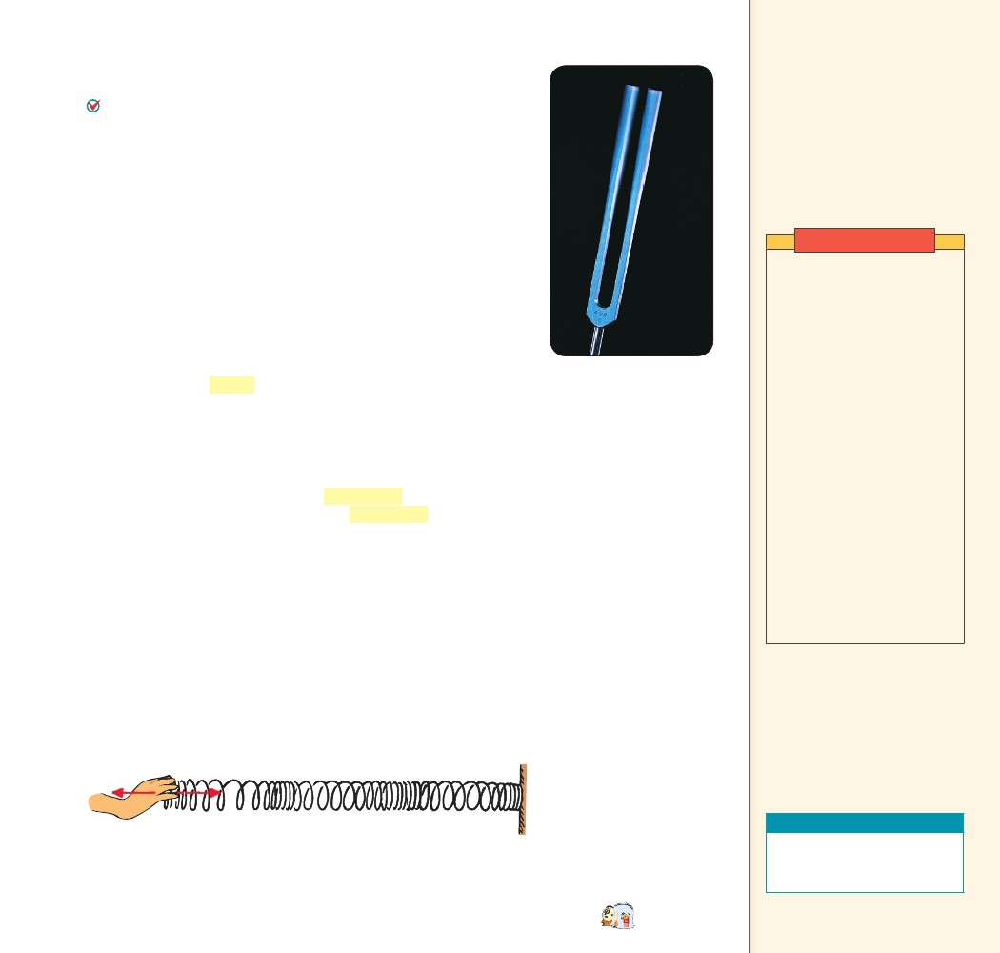
26.1 The Origin
26.1 The Origin of Sound
All sounds originate in the vibrations of material objects. In a
piano, violin, or guitar, a sound wave is produced by vibrating strings;
in a saxophone, by a vibrating reed; in a flute, by a fluttering column
of air at the mouthpiece. The prongs of the tuning fork in Figure 26.1
vibrate when the fork is struck. Your voice results from the vibration
of your vocal chords.
In each of these cases, the original vibration stimulates the vibra-
tion of something larger or more massive—the sounding board of
a stringed instrument, the air column within a reed or wind instru-
ment, or the air in the throat and mouth of a singer. This vibrating
material then sends a disturbance through a surrounding medium,
usually air, in the form of longitudinal waves. Under ordinary con-
ditions, the frequency of the sound waves produced equals the fre-
quency of the vibrating source.
We describe our subjective impression about the frequency of
sound by the word pitch. A high-pitched sound like that from a pic-
colo has a high vibration frequency, while a low-pitched sound like
that from a foghorn has a low vibration frequency.
A young person can normally hear pitches with frequencies
from about 20 to 20,000 hertz. As we grow older, our hearing range
shrinks, especially at the high-frequency end. Sound waves with
frequencies below 20 hertz are called infrasonic, and those with
frequencies above 20,000 hertz are called ultrasonic. We cannot
hear infrasonic or ultrasonic sound waves. Dogs can hear frequencies
of 40,000 Hz or more. Bats can hear sounds at over 100,000 Hz.
CONCEPT
of Sound
Key Terms
pitch, infrasonic, ultrasonic
Teaching Tip State that
sound is the only thing that the
ear can hear. Then state that
the source of sound or any wave
motion is a vibrating object.
Demonstrations
Tap a large tuning fork and
show that it is vibrating
by dipping the vibrating
prongs in a cup of water.
The splashing water shows
that the prongs are moving.
(Small forks do not work well
because the frequency is too
high for the eyes to see.)
Show a large radio speaker
without its cover. Play low
frequencies with an audio
oscillator (or other source) so
students gathered around can
see the diaphragm vibrating.
Rub some pine pitch or rosin
on your fingers and stroke
an aluminum rod. If you do it
properly, it will “sing” quite
loudly. Do this while holding
the rod at its midpoint, and
then at different places to
show harmonics. (Of course
you have practiced this first!)
FIGURE 26.1
The source of all sound
waves is vibration.
......
CHECK
What is the source of all sound?
26.2 Sound in Air
Clap your hands and you produce a sound pulse that goes out in
all directions. The pulse vibrates the air somewhat as a similar
pulse would vibrate the coiled spring shown in Figure 26.2. Each
particle moves back and forth along the direction of motion of the
expanding wave.
FIGURE 26.2
A compression travels
along the spring.
All sounds originate
CHECK in the vibrations of
material objects.
CONCEPT
Teaching Resources
Conceptual Physics Alive!
DVDs
Vibrations and Sound I, II
CHAPTER 26
SOUND
......
515
515

26.2 Sound in Air
Key Terms
compression, rarefaction
Teaching Tip Vibrate a
Slinky transversely to show a
transverse wave. Then vibrate
it longitudinally to show a
longitudinal wave. Call attention
to the compressions and
rarefactions of the longitudinal
wave and relate them to the
compressions and rarefactions
that occur in air as sound passes
through it.
For a clearer picture of this process, consider the long room
shown in Figure 26.3. At one end is an open window with a curtain
over it. At the other end is a door.
FIGURE 26.3
Opening and closing a door
produces compressions and rar-
efactions. a. When the door is
opened, a compression travels
across the room. b. When the
door is closed, a rarefaction
travels across the room.
a
b
As a source of sound
CHECK vibrates, a series of
compressions and rarefactions
travels outward from the source.
CONCEPT
Teaching Resources
• Reading and Study
Workbook
• PresentationEXPRESS
• Interactive Textbook
FIGURE 26.4
The vibrating cone of the
speaker produces the
pleasing sound of music.
When you quickly open the door as in Figure 26.3a, you can
imagine the door pushing the molecules next to it away from their
initial positions, and into their neighbors. Neighboring molecules, in
turn, push into their neighbors, and so on, like a compression wave
moving along a spring, until the curtain flaps out the window. A
pulse of compressed air has moved from the door to the curtain. This
pulse of compressed air is called a compression.
When you quickly close the door as in Figure 26.3b, the door
pushes neighboring air molecules out of the room. This produces an
area of low pressure next to the door. Neighboring molecules then
move into it, leaving a zone of lower pressure behind them. We say
the air in this zone of lower pressure is rarefied. Other molecules far-
ther from the door, in turn, move into these rarefied regions, result-
ing in a pulse of rarefied air moving from the door to the curtain.
This is evident when the lower-pressure air reaches the curtain, which
flaps inward. This pulse of low-pressure air is called a rarefaction.
For all wave motion, it is not the medium that travels across the
room, but a pulse that travels. In both cases the pulse travels from the
door to the curtain. We know this because in both cases the curtain
moves after the door is opened or closed.
If you swing the door open and closed in periodic fashion, you
can set up a wave of periodic compressions and rarefactions that
will make the curtain swing in and out of the window. On a much
smaller but more rapid scale, this is what happens when a tuning fork
is struck or when the speaker in Figure 26.4 produces music. As
a source of sound vibrates, a series of compressions and rarefac-
tions travels outward from the source. The vibrations of the tuning
fork and the waves it produces are considerably higher in frequency
and lower in amplitude than in the case of the swinging door. You
don’t notice the effect of sound waves on the curtain, but you are well
aware of them when they meet your sensitive eardrums.
516
......
516

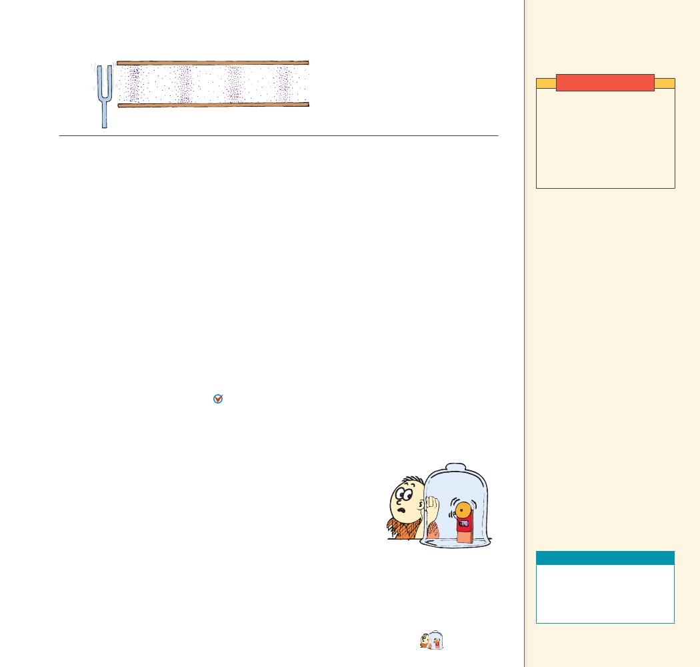
26.3 Media That
Transmit Sound
FIGURE 26.5
Compressions and rarefactions
travel from the tuning fork
through the tube.
Demonstration
Place a bell or ringing alarm
clock in a bell jar. Using a
vacuum pump, remove the air
from the jar while the bell is
ringing. Students will notice
how the sound diminishes as
the air is removed from the
jar.
Consider sound waves in the tube shown in Figure 26.5. For sim-
plicity, only the waves that travel in the tube are shown. When the
prong of the tuning fork next to the tube moves toward the tube, a
compression enters the tube. When the prong swings away, in the
opposite direction, a rarefaction follows the compression. It is like the
table-tennis paddle moving back and forth in a room packed with
table-tennis balls. As the source vibrates, a series of compressions and
rarefactions is produced.
CONCEPT
CHECK
How does a sound wave travel through air?
26.3 Media That Transmit Sound
Most sounds you hear are transmitted through the air, but put your
ear to the ground as Native Americans did, and you can hear the
hoofbeats of distant horses through the ground before you can hear
them through the air. More practically, put your ear to a metal fence
and have a friend tap it far away. The sound is transmitted louder and
faster by the metal than by the air. Sound travels in solids, liquids,
and gases.
Or click two rocks together underwater while your ear is sub-
merged. You’ll hear the clicking sound very clearly. If you’ve ever
been swimming in the presence of motorized boats, you’ve probably
noticed that you can hear the boats’ motors much more clearly under
water than above water. Solids and liquids are generally good conduc-
tors of sound—much better than air. The speed of sound differs in
different materials. In general, sound is transmitted faster in liquids
than in gases, and still faster in solids.
The boy in Figure 26.6 cannot hear the ringing bell when air is
removed from the jar because sound cannot travel in a vacuum. The
transmission of sound requires a medium. If there is nothing to com-
press and expand, there can be no sound. There may still be vibra-
tions, but without a medium there is no sound.
Teaching Tip While the
loudness of sound from the
ringing doorbell diminishes,
discuss the movement of sound
through different media—gases,
liquids, and solids (vibrating table
tennis balls analogy). Ask why
sound moves faster in warm air.
(Faster-moving balls take less
time to bump into one another.)
......
CONCEPT
CHECK
gases.
Sound travels in
solids, liquids, and
Teaching Resources
FIGURE 26.6
Sound can be heard from
the ringing bell when air is
inside the jar, but not when
the air is removed.
• Reading and Study
Workbook
• PresentationEXPRESS
• Interactive Textbook
CONCEPT
......
CHECK
What media transmit sound?
......
CHAPTER 26
SOUND
517
517

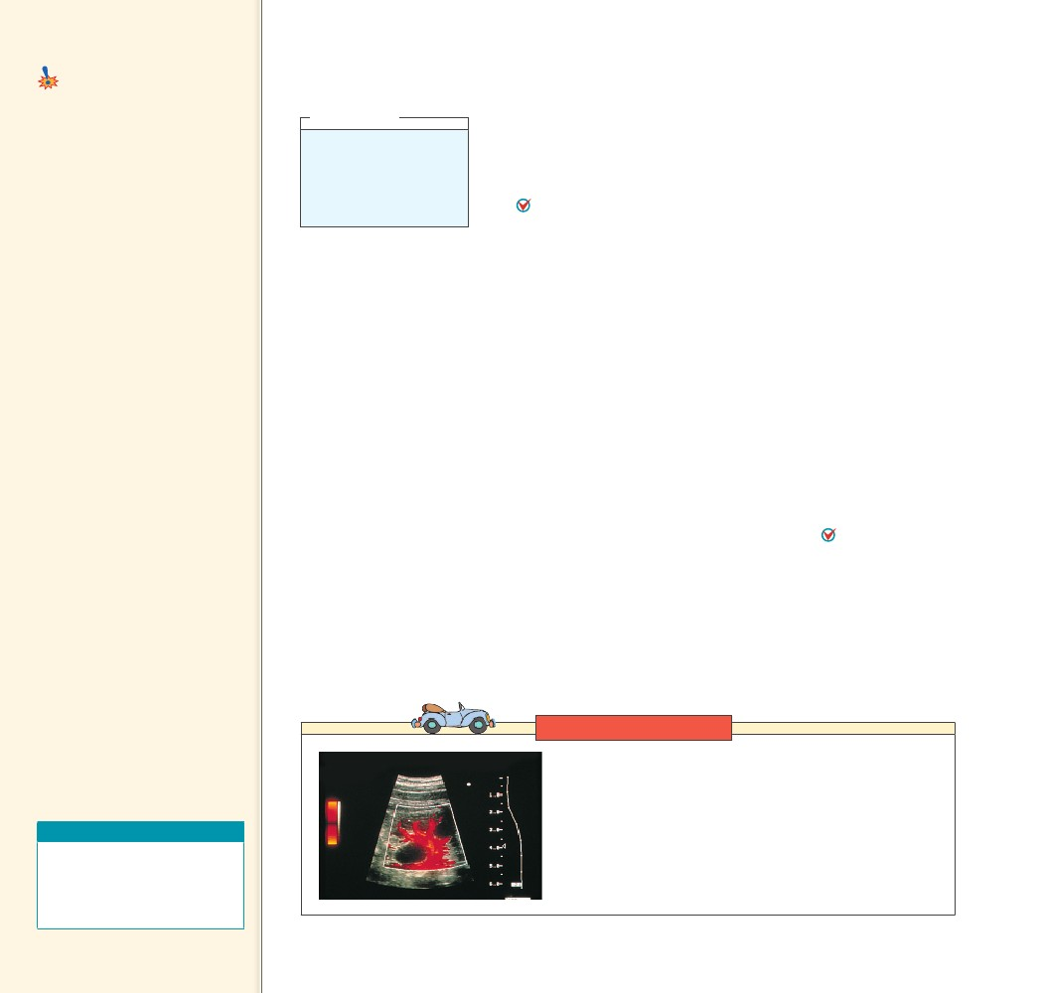
26.4 Speed of Sound
Common Misconception
The speed of sound is the same in all
media.
The speed of sound
depends on the medium, its
temperature, and its elasticity.
FACT
26.4 Speed of Sound
think!
How far away is a storm
if you note a 3-second
delay between a lightning
flash and the sound of
thunder? Answer: 26.4
Teaching Tip Discuss
the speed of sound through
different media—four times as
fast in water as in air—about
fifteen times as fast in steel.
The elasticity of these materials
accounts for the different speeds.
Explain why Native Americans
used to place their ears to the
ground to hear distant hoof
beats and how one could (but
should not) put an ear to a track
to listen for distant trains.
Teaching Tip Explain that
sound travels faster in moist
air than in dry air because H2O
molecules move faster than N2 or
O2 molecules. This shortens the
time between the collisions that
transmit the sound energy. H2O
molecules move faster because
they have less mass (18 amu) than
O2 (32 amu) and N2 (28 amu). At
the same temperature, molecules
have the same KE, so the less
massive ones move faster.
Teaching Tip Point out that
light travels quite fast, nearly one
million times faster through air
than sound travels.
The speed of sound
CHECK in a gas depends on
the temperature and the mass of
the particles. The speed of sound
in a material depends on
elasticity.
CONCEPT
Have you ever watched a distant person chopping wood or hammer-
ing, and noticed that the sound of the blow takes time to reach your
ears? You see the blow before you hear it. This is most noticeable in
the case of lightning. You hear thunder after you see the lightning.
These experiences are evidence that sound is much slower than light.
The speed of sound in a gas depends on the temperature of
the gas and the mass of the particles in the gas. The speed of sound
in dry air at 0°C is about 330 meters per second, or about 1200 kilo-
meters per hour, about one-millionth the speed of light. Water vapor
in the air and increased temperatures increase this speed slightly. This
makes sense, for the faster-moving molecules in warm air bump into
each other more often and therefore can transmit a pulse in less time.
For each degree increase in air temperature above 0°C, the speed of
sound in air increases by about 0.60 m/s. So in air at a normal room
temperature of about 20°C, sound travels at about 340 m/s. The
speed of sound in a gas also depends on the mass of its particles.
Lighter particles such as hydrogen molecules and helium atoms move
faster and transmit sound much more quickly than heavier gases
such as oxygen and nitrogen, found in air.
The speed of sound in a solid material depends not on the mate-
rial’s density, but on its elasticity. Elasticity is the ability of a material
to change shape in response to an applied force, and then resume its
initial shape once the distorting force is removed. The speed of
sound in a material depend on the material’s elasticity. Steel is very
elastic; putty is inelastic.26.4 In elastic materials, the atoms are relatively
close together and respond quickly to each other’s motions, transmit-
ting energy with little loss. Sound travels about fifteen times faster in
steel than in air, and about four times faster in water than in air.
CONCEPT
......
CHECK
What determines the speed of sound in a medium?
......
Link to TECHNOLOGY
Ultrasound Imaging A technique for harmlessly “seeing” inside
a body uses high-frequency sound (ultrasound) instead of X-rays.
Ultrasound that enters the body is reflected more strongly from
the outside of an organ than from its inside, and we get a picture
of the outline of the organ. When ultrasound is incident upon
a moving object, the reflected sound has a slightly different
frequency. Using this Doppler effect, a physician can “see” the
beating heart of a developing fetus that is only 11 weeks old.
Teaching Resources
• Concept-Development
Practice Workbook 26-1
• Next-Time Question 26-1
• Laboratory Manual 72
518
518

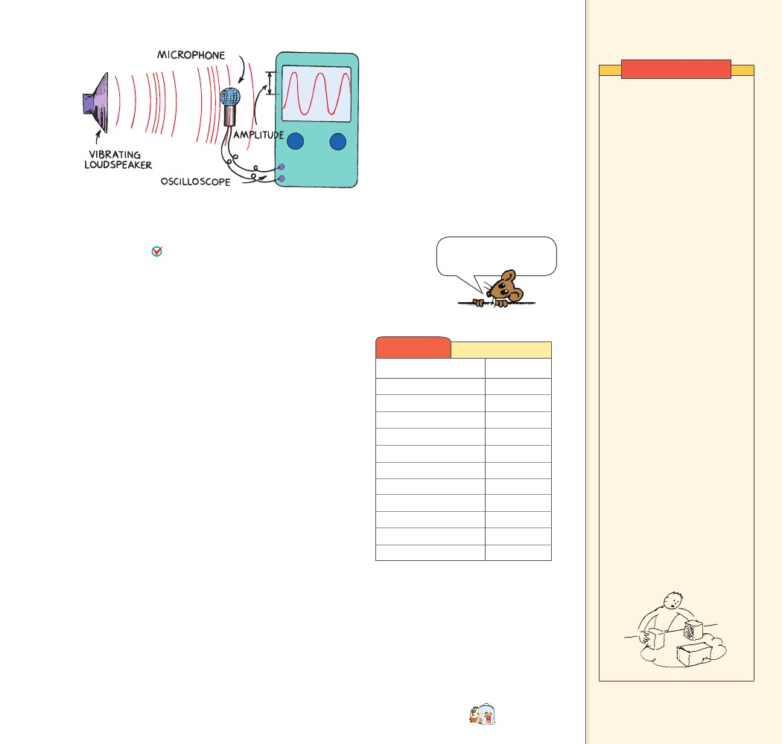
26.5 Loudness
FIGURE 26.7
The loudspeaker at the left is a paper
cone that vibrates in rhythm with an
electric signal. The sound sets up
similar vibrations in the microphone,
which are displayed on the screen
of an oscilloscope. The wave on
the oscilloscope reveals information
about the sound.
Demonstration
Play mono music from a tape
recorder through a pair of
enclosed stereo speakers
placed side by side facing the
class. First, play one speaker.
Then play both in phase. The
resulting sound is slightly
louder than with one speaker.
Reverse the speaker wires to
one of the speakers to reverse
its phase. (Speaker systems
for stereos have polarity
indications on their terminals.)
The sound is much less intense
than from the single speaker.
With the speakers still facing
forward, vary the separation
distance and illustrate the
wavelength dependence
of the interference. (As the
distance between the speakers
becomes greater, so does the
loudness of the sound. Sound
with wavelengths greater than
the distance between speakers
is canceled. Note the variations
in the quality of the sound.
Finally, face the speakers
toward each other with only a
small gap between them. Play
one, and then both, in phase.
Then reverse the polarity of
one of the speakers. The result
is almost total silence. Sound
at virtually all wavelengths is
being canceled by destructive
interference. As you increase
the distance between the
speakers, shorter wavelengths
avoid total destructive
interference, and the sound
level increases. Spectacular!
26.5 Loudness
The intensity of a sound is proportional to the square of the amplitude
The decibel scale for
of a sound wave. Sound intensity is objective and is measured
loudness is logarithmic.
by instruments. Loudness, on the other hand, is a physiological
sensation sensed in the brain. It differs for different people. Loudness
is subjective but is related to sound intensity. The unit of intensity for
sound is the decibel (dB), after Alexander Graham Bell, inventor of the
telephone. The oscilloscope shown in Figure 26.7 measures sound.
Some common sources and sound levels are given in
Table 26.1 Sound Levels
Table 26.1. Starting with zero at the threshold of hearing
for a normal ear, an increase of each 10 dB means thatSource of SoundLevel (dB)
sound intensity increases by a factor of 10. A sound of
Jet engine, at 30 m140
10 dB is 10 times as intense as sound of 0 dB; 20 dB is
Threshold of pain120
not twice but 10 times as intense as 10 dB, or 100 times as
Loud rock music115
intense as the threshold of hearing. A 60-dB sound is
Old subway train100100 times as intense as a 40-dB sound.
Average factory90Roughly, the sensation of loudness follows this decibel
scale. We hear a 100-dB sound to be about as much louderBusy street trafﬁc70
than a 70-dB sound as the 70-dB sound is louder than a
Normal speech60
40-dB sound because there is a 30-dB difference between
Library40
the pairs of sound each time.
Close whisper20
Physiological hearing damage begins at exposure to
Normal breathing10
85 decibels. The extent of damage depends on the length
Hearing threshold0of exposure and on frequency characteristics. A single
burst of sound can produce vibrations intense enough
to tear apart the organ of Corti, the receptor organ in
the inner ear. Less intense, but severe, noise can interfere with cel-
lular processes in the organ and cause its eventual breakdown.
Unfortunately, the cells of the Corti do not regenerate.
CHECK
......
CONCEPT What is the difference between sound
intensity and loudness?
CHAPTER 26
SOUND
519
519

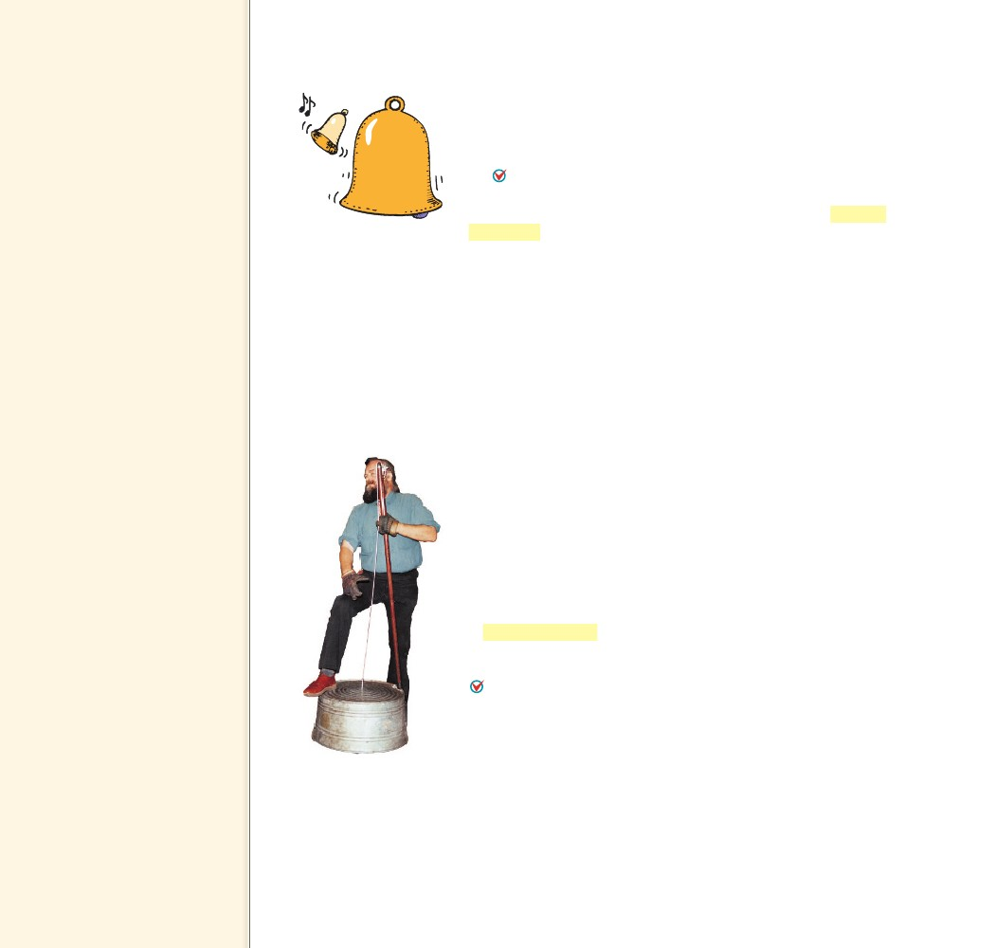
Teaching Tip The loudest
sounds emitted by a creature
are those from the Blue Whale.
They can emit sounds at a volume
greater than 180 dB in water,
but pitched too low for humans
to detect without sensitive
equipment.
Sound intensity is
CHECK objective and is
measured by instruments.
Loudness is a physiological
sensation sensed in the brain.
CONCEPT
26.6 Natural Frequency
Drop a wrench and a baseball bat on the floor, and you hear dis-
tinctly different sounds. Objects vibrate differently when they strike
the floor. Tap a wrench, and the vibrations it makes are different from
the vibrations of a baseball bat, or of anything else.
When any object composed of an elastic material is dis-
turbed, it vibrates at its own special set of frequencies, which
together form its special sound. We speak of an object’s natural
frequency, which is the frequency at which an object vibrates when
it is disturbed. An object’s natural frequency depends on the elastic-
ity and shape of the object. The bells shown in Figure 26.8 and tun-
ing forks vibrate at their own characteristic frequencies. Interestingly
enough, most things—from planets to atoms and almost everything
else in between—have a springiness to them and vibrate at one or
more natural frequencies. A natural frequency is one at which mini-
mum energy is required to produce forced vibrations. It is also the
frequency that requires the least amount of energy to continue this
vibration.
CONCEPT
......
FIGURE 26.8
The natural frequency of the
smaller bell is higher than
that of the big bell, and it
rings at a higher pitch.
26.6 Natural
Frequency
Key Term
natural frequency
Teaching Tip Compare the
sounds of a couple of pennies
dropped on a hard surface—one
dated before 1982 and one after.
The old penny is made of 95%
copper and 5% zinc, and sounds
noticeably different than the
newer pure zinc core pennies
plated with copper.
Teaching Tip Note that the
human ear can discriminate
among more than 300,000 tones!
When an object
CHECK composed of an
elastic material is disturbed, it
vibrates at is own special set of
frequencies.
CONCEPT
......
......
CHECK
What happens when an elastic material is disturbed?
26.7 Forced Vibration
When you strike an unmounted tuning fork, the sound it makes is
faint. Strike a tuning fork while holding its base on a tabletop, and
the sound is relatively loud. Why? It is because the table is forced to
vibrate, and its larger surface sets more air in motion. The tabletop
becomes a sounding board, and can be forced into vibration with
forks of various frequencies. This is a case of a forced vibration.
A forced vibration occurs when an object is made to vibrate by
another vibrating object that is nearby.
The washtub in Figure 26.9 serves as a sounding board.
Sounding boards are an important part of all stringed musical
instruments because they are forced into vibration and produce the
sound. The vibration of guitar strings in an acoustical guitar would
be faint if they weren’t transmitted to the guitar’s wooden body. The
mechanism in a music box is mounted on a sounding board. Without
the sounding board, the sound the music box mechanism makes is
barely audible.
CONCEPT Why are sounding boards an important part of
26.7 Forced
Vibration
Key Term
forced vibration
Sounding boards are
CHECK an important part of
all stringed musical instruments
because they are forced into
vibration and produce the sound.
CONCEPT
......
FIGURE 26.9
When the string is plucked,
the washtub is set into
forced vibration and serves
as a sounding board.
......
CHECK
stringed instruments?
520
520

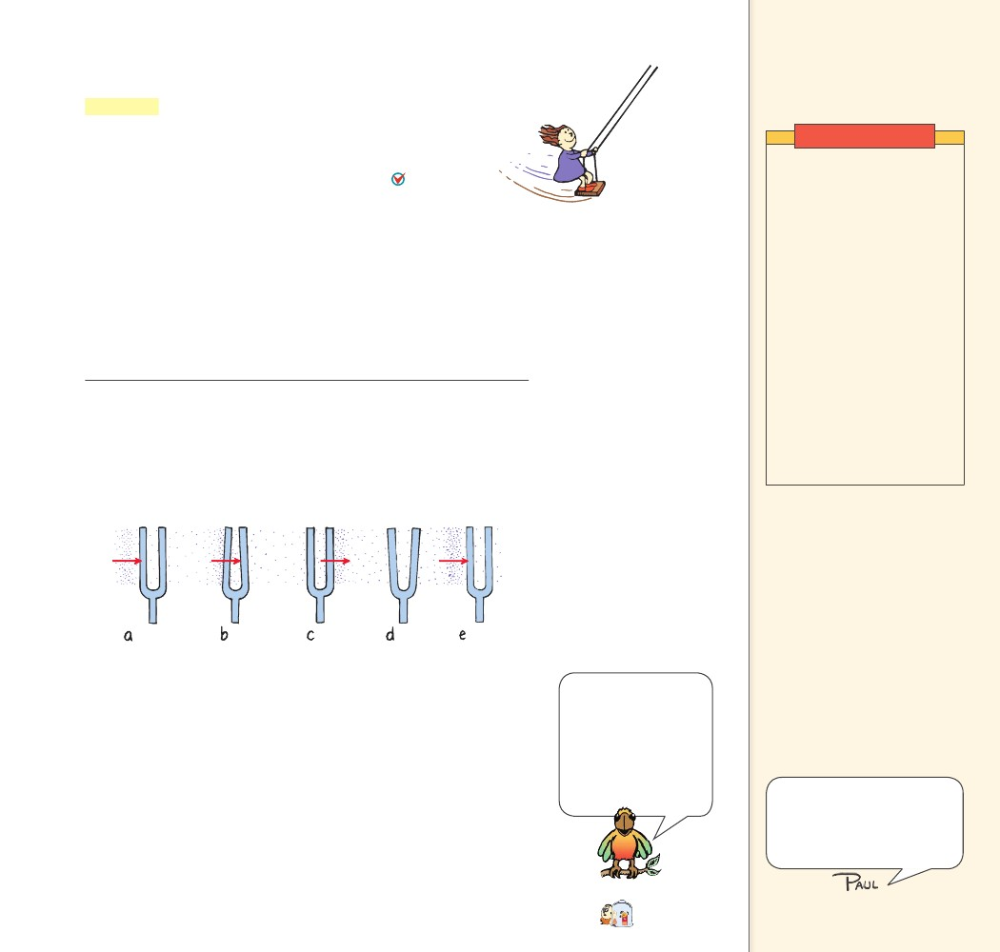
26.8 Resonance
26.8 Resonance
Resonance is a phenomenon that occurs when the frequency of a
vibration forced on an object matches the object’s natural frequency
and a dramatic increase in amplitude occurs. Resonance means to
re-sound, or sound again. Putty doesn’t resonate because it isn’t
elastic, and a dropped handkerchief is too limp. An object
resonates when there is a force to pull it back to its starting
position and enough energy to keep it vibrating.
A common experience illustrating resonance occurs on a swing
like the one shown in Figure 26.10. When pumping a swing, you
pump in rhythm with the natural frequency of the swing. More
important than the force with which you pump is the timing. Even
small pumps, or even small pushes from someone else, if delivered in
rhythm with the natural frequency of the swinging motion, produce
large amplitudes.
FIGURE 26.11
The stages of resonance are shown for a tuning fork. a. The first
compression meets the fork and gives it a tiny and momentary push.
b. The fork bends. c. The fork returns to its initial position just at the
time a rarefaction arrives. d. It keeps moving and overshoots in the
opposite direction. e. When it returns to its initial position, the next
compression arrives to repeat the cycle.
Key Term
resonance
Demonstration
Show resonance using a long
stove pipe. Put three layers
of wire window screen on
crossed wires 1/4 of the way
up from the bottom of the
stove pipe. Heat gently over
a Bunsen burner (not so hot
as to melt the screen). The
screen becomes a white-noise
generator, while the tube is
the frequency selector that
resonates at the fundamental
frequency of the tube. When
the tube is removed from the
flame, it continues to sound
as the wire screen cools. Turn
the pipe horizontal until the
sound subsides for a few
seconds, and then turn it back
to vertical—the sound returns.
Very impressive!
FIGURE 26.10
Pumping a swing in rhythm
with its natural frequency
produces larger amplitudes.
Teaching Tip Give other
examples of resonance; the
chattering vibration of a glass
shelf when a radio placed on it
plays a certain note; the loose
front end of a car that vibrates at
only certain speeds; crystal glass
shattered by a singer’s voice;
troops marching in step across a
bridge.
A common classroom demonstration of resonance uses a pair
of tuning forks adjusted to the same frequency and spaced about a
meter apart. When one of the forks is struck, it sets the other fork
into vibration as shown in Figure 26.11. This is a small-scale ver-
sion of pushing a friend on a swing—it’s the timing that’s important.
When a sound wave impinges on the fork, each compression gives the
prong a tiny push. Since the frequency of these pushes corresponds to
the natural frequency of the fork, the pushes successively increase the
amplitude of the fork’s vibration. This is because the pushes occur at
the right time and are repeatedly in the same direction as the instan-
taneous motion of the fork.
Like humans, we
parrots use our
tongues to craft and
shape sound. Tiny
changes in the position
of my tongue produce
big differences in the
sound I make.
Forced vibrations, resonance,
and interference provide a
useful background for the same
concepts applied to light in
following chapters.
CHAPTER 26
SOUND
521
521

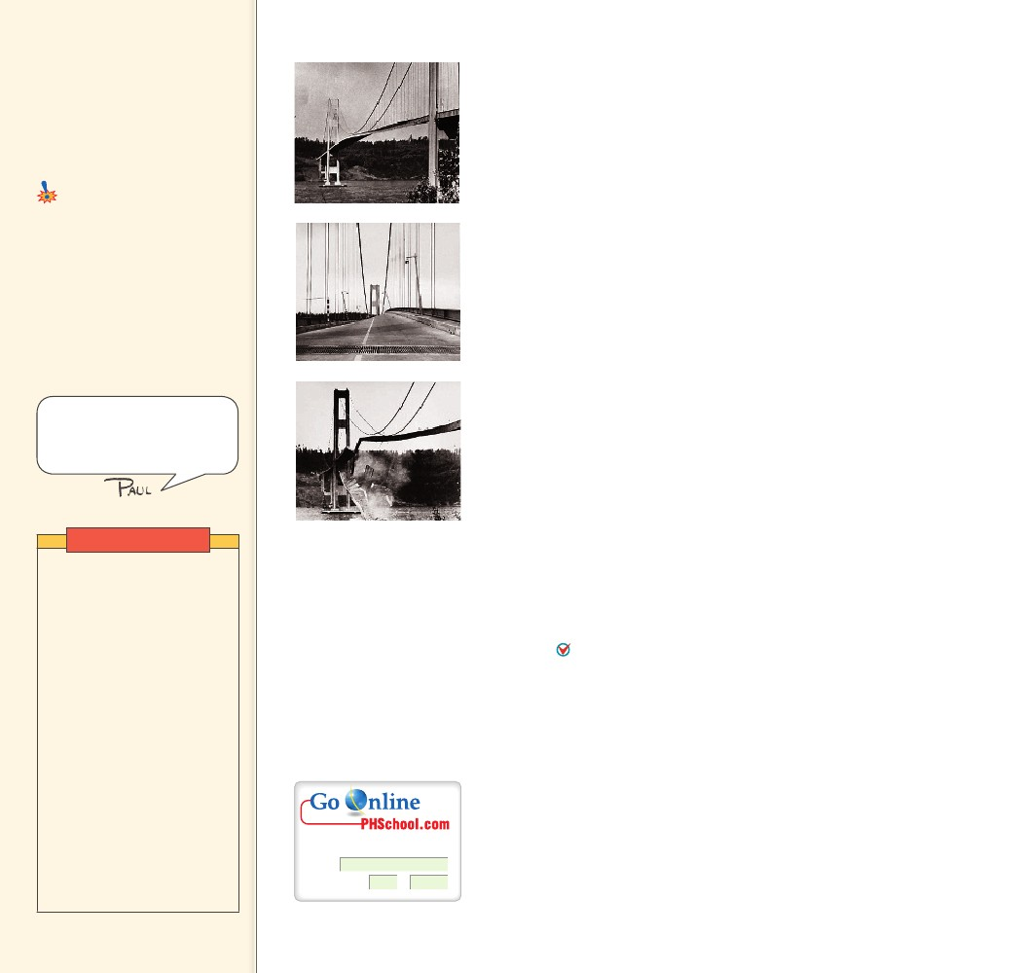
An object resonates
CHECK when there is a force
to pull it back to its starting
position and enough energy to
keep it vibrating.
CONCEPT
......
26.9 Interference
Common Misconception
Sound cannot cancel sound.
Sound waves, like
any waves, can interfere
constructively or destructively.
FACT
Teaching Tip Review
interference by sketching
overlapping sine curves on the
board (Figure 26.13, or
Figure 25.10 on p. 498).
If the forks are not adjusted for matched frequencies, the timing
of pushes will be off and resonance will not occur. When you tune
your radio set, you are similarly adjusting the natural frequency of
the electronics in the set to match one of the many incoming signals.
The set then resonates to one station at a time, instead of playing all
the stations at once.
Resonance occurs whenever successive impulses are applied to a
vibrating object in rhythm with its natural frequency. English infan-
try troops marching across a footbridge in 1831 inadvertently caused
the bridge to collapse when they marched in rhythm with the bridge’s
natural frequency. Since then, it is customary for troops to “break
step” when crossing bridges. The Tacoma Narrows Bridge disaster
in 1940, shown in Figure 26.12, is attributed to wind-generated
resonance. A mild 40-mile-per-hour wind gale produced a fluctuat-
ing force that resonated with the natural frequency of the bridge,
steadily increasing the amplitude over several hours until the bridge
collapsed.
CONCEPT
......
Now you’re ready for a series
of fantastic demonstrations—
perhaps the most unforgettable
of your course!
CHECK
What causes resonance?
26.9 Interference
Sound waves, like any waves, can be made to interfere. A comparison
of interference for transverse waves and longitudinal waves is shown
in Figure 26.13. For sound, the crest of a wave corresponds to a com-
pression, and the trough of a wave corresponds to a rarefaction.
In either case, when the crests of one wave overlap the crests of
another wave, there is constructive interference and an increase in
amplitude. Or when the crests of one wave overlap the troughs of
another wave, there is destructive interference and a decrease in
amplitude. When constructive interference occurs with sound
waves, the listener hears a louder sound. When destructive interfer-
ence occurs, the listener hears a fainter sound or no sound at all.
The listener in Figure 26.14a is equally distant from two sound speak-
ers that simultaneously trigger identical sound waves of constant
frequency. The listener hears a louder sound because the waves add.
The compressions and rarefactions arrive in phase, that is, in step.
In Figure 26.14b, the listener moved to the side so that paths from
the speakers differ by a half wavelength. The rarefactions from one
speaker reach the listener at the same time as compressions from the
other. It’s like the crest of one water wave exactly filling in the trough
of another water wave—destructive interference. (If the speakers emit
many frequencies, not all wavelengths destructively interfere for a
given difference in path lengths.)
Demonstration
Remove the foam cover
from a small speaker (a few
centimeters in diameter).
Connect the speaker to the
auxiliary output of a portable
tape recorder. Play music
through the speaker. The
music will sound quite tinny.
Then produce a baffle (large
flat piece of cardboard or
whatever) with a hole slightly
smaller than the size of the
speaker cut in its middle. Place
the speaker behind the hole
and note the much-improved
sound quality. (The baffle
reduces the interference
between the back and front
waves.) Place the same
speaker behind a hole in a
small closed box to show even
better quality.
FIGURE 26.12
In 1940, four months after
being completed, the
Tacoma Narrows Bridge in
the state of Washington was
destroyed by a 40-mile-per-
hour wind.
For: Links on interference
Visit: www.SciLinks.org
Web Code: csn – 2609
522
522

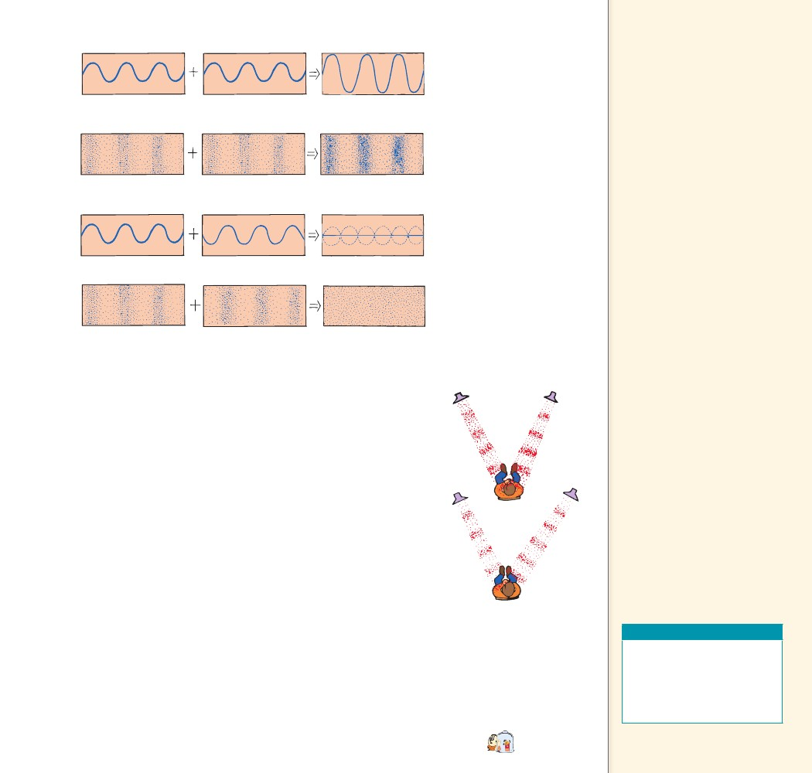
FIGURE 26.13
Both transverse and longi-
tudinal waves display wave
interference when they are
superimposed.
a. Two identical transverse waves in phase produce a wave of increased
amplitude.
b. Two identical longitudinal waves in phase produce a wave of increased
amplitude.
c. Two identical transverse waves that are out of phase destroy each other.
Teaching Tip Explain that
a speaker produces waves from
both its front and its rear. These
waves are 180° out of phase.
As it produces a compression in
front, it produces a rarefaction in
back, and vice versa. When sound
reaches your ears from both the
front and back of a speaker,
destructive interference occurs.
This is most pronounced for long
waves where the difference in
the distances traveled from the
speaker to you is relatively small.
An uncovered speaker sounds
tinny because it produces little
sound energy for wavelengths
much longer than its diameter.
The long-wavelength bass notes
are canceled. This cancellation is
notably reduced when the baffle
is introduced.
d. Two identical longitudinal waves that are out of phase destroy each other.
Destructive interference of sound waves is usually not a problem
because there is usually enough reflection of sound to fill in canceled
spots. Nevertheless, “dead spots” are sometimes evident in poorly
designed theaters and gymnasiums, where sound waves reflected off
walls interfere with unreflected waves to form zones of low ampli-
tude. Often, moving your head a few centimeters in either direction
can make a noticeable difference.
Destructive sound interference is a useful property in antinoise
technology. Noisy devices such as jackhammers are being equipped
with microphones that send the sound of the device to electronic
microchips. The microchips create mirror-image wave patterns of
the sound signals. For the jackhammer, this mirror-image sound
signal is fed to earphones worn by the operator. Sound compressions
(or rarefactions) from the hammer are neutralized by mirror-image
rarefactions (or compressions) in the earphones. The combination
of signals neutralizes the jackhammer noise. Noise-canceling ear-
phones, shown in Figure 26.15, are already common for pilots. Some
automobiles enjoy quiet riding due to noise cancellation. Noise-
detecting microphones inside the car pick up engine or road noise.
Speakers in the car then emit an opposite signal that cancels out
those noises, so the human ear can’t detect them. Similarly, the cab-
ins of some airplanes are now quieted with antinoise technology.
a
b
When constructive
CHECK interference occurs
with sound waves, the listener
hears a louder sound. When
destructive interference occurs,
the listener hears a fainter sound
or no sound at all.
CONCEPT
FIGURE 26.14
The sound waves from two
speakers interfere. a. Waves
arrive in phase. b. Waves
arrive out of phase.
Teaching Resources
• Reading and Study
Workbook
• Transparency 54
• PresentationEXPRESS
• Interactive Textbook
CHAPTER 26
SOUND
CHECK
......
CONCEPT What are the effects of constructive and
destructive interference?
523
......
523

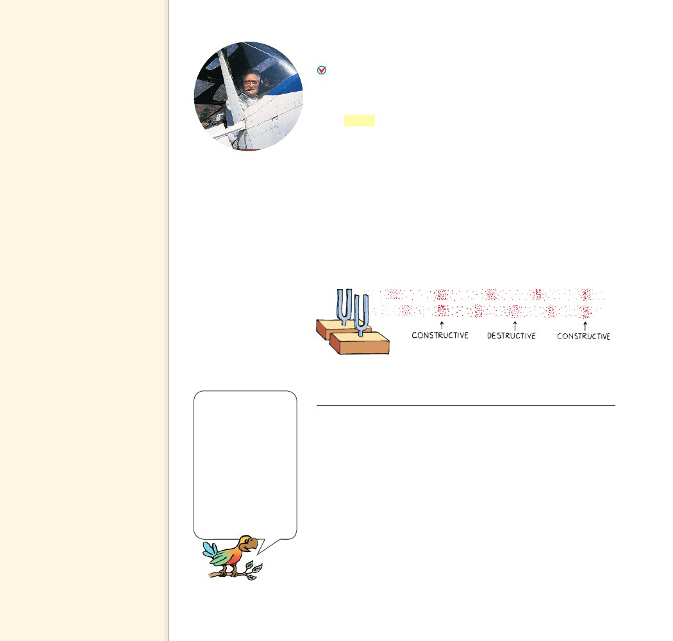
26.10 Beats
Key Term
beats
Teaching Tip Tell students
they can produce beats next
time they are in a room with a
ventilation fan. If they hum at
the same frequency as the hum
of the fan, they will hear beats.
Teaching Tip You can show
interference and beats with an
oscilloscope trace of a pair of
sound sources slightly out of sync.
26.10 Beats
When two tones of slightly different frequency are sounded
together, a regular fluctuation in the loudness of the combined
sounds is heard. The sound is loud, then faint, then loud, then
faint, and so on. This periodic variation in the loudness of sound is
called beats. Beats are an interesting and special case of interference.
Beats can be heard when two slightly mismatched tuning forks,
like the ones shown in Figure 26.16, are sounded together. Because
one fork vibrates at a frequency different from the other, the vibra-
tions of the forks will be momentarily in step, then out of step, then
in again, and so on. When the combined waves reach your ears in
step—say when a compression from one fork overlaps a compression
from the other—the sound is a maximum. A moment later, when
the forks are out of step, a compression from one fork is met with a
rarefaction from the other, resulting in a minimum. The sound that
reaches your ears throbs between maximum and minimum loudness
and produces a tremolo effect.
FIGURE 26.15
Ken Ford tows gliders in
quiet comfort when he
wears his noise-canceling
earphones.
FIGURE 26.16
A sound wave traveling
through the ear canal
vibrates the eardrum,
which vibrates three
tiny bones, which
vibrate the fluid-filled
cochlea. Inside the
cochlea, tiny hair cells
convert the pulse into
an electrical signal to
the brain. Ear plugs
typically reduce noise
by about 30 dB.
The interference of two sound sources of slightly different
frequencies produces beats.
If you walk side by side with someone who has a different stride,
there will be times when you are both in step, and times when you
are both out of step. Suppose, for example, that you take exactly 70
steps in one minute and your friend takes 72 steps in the same time.
Your friend gains two steps per minute on you. A little thought will
show that you two will be momentarily in step twice each minute.
In general, when two people with different strides walk together, the
number of times they are in step in each unit of time is equal to the
difference in the frequencies of their steps. This applies also to a pair
of tuning forks. When one fork vibrates 264 times per second, and
the other fork vibrates 262 times per second, they are in step twice
each second. A beat frequency of 2 hertz is heard.
524
524

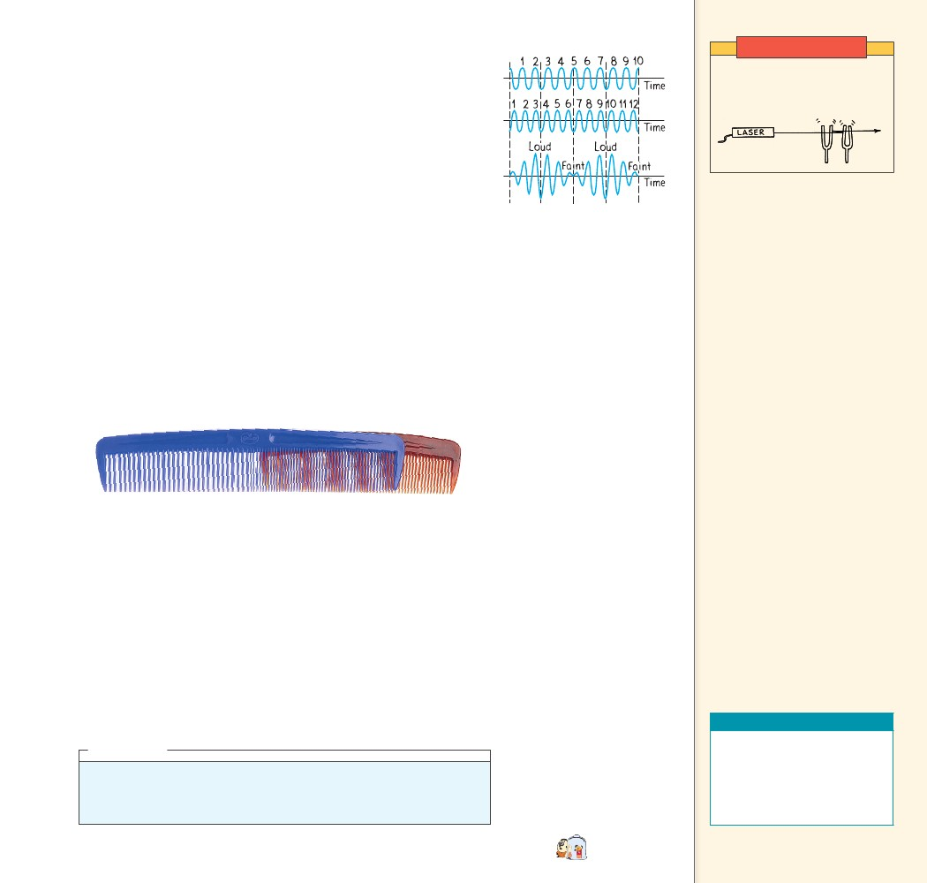
Demonstration
Beats can be nicely displayed on an oscilloscope. When sound
signals of slightly different frequencies are fed into an oscilloscope,
graphical representations of their pressure patterns can be displayed
both individually and when the sounds overlap. Figure 26.17 shows
the wave forms for two waves separately, and superposed. Although
the separate waves are of constant amplitude, we see amplitude varia-
tions in the superposed wave form. Careful inspection of the figure
shows this variation is produced by the interference of the two super-
posed waves. Maximum amplitude of the composite wave occurs
when both waves are in phase, and minimum amplitude occurs when
both waves are completely out of phase. Like the walkers in the pre-
vious example, the waves are in step twice each second, producing a
beat frequency of 2 Hz. The 10- and 12-Hz waves, chosen for con-
venience here, are infrasonic, so they and their beats are inaudible.
Higher-frequency audible waves behave exactly the same way and can
produce audible beats.
If you overlap two combs of different teeth spacings as shown in
Figure 26.18, you’ll see a moiré pattern that is related to beats. The
number of beats per length will equal the difference in the number of
teeth per length for the two combs.
Show beats by bouncing laser
light off a pair of vibrating
tuning forks as shown below.
FIGURE 26.17
Sinusoidal representations
of a 10-Hz sound wave and
a 12-Hz sound wave dur-
ing a 1-second time inter-
val. When the two waves
overlap, they produce a
composite wave with a beat
frequency of 2 Hz.
FIGURE 26.18
The unequal spacings of the combs produce a moiré
pattern that is similar to beats.
Beats can occur with any kind of wave and are a practical way to
compare frequencies. To tune a piano, a piano tuner listens for beats
produced between a standard tuning fork and a particular string on
the piano. When the frequencies are identical, the beats disappear.
The members of an orchestra tune up by listening for beats between
their instruments and a standard tone produced by an oboe.
CONCEPT
When two tones of
CHECK slightly different
frequency are sounded together,
a regular fluctuation in the
loudness of the combined sounds
is heard.
CONCEPT
......
CHECK
What causes beats?
Teaching Resources
• Reading and Study
Workbook
• Transparency 55
• PresentationEXPRESS
• Interactive Textbook
CHAPTER 26
SOUND
think!
What is the beat frequency when a 262-Hz and a 266-Hz tuning fork are
sounded together? A 262-Hz and a 272-Hz?
Answer: 26.10
......
525
525

Science, Technology,
and Society
CRITICAL THINKING
Students’
examples may vary. Accept all
reasonable responses. Hearing
can be protected by limiting
(or avoiding) time spent in
excessively noisy environments
or by wearing ear protectors
such as ear plugs.
Science, Technology, and Society
Noise and Your Health
Most of us try to protect
our eyes from excess light,
but few give the same
care to our ears. Near
loudspeakers during her
first time at a concert,
Allison was alarmed at
the pain in her ears. Her
friends meant to reassure
her when they told her
she’d get used to it. But
what they didn’t tell her
was that after the fine
tuning of her ears was
blasted, she wouldn’t
know the difference.
Teaching Tip The loudest
sounds emitted by a creature
are those from the Blue Whale.
They can emit sounds at a volume
greater than 180 db in water, but
the sounds are pitched too low
for humans to detect without
sensitive equipment.
Industrial noise is even
more damaging to the
ears than amplified music
because of its sudden
high-energy peaks. Loud
motorcycles, jackhammers,
chain saws, and power
tools not only produce
steady high-volume sound, but also produce sporadic peaks of energy
that can destroy tiny hair cells in the inner ear. When these tiny sensory
cells in the inner ear are destroyed they can never be restored. Noise-
induced hearing loss is insidious.
Fortunately for music devotees, damage caused by energetic peaks is
somewhat limited by an inadequate response of electronic amplifiers
and loudspeakers. Similarly for live music where most of the sound
comes from amplifying equipment. If amplifying equipment were more
responsive to sudden sound bursts, hearing loss at concerts would be
more severe.
The impact of hearing loss isn’t fully apparent until compounded by age.
Today’s young people will be tomorrow’s old people—probably the hardest
of hearing ever. Start now to care for your ears and prevent further hearing
loss!
Critical Thinking Describe some situations you might find yourself
in that could cause hearing loss. What can you do to protect your
hearing?
526
526

