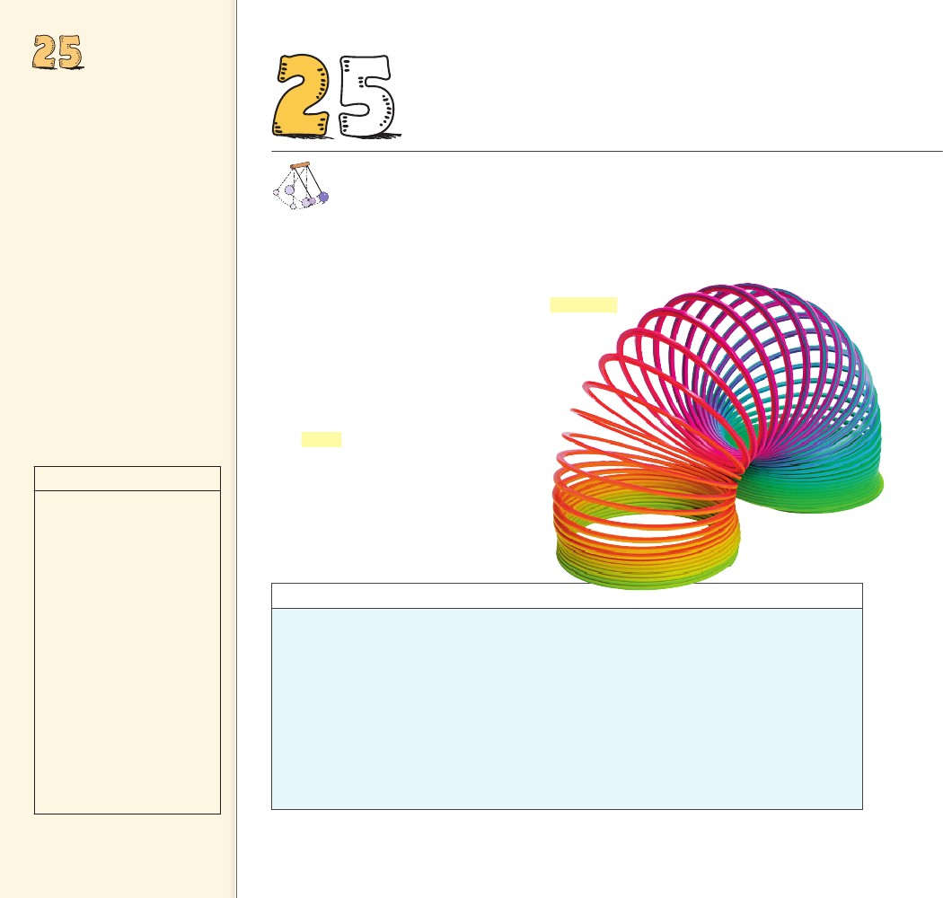
VIBRATIONS
AND WAVES
Objectives
• Describe the period of a
pendulum. (25.1)
• Describe the characteristics and
properties of waves. (25.2)
• Describe wave motion. (25.3)
• Describe how to calculate the
speed of a wave. (25.4)
• Give examples of transverse
waves. (25.5)
• Give an example of a
longitudinal wave. (25.6)
• Explain what causes
interference patterns. (25.7)
• Describe how a standing wave
occurs. (25.8)
• Describe how the apparent
frequency of waves change as a
wave source moves. (25.9)
• Describe bow waves. (25.10)
• Describe sonic booms. (25.11)
5
THE BIG
VIBRATIONS
AND WAVES
........
Waves transmit energy through
space and time.
IDEA
discover!
MATERIALS
foam cup, water
Regions of
still water, nodes, and regions
of choppy water, antinodes,
should be observable. This
pattern is the result of the
interference of traveling
waves reflecting from the
vibrating walls of the cup.
EXPECTED OUTCOME
ANALYZE AND CONCLUDE
ll around us we see things that wiggle and jiggle. Even
things too small to see, such as atoms, are constantly
wiggling and jiggling. A repeating, back-and-forth
motion about an equilibrium position is a vibration.
A vibration cannot exist in one instant. It needs
time to move back and forth. Strike a bell and
the vibrations will continue for some time
before they die down.
A disturbance that is transmitted pro-
gressively from one place to the next
with no actual transport of matter is
a wave. A wave cannot exist in one
place but must extend from one place
to another. Light and sound are both
forms of energy that move through
space as waves. This chapter is about
vibrations and waves, and the follow-
ing chapters continue with the study of
sound and light.
A
discover!
What Are Standing Waves?
1. Fill a foam cup nearly to the top with water.
Place the cup on a smooth, dry surface.
2. While applying a moderate downward pres-
sure, drag the cup across the surface.
3. Adjust the downward pressure on the cup
until a pattern of waves, called standing
waves, appears on the surface of the water.
4. Now try to change the pattern by altering
both the speed of the cup and the downward
pressure.
Analyze and Conclude
1. Observing Describe the patterns that you
produced on the surface of the water.
2. Predicting What do you think might happen if
you were to drag the cup on a different kind
of surface?
3. Making Generalizations Do you think stand-
ing waves can be produced in other media?
Explain.
1. Students should observe
regions of still water and
regions of choppy water.
2. The pattern changes
because the cup vibrates
differently on different
surfaces.
3. Yes, because waves travel in
all media and interference
is a characteristic of waves.
490
490

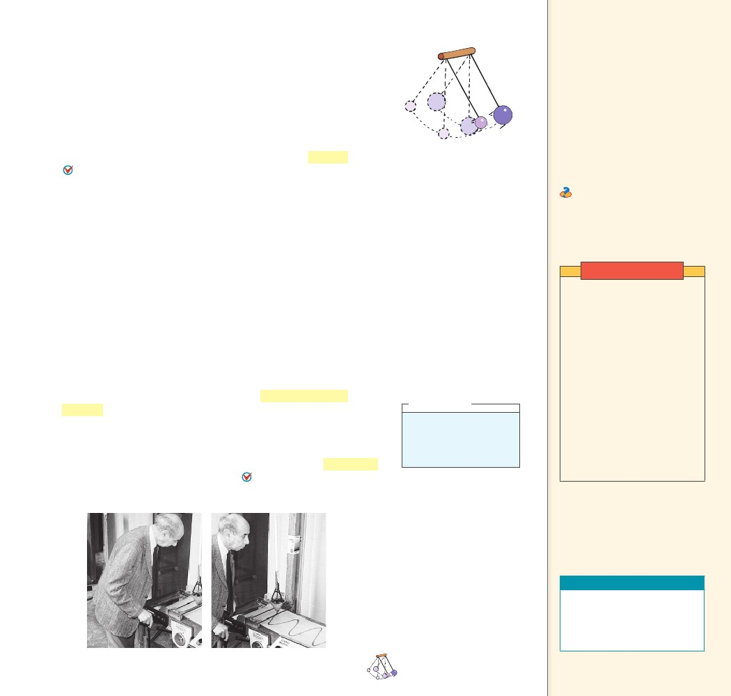
25.1 Vibration of a
25.1 Vibration of a Pendulum
Suspend a stone at the end of a string and you have a simple pen-
dulum. Pendulums like the one in Figure 25.1 swing back and forth
with such regularity that they have long been used to control the
motion of clocks. Galileo discovered that the time a pendulum takes
to swing back and forth through small angles depends only on the
length of the pendulum—the mass has no effect. The time of a
back-and-forth swing of the pendulum is called the period.
The period of the pendulum depends only on the length of a
pendulum and the acceleration of gravity. 25.1
A long pendulum has a longer period than a shorter pendulum;
that is, it swings back and forth more slowly—less frequently—than a
short pendulum. When walking, we allow our legs to swing with the
help of gravity, like a pendulum. In the same way that a long pendu-
lum has a greater period, a person with long legs tends to walk with
a slower stride than a person with short legs. This is most noticeable
in long-legged animals such as giraffes and horses, which run with a
slower gait than do short-legged animals such as hamsters and mice.
CONCEPT
Pendulum
Key Terms
period, vibration, waves
Teaching Tip Distinguish
between a simple pendulum (the
bob is very small compared to the
length of string) and a physical
pendulum (the stick makes up
a significant part of the mass).
Explain that their rotational
inertias are different.
Ask What principle of
mechanics accounts for the
different periods of pendulums
of different lengths? Rotational
inertia
FIGURE 25.1
Two pendulums of the same
length have the same period
regardless of mass.
Demonstration
Attach a small heavy weight
to the end of a piece of string
about 1 m long. Swing it
to and fro: this is a simple
pendulum. Identify frequency
and period. Time how long
the pendulum takes to make
10 complete cycles. Repeat
to show that the result does
not change from trial to trial.
Divide the time by 10 to get
the period. Add more mass to
the end of the string without
changing the overall length of
the pendulum. Time 10 more
cycles to show that weight
does not affect the period.
......
CHECK
What determines the period of a pendulum?
25.2 Wave Description
The back-and-forth vibratory motion (often called oscillatory
motion) of a swinging pendulum is called simple harmonic
motion. 25.2 The pendulum bob filled with sand in Figure 25.2
exhibits simple harmonic motion above a conveyor belt. When the
conveyor belt is stationary, the sand traces out a straight line. More
interestingly, when the conveyor belt is moving at constant speed, the
sand traces out a special curve known as a sine curve. A sine curve
is a pictorial representation of a wave. The source of all waves is
something that vibrates.
think!
What is the frequency in
vibrations per second of a
100-Hz wave?
Answer: 25.2.1
FIGURE 25.2
Frank Oppenheimer, founder
of the Exploratorium® science
museum in San Francisco, demon-
strates that a pendulum swinging
back and forth traces out a straight
line over a stationary surface and a
sine curve when the surface moves
at constant speed.
The period of the
CHECK pendulum depends
only on the length of a pendulum
and the acceleration of gravity.
CONCEPT
Teaching Resources
• Problem-Solving Exercises in
Physics 12-1, 12-2
• Laboratory Manual 68, 69
• Probeware Lab Manual 13
......
CHAPTER 25
VIBRATIONS AND WAVES
491
491

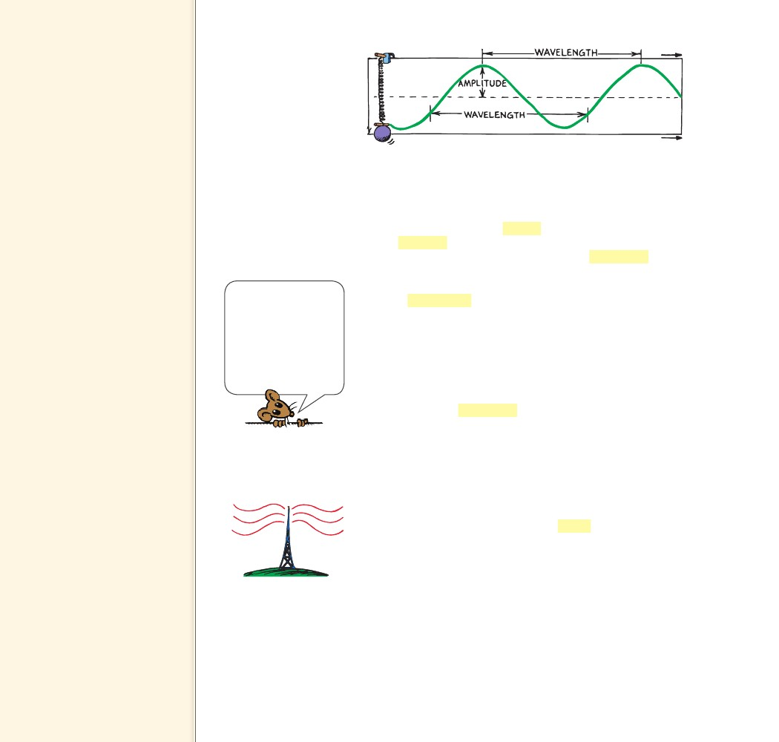
25.2 Wave
Description
Key Terms
simple harmonic motion, sine
curve, crest, trough, amplitude,
wavelength, frequency, hertz
Teaching Tip Begin by
tapping your lecture table or the
chalkboard. Call attention to how
frequently you tap and relate
this to the term frequency. Call
attention to the time interval
between taps and relate this
to the period. Establish the
reciprocal relationship between
frequency and period.
Teaching Tip Move a piece of
chalk up and down on the board,
tracing and retracing a vertical
straight line. Call attention to
how “frequently” you oscillate
the chalk, again tying this to
the definition of frequency.
Discuss the idea of displacement
and amplitude (maximum
displacement). With appropriate
motions, show different
frequencies and different
amplitudes. Then do the same
while walking across the front
of the board tracing out a sine
wave. Repeat showing waves of
different wavelengths.
Teaching Tip Point out that
since a vibration is also called a
cycle, one hertz is also one cycle
per second.
(1 kHz 5 103 cycles/s;
1 MHz 5 106 cycles/s)
FIGURE 25.3
A sine curve is a pictorial
representation of a wave.
Be clear about the
distinction between
frequency and speed.
How frequently a wave
vibrates is altogether
different from how fast
it moves from one loca-
tion to another.
The Parts of a Wave A weight attached to a spring undergoes
vertical simple harmonic motion as shown in Figure 25.3. A marking
pen attached to the bob traces a sine curve on a sheet of paper that
is moving horizontally at constant speed. Like a water wave, the high
points on a wave are called crests. The low points on a wave are
called troughs. The straight dashed line represents the “home” posi-
tion, or midpoint of the vibration. The term amplitude refers to the
distance from the midpoint to the crest (or trough) of the wave. So
the amplitude equals the maximum displacement from equilibrium.
The wavelength of a wave is the distance from the top of one
crest to the top of the next one. Or equivalently, the wavelength is the
distance between successive identical parts of the wave. The wave-
lengths of waves at the beach are measured in meters, the wavelengths
of ripples in a pond in centimeters, and the wavelengths of light in
billionths of a meter (nanometers).
Frequency The number of vibrations an object makes in a unit of
time is an object’s frequency. The frequency of a vibrating pendu-
lum, or object on a spring, specifies the number of back-and-forth
vibrations it makes in a given time (usually one second). A complete
back-and-forth vibration is one cycle. If it occurs in one second, the
frequency is one vibration per second or one cycle per second. If two
vibrations occur in one second, the frequency is two vibrations or
two cycles per second. The frequency of the vibrating source and the
frequency of the wave it produces are the same.
The unit of frequency is called the hertz (Hz). A frequency of
one cycle per second is 1 hertz, two cycles per second is 2 hertz, and
so on. Higher frequencies are measured in kilohertz (kHz—thou-
sands of hertz), and still higher frequencies in megahertz (MHz—
millions of hertz) or gigahertz (GHz—billions of hertz). AM radio
waves are broadcast in kilohertz, while FM radio waves are broadcast
in megahertz; radar and microwave ovens operate at gigahertz. A
station at 960 kHz broadcasts radio waves that have a frequency of
960,000 hertz. A station at 101 MHz broadcasts radio waves with a
frequency of 101,000,000 hertz. As Figure 25.4 shows, these radio-
wave frequencies are the frequencies at which electrons vibrate in the
transmitting antenna of a radio station.
FIGURE 25.4
Electrons in the transmitting
antenna of a radio station at
960 kHz on the AM dial
vibrate 960,000 times each
second and produce
960-kHz radio waves.
492
492

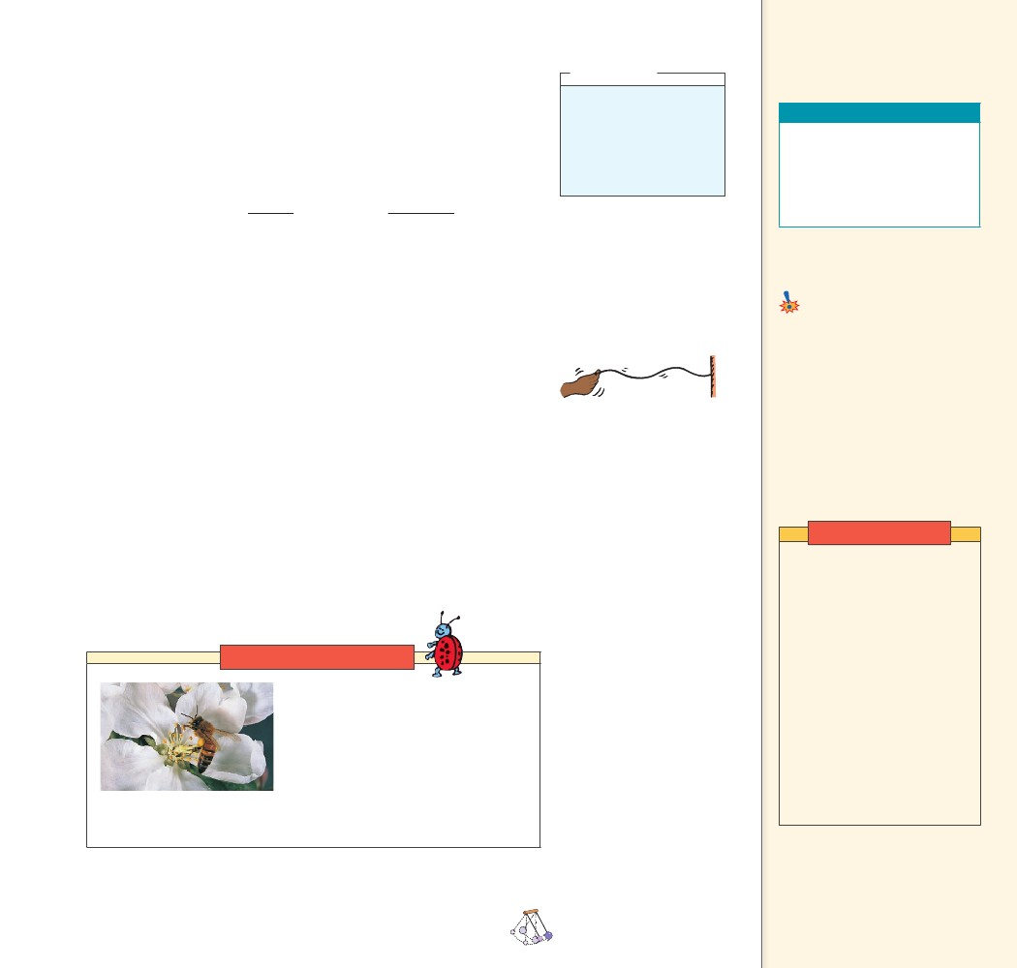
If the frequency of a vibrating object is known, its period can be
calculated, and vice versa. Suppose, for example, that a pendulum
makes two vibrations in one second. Its frequency is 2 Hz. The time
needed to complete one vibration—that is, the period of vibration—
is 1/2 second. Or if the vibration period is 3 Hz, then the period is 1/3
second. As you can see below, frequency and period are inverses of
each other:
11
frequencyor period
periodfrequency
CONCEPT
think!
The Sears Tower in
Chicago sways back and
forth at a frequency of
about 0.1 Hz. What is
its period of vibration?
Answer: 25.2.2
The source of all
CHECK waves is something
that vibrates.
CONCEPT
Teaching Resources
• Reading and Study
Workbook
• Transparency 50
• PresentationEXPRESS
• Interactive Textbook
......
CHECK
What is the source of all waves?
25.3 Wave Motion
Common Misconception
When a wave travels in a medium,
the medium moves with the wave.
As a wave travels through
a medium, there is no transfer of
matter.
FACT
25.3 Wave Motion
Most of the information around us gets to us in some form of wave.
Sound is energy that travels to our ears in the form of a wave. Light is
energy that comes to our eyes in the form of a different kind of wave
(an electromagnetic wave). The signals that reach our radio and tele-
vision sets also travel in the form of electromagnetic waves.
When energy is transferred by a wave from a vibrating source to a
distant receiver, there is no transfer of matter between the two points.
To see this, think about the very simple wave produced when one end
of a horizontally stretched string is shaken up and down as shown
in Figure 25.5. After the end of the string is shaken, a rhythmic dis-
turbance travels along the string. Each part of the string moves up
and down while the disturbance moves horizontally along the length
of the string. It is the disturbance that moves along the length of the
string, not parts of the string itself.
Link to ENTOMOLOGY
Noisy Bugs Big bumblebees flap
their wings at about 130 flaps per
second, and produce sound of 130 Hz.
A honeybee flaps its wings at 225 flaps
per second and produces a higher-
pitched sound of 225 Hz. The annoying
high-pitched whine of a mosquito
results from its wings flapping at 600 Hz. These sounds are produced
by pressure variations in the air caused by vibrating wings.
FIGURE 25.5
When the string is shaken
up and down, a disturbance
moves along the string.
Teaching Tip Point out that
if a leaf is floating in a pond as
a wave passes, the leaf will move
up and down with the water
but will not move along with
the wave.
Demonstration
Have a student hold one
end of a stretched spring or
a Slinky while you hold the
other. Send transverse pulses
along it, stressing the idea
that the disturbance rather
than the medium moves along
the spring. Shake the spring
and produce a sine wave. Then
send a stretch and squeeze
(elongation and compression)
down the spring, showing
a longitudinal pulse. Send a
sequence of pulses and you
have a wave. After some
discussion, produce standing
waves.
......
CHAPTER 25
VIBRATIONS AND WAVES
493
493

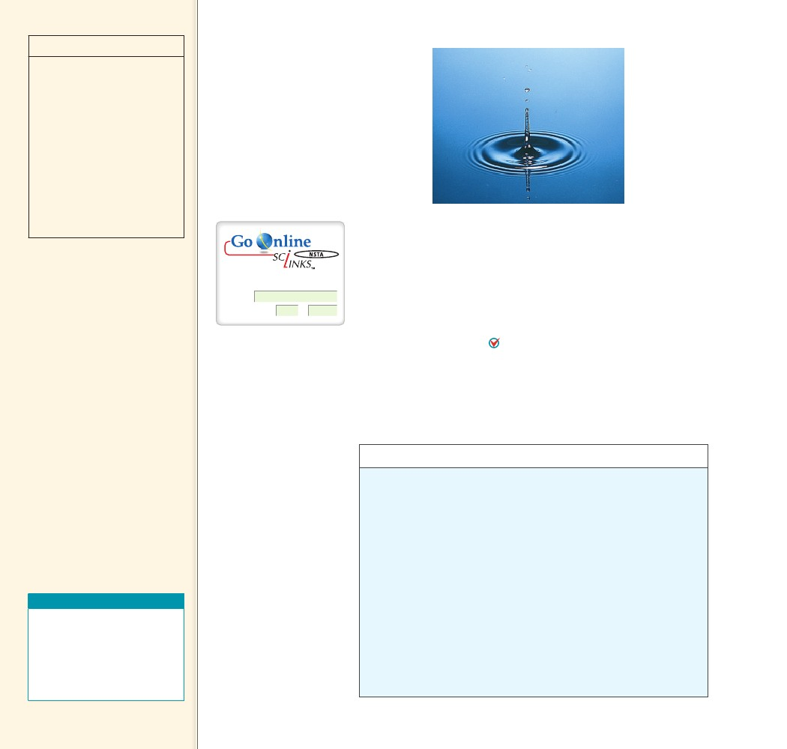
discover!
MATERIALS
pen, paper, wide
pan, water
In Part 1,
students will create a pictorial
representation of a wave.
They will observe the same
pattern as in Figure 25.2. In
Part 2, students will actually
make waves.
EXPECTED OUTCOME
THINK, PART 1
FIGURE 25.6
A circular water wave in a still
pond moves out from the center
in an expanding circle.
The wavelength
The wavelength
increases.
THINK, PART 2
decreases.
For: Links on wave motion
Visit: www.SciLinks.org
Web Code: csn – 2503
Drop a stone in a quiet pond and you’ll produce a wave that
moves out from the center in an expanding circle as shown in Figure
25.6. It is the disturbance that moves, not the water, for after the dis-
turbance passes, the water is where it was before the wave passed.
When someone speaks to you from across the room, the sound wave
is a disturbance in the air that travels across the room. The air molecules
themselves do not move along, as they would in a wind. The air, like the
rope and the water in the previous examples, is the medium through
which wave energy travels. The energy transferred by a wave from
a vibrating source to a receiver is carried by a disturbance in a
medium. Energy is not transferred by matter moving from one place to
another within the medium.
CONCEPT
......
CHECK
How does a wave transfer energy?
discover!
Making Waves
Part 1
The energy
CHECK transferred by a
wave from a vibrating source
to a receiver is carried by a
disturbance in a medium.
CONCEPT
1. Oscillate a marking pen back and forth across a piece of paper
as you slowly pull the paper in a direction perpendicular to your
oscillation.
2. Repeat Step 1, but pull the paper faster this time.
3. Think What happens to the wavelength of the curves when you
pull the paper faster?
Teaching Resources
• Reading and Study
Workbook
• Problem-Solving Exercises
in Physics 13-1
• PresentationEXPRESS
• Interactive Textbook
......
Part 2
1. Repeatedly dip your finger into a wide pan of water to make
circular waves on the surface.
2. Repeat Step 1, but dip your finger more frequently.
3. Think What happens to the wavelength of the waves when you dip
your finger more frequently?
494
494

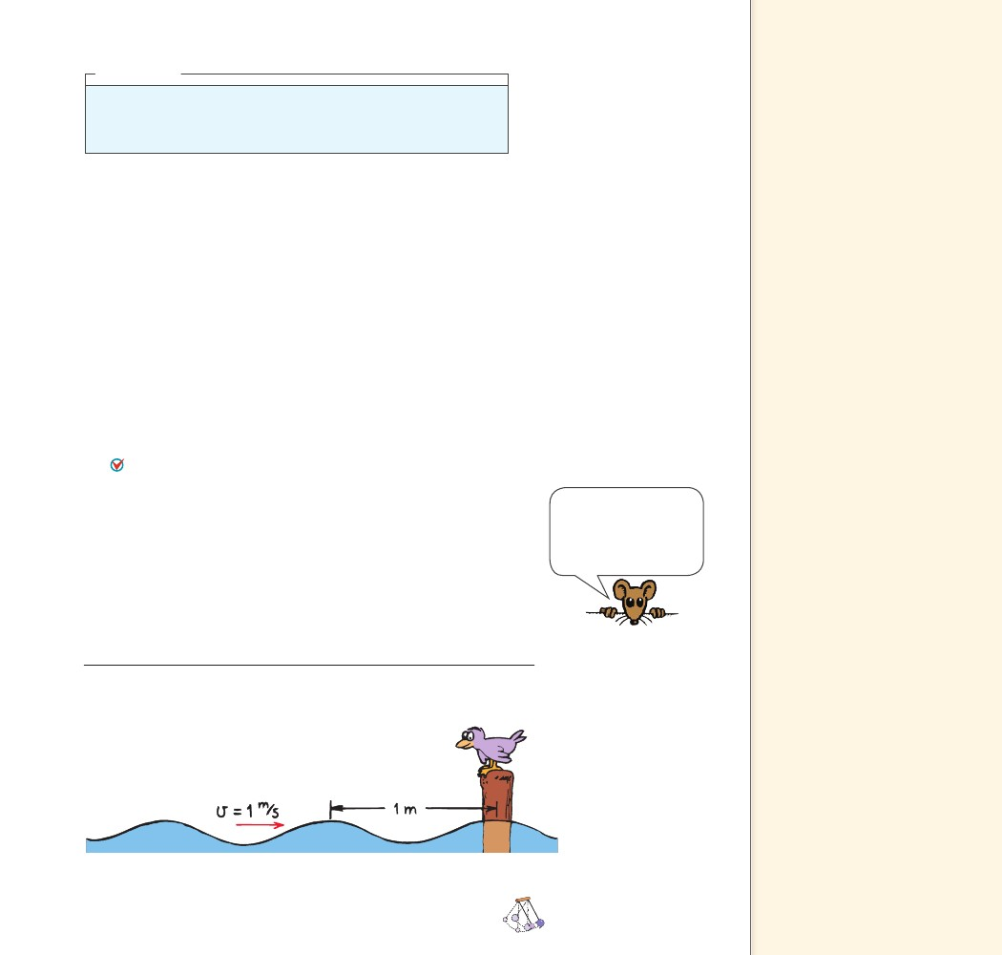
25.4 Wave Speed
think!
If a water wave vibrates up and down two times each second and the
distance between wave crests is 1.5 m, what is the frequency of the wave?
What is its wavelength? What is its speed? Answer: 25.4.1
Teaching Tip Explain that the
frequency of a vibrating source is
the same as the frequency of the
wave it produces.
Teaching Tip Explain or
derive wave speed: Speed 5
wavelength 3 frequency.
Support this with the freight
car example.
Teaching Tip Have students
calculate the wavelengths of
their favorite local radio stations.
Wavelength 5 speed/frequency.
For example, 1000-kHz waves
have wavelengths 5 (3 3 108 m/s)/
(106 Hz) 5 300 m. Surprisingly
long!
25.4 Wave Speed
The speed of a wave depends on the medium through which the wave
moves. Sound waves, for example, move at speeds of about
330 m/s to 350 m/s in air (depending on temperature), and about four
times faster in water. Whatever the medium, the speed, wavelength,
and frequency of the wave are related. Consider the simple case of
water waves, as shown in Figure 25.7. Imagine that you fix your eyes
at a stationary point on the surface of water and observe the waves
passing by this point. If you observe the distance between crests (the
wavelength) and also count the number of crests that pass each
second (the frequency), then you can calculate the horizontal
distance a particular crest moves each second. For example, in
Figure 25.7, one crest passes by the bird every second. The waves
therefore move at 1 meter per second.
You can calculate the speed of a wave by multiplying the
wavelength by the frequency. For example, if the wavelength is
3 meters and if two crests pass a stationary point each second, then
3 meters 2 waves pass by in 1 second. The waves therefore move at
6 meters per second. In equation form, this relationship is written as
v
f
where v is wave speed, l (Greek letter lambda) is wavelength, and
f is wave frequency. This relationship holds for all kinds of waves,
whether they are water waves, sound waves, radio waves, or light waves.
fThe equation v
makes sense: During
each vibration, a wave
travels a distance of one
wavelength.
FIGURE 25.7
If the wavelength is 1 meter, and one
wavelength per second passes the pole,
then the speed of the wave is 1 m/s.
CHAPTER 25
VIBRATIONS AND WAVES
495
495

Be sure to distinguish
electromagnetic waves from
longitudinal sound waves.
Consider discussing Chapter 27
and Chapter 37 material here
to lead into the family of
electromagnetic waves. Show
how electromagnetic waves
are grouped according to their
wavelengths and frequencies.
Table 25.1
Wavelength (m)
Sound Waves
Frequency (Hz)
Wave Speed (m/s)
2.13
1.29
0.86
0.64
160
264
396
528
340
340
340
340
think!
What is the wavelength
of a 340-Hz sound wave
when the speed of sound
in air is 340 m/s?
Answer: 25.4.2
Table 25.1 shows some wavelengths and corresponding frequen-
cies of sound in air at the same temperature. Notice that the product of
wavelength and frequency is the same for each example—340 m/s in this
case. During a concert, you do not hear the high notes in a chord before
you hear the low notes. The sounds of all instruments reach you at the
same time. Notice that long wavelengths have low frequencies, and short
wavelengths have high frequencies. Wavelength and frequency vary
inversely to produce the same wave speed for all sounds.
CONCEPT
......
CHECK
How do you calculate the speed of a wave?
do the math!
If a train of freight cars, each 10 m long, rolls by you at the rate
of 2 cars each second, what is the speed of the train?
You can look at this problem in two ways, the Chapter 4 way and the
Chapter 25 way.
From Chapter 4 recall:
v
d
t
2
10 m
1s
20 m/s
Note that d is the length of that part of the train that passes you in
time t.
Here in Chapter 25 we compare the train to wave motion,
where the wavelength corresponds to 10 m, and the frequency is
2 Hz. Then
wave speed
wavelength frequency
(10 m) (2 Hz)20 m/s
You can calculate the
CHECK speed of a wave by
multiplying the wavelength by
the frequency.
CONCEPT
......
Teaching Resources
• Reading and Study
Workbook
• PresentationEXPRESS
• Interactive Textbook
One of the nice things about physics is that different ways of
looking at things produce the same answer. When this doesn’t hap-
pen, and there is no error in computation, then the validity of one (or
both!) of those ways is suspect.
496
496

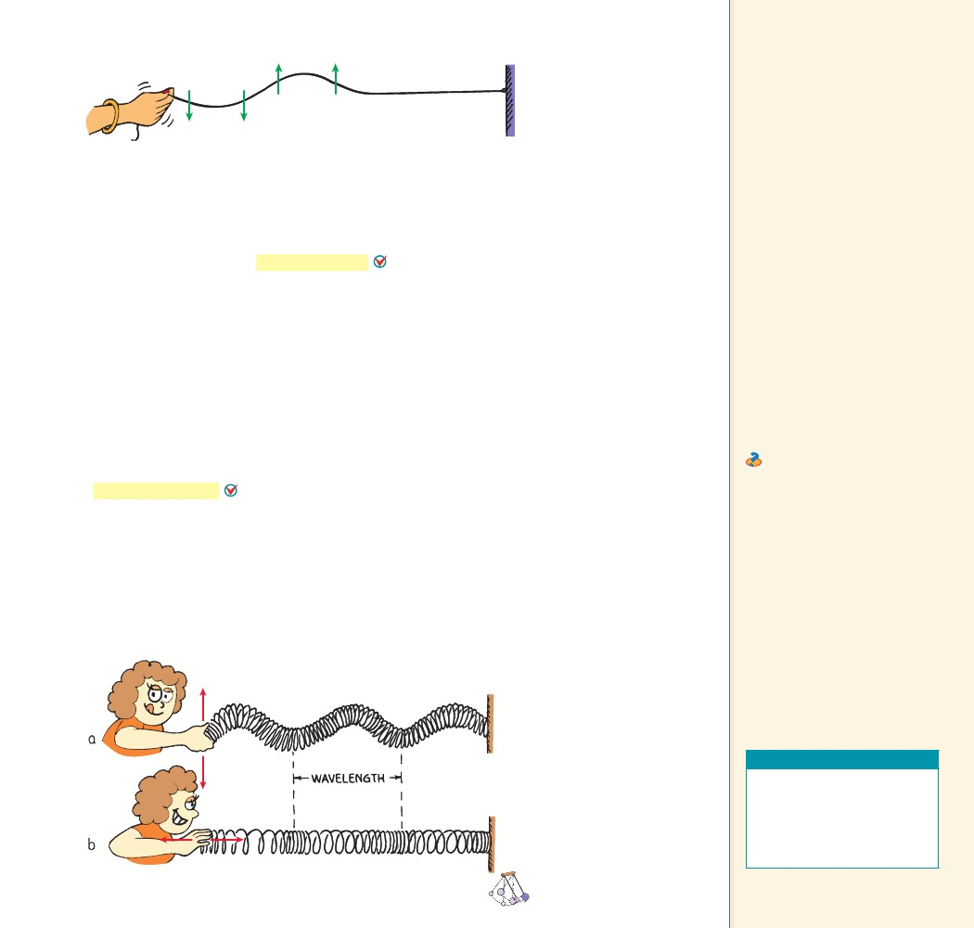
25.5 Transverse
FIGURE 25.8
A person creates a trans-
verse wave by shaking
the free end of a rope up
and down. The arrows
represent the motion of
the rope.
Waves
Key Term
transverse wave
Waves in the
CHECK stretched strings
of musical instruments and the
electromagnetic waves that
make up radio waves and light
are transverse.
CONCEPT
25.5 Transverse Waves
Suppose you create a wave along a rope by shaking the free end up
and down, as shown in Figure 25.8. The motion of the rope is at right
angles to the direction in which the wave is moving. Whenever the
motion of the medium is at right angles to the direction in which
Waves in thea wave travels, the wave is a transverse wave.
stretched strings of musical instruments and the electromagnetic
waves that make up radio waves and light are transverse.
CONCEPT
25.6 Longitudinal
Waves
Key Term
longitudinal wave
Teaching Tip Allow
students to play with large
springs or Slinkys until they can
demonstrate and explain the
difference between transverse
and longitudinal waves.
Ask With respect to the
direction of the wave’s motion,
how do the directions of
vibrations differ for transverse
and longitudinal waves?
Perpendicular for transverse;
parallel for longitudinal
......
CHECK
What are some examples of transverse waves?
25.6 Longitudinal Waves
Not all waves are transverse. Sometimes the particles of the
medium move back and forth in the same direction in which the
wave travels. When the particles oscillate parallel to or along the
direction of the wave rather than at right angles to it, the wave is
Sound waves are longitudinal waves.a longitudinal wave.
Both transverse and longitudinal waves can be demonstrated with
a loosely-coiled spring, as shown in Figure 25.9. A transverse wave is
demonstrated by shaking the end of a coiled spring up and down. A
longitudinal wave is demonstrated by shaking the end of the coiled
spring in and out. In this case we see that the medium vibrates paral-
lel to the direction of energy transfer.
CONCEPT
......
CHECK
What is an example of a longitudinal wave?
CONCEPT
Transverse and longitudi-
nal waves transfer energy
from left to right.
a. When the end of a
coiled spring is shaken up
and down, a transverse
wave is produced.
b. When it is shaken in
and out, a longitudinal
wave is produced.
CHAPTER 25
VIBRATIONS AND WAVES
CHECK
Teaching Resources
• Reading and Study
Workbook
• Transparency 51
• PresentationEXPRESS
• Interactive Textbook
......
FIGURE 25.9
......
Sound waves are
longitudinal waves.
497
497

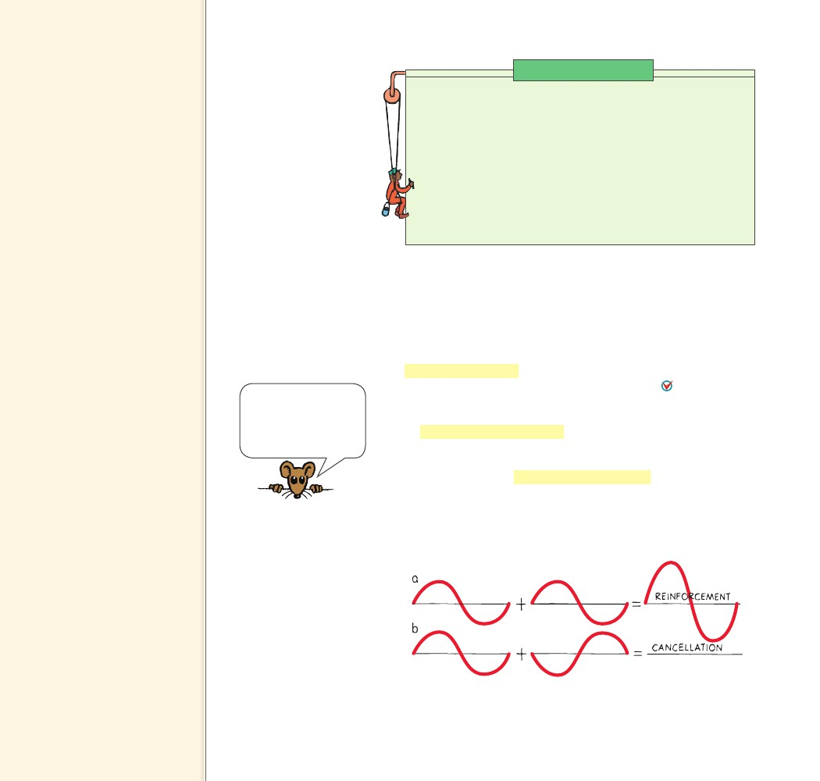
25.7 Interference
Key Terms
interference pattern,
constructive interference,
destructive interference, out of
phase, in phase
Teaching Tip Describe
interference by drawing
Figure 25.10 on the board. If
you have a ripple tank, show
the overlapping of water waves
and interference.
Physics on the Job
Seismologist
When an earthquake occurs, the sudden release of energy produces
waves. Seismologists study and interpret those waves in order to
determine the strength and location of the earthquake. They compare
the speed, amplitude, and reception of primary longitudinal waves
with secondary transverse waves. Because they understand how waves
travel and the materials through which they pass, seismologists are
able to describe earthquakes, learn about the composition of Earth,
and possibly predict future earthquakes. Seismologists conduct
research from university and government facilities, such as the National
Earthquake Information Service (NEIS) in Colorado.
25.7 Interference
A material object such as a rock will not share its space with another
rock. But more than one vibration or wave can exist at the same
time in the same space. If you drop two rocks in water, the waves
produced by each can overlap and form an interference pattern.
An interference pattern is a regular arrangement of places where
wave effects are increased, decreased, or neutralized. Interference
patterns occur when waves from different sources arrive at the
same point—at the same time.
In constructive interference, the crest of one wave overlaps the
crest of another and their individual effects add together. The result
is a wave of increased amplitude. As Figure 25.10a shows, this is
called reinforcement. In destructive interference, the crest of one
wave overlaps the trough of another and their individual effects are
reduced. The high part of one wave simply fills in the low part of
another. As Figure 25.10b shows, this is called cancellation.
Sound, a longitudinal
wave, requires a medium.
It can’t travel in a vacuum
because there’s nothing
to compress and stretch.
FIGURE 25.10
There are two types of wave
interference. a. In construc-
tive interference, the waves
reinforce each other to pro-
duce a wave of increased
amplitude. b. In destructive
interference, the waves can-
cel each other and no wave
is produced.
498
498

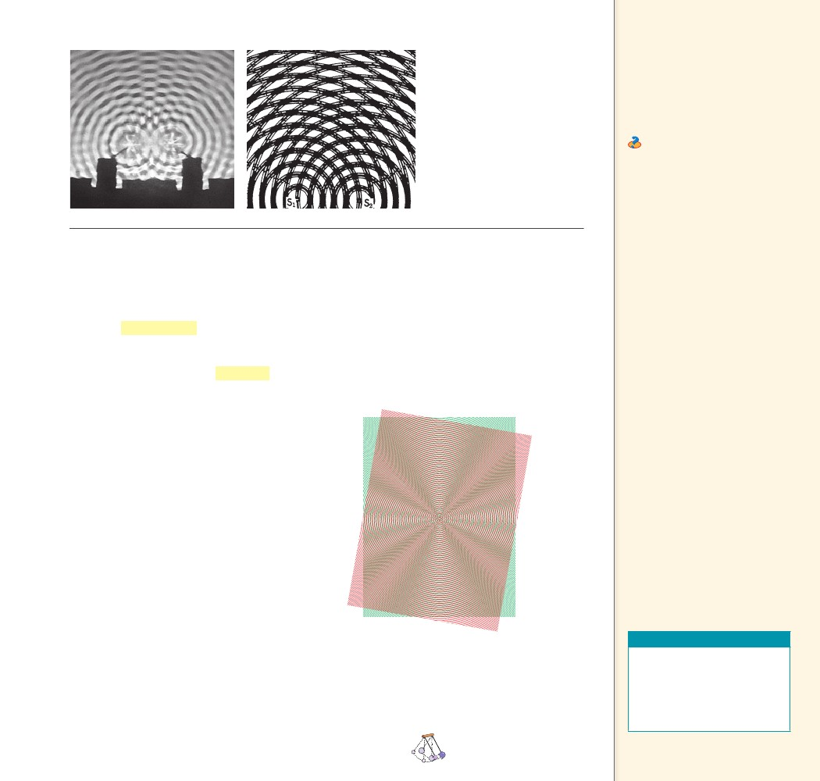
FIGURE 25.11
a. Two overlapping water
waves produce an interfer-
ence pattern.
b. Overlapping concentric
circles produce a pictorial
representation of an interfer-
ence pattern.
Teaching Tip Make a pair
of transparencies of concentric
circles. Superimpose them on
your overhead projector and
show the variety of interference
patterns that result when their
centers are displaced. One
example is shown in Figure 25.12.
Ask Can waves overlap
in such a way as to produce
a zero amplitude? Yes, that is
the destructive interference
characteristic of all waves.
a
b
Wave interference is easiest to see in water. Figure 25.11a shows
the interference pattern made when two vibrating objects touch the
surface of water. The gray “spokes” are regions where waves cancel
each other out. At points along these regions, the waves from the two
objects arrive “out of step,” or out of phase, with one another. When
waves are out of phase, the crests of one wave overlap the troughs
of another to produce regions of zero amplitude. The dark and light-
striped regions are where the waves are “in step,” or in phase, with
each other. When waves are in phase, the crests of one wave overlap
the crests of the other, and the troughs overlap as well.
Interference patterns are nicely illustrated by
the overlapping of concentric circles printed on a
pair of clear sheets, as shown in Figures 25.11b and
25.12. When the sheets overlap with their centers
slightly apart, a so-called moiré pattern is formed
that is very similar to the interference pattern of
water waves (or any kind of waves). A slight shift
in either of the sheets produces noticeably differ-
ent patterns. If a pair of such sheets is available,
be sure to try this and see the variety of patterns
for yourself.
Interference is characteristic of all wave
motion, whether the waves are water waves, sound
waves, or light waves. The interference of sound is
discussed in the next chapter, and the interference
of light in Chapter 31.
CONCEPT
FIGURE 25.12
A moiré pattern is very similar
to an interference pattern.
Interference patterns
CHECK occur when waves
from different sources arrive at
the same point—at the same
time.
CONCEPT
Teaching Resources
• Reading and Study
Workbook
• Laboratory Manual 71
• PresentationEXPRESS
• Interactive Textbook
......
CHECK
What causes interference patterns?
......
CHAPTER 25
VIBRATIONS AND WAVES
499
499

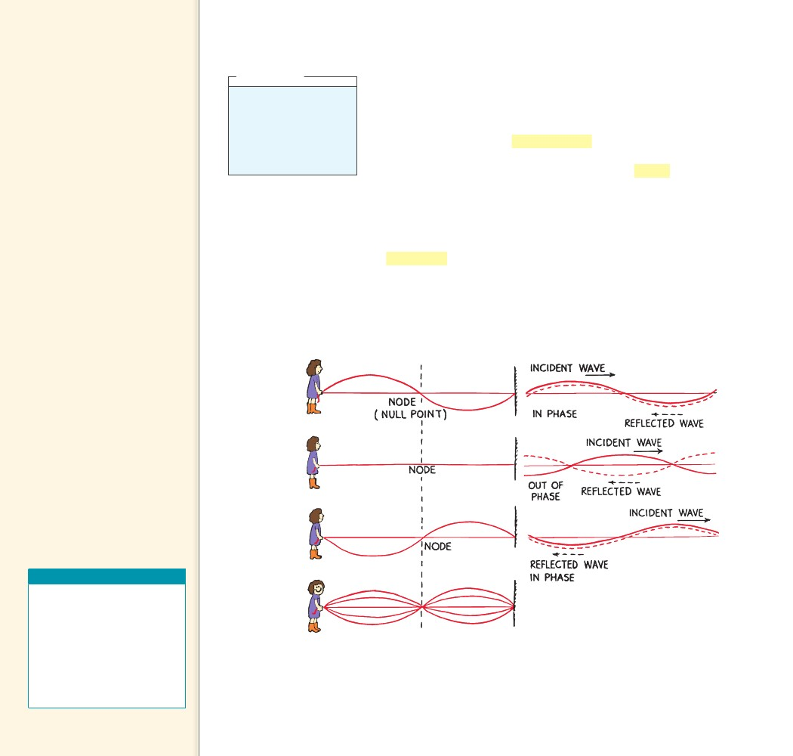
25.8 Standing
Waves
Key Terms
standing wave, node, antinode
Teaching Tip Emphasize that
a standing wave is the result of
interference.
Teaching Tip Use a long thin
spring or a rope to demonstrate
standing waves. Have students
identify the nodes and come up
close to inspect them. Change
the frequency and show that only
specific frequencies allow the
creation of standing waves.
Teaching Tidbit Figure
25.14a shows the lowest
frequency of vibration of a
standing wave—the fundamental
frequency.
Teaching Tip Point out that
for a string free at one end and a
tube open at one end and closed
at the other end, standing waves
form when odd integer multiples
of quarter wavelengths fit into
the vibrating medium. A soda-
pop bottle is an example of a
tube open at one end and closed
at the other end.
think!
Is it possible for one wave
to cancel another wave so
that the combined ampli-
tude is zero? Explain your
answer.
Answer: 25.8
25.8 Standing Waves
If you tie a rope to a wall and shake the free end up and down, you
will produce a wave in the rope. The wall is too rigid to shake, so
the wave is reflected back along the rope to you. By shaking the rope
just right, you can cause the incident (original) and reflected waves
to form a standing wave. A standing wave is a wave that appears to
stay in one place—it does not seem to move through the medium.
Certain parts of a standing wave remain stationary. Nodes are the
stationary points on a standing wave.
Interestingly enough, you could hold your fingers on either side
of the rope at a node, and the rope would not touch them. Other
parts of the rope would make contact with your fingers. The posi-
tions on a standing wave with the largest amplitudes are known
as antinodes. Antinodes occur halfway between nodes.
Standing waves are the result of interference. When two waves of
equal amplitude and wavelength pass through each other in opposite
directions, the waves are always out of phase at the nodes. As Figure
25.13 shows, the nodes are stable regions of destructive interference.
A standing wave
CHECK forms only if half a
wavelength or a multiple of half
a wavelength fits exactly into the
length of the vibrating medium.
CONCEPT
Teaching Resources
• Reading and Study
Workbook
• Problem-Solving Exercises in
Physics 13-3
• Transparency 52
• PresentationEXPRESS
• Interactive Textbook
• Next-Time Question 25-1
......
FIGURE 25.13
The incident and reflected waves interfere
to produce a standing wave. The nodes
are places that remain stationary.
500
500

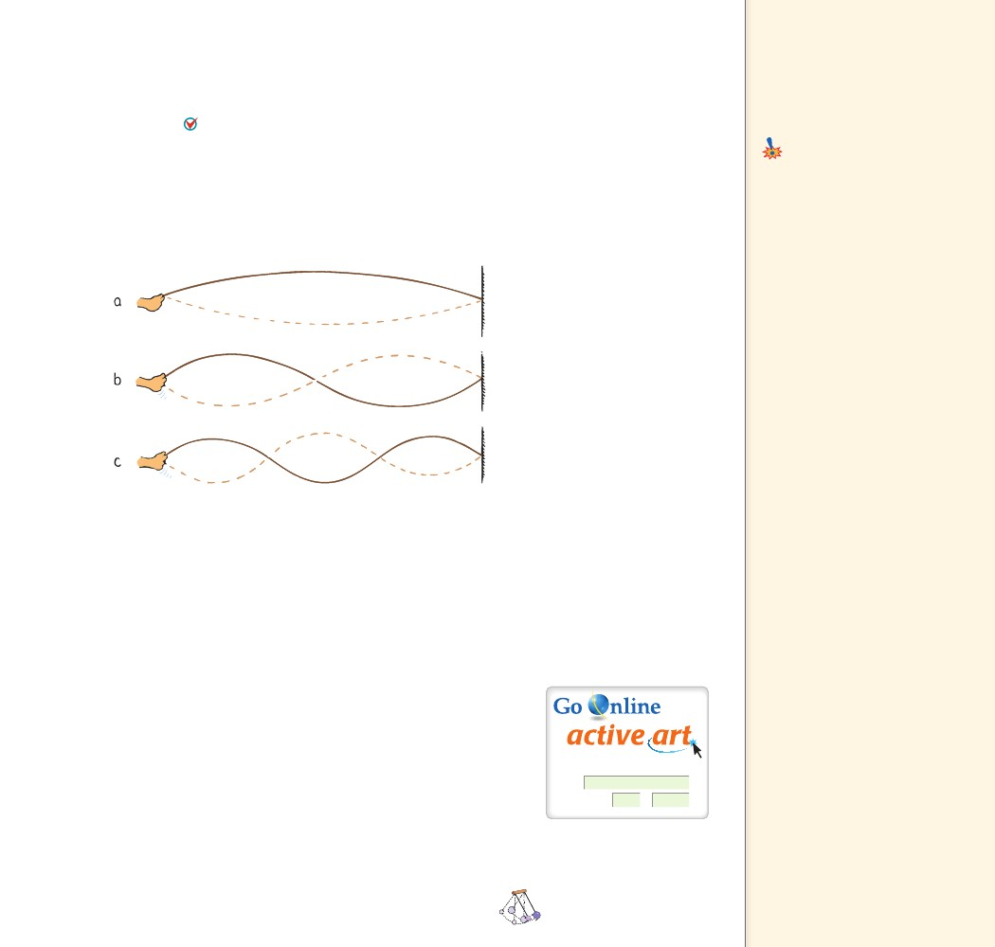
25.9 The Doppler
You can produce a variety of standing waves by shaking the rope
at different frequencies. Once you find a frequency that produces a
standing wave, doubling or tripling the frequency will also produce a
standing wave. A standing wave forms only if half a wavelength
or a multiple of half a wavelength fits exactly into the length of the
vibrating medium. In Figure 25.14a, the rope length equals half a
wavelength. In Figure 25.14b, the rope length equals one wavelength.
In Figure 25.14c, the rope length equals one and one-half wave-
lengths. If you keep increasing the frequency, you’ll produce more
interesting waves.
FIGURE 25.14
You can produce a variety of
standing waves.
a. Shake the rope until you set up
a standing wave of 1 wavelength.2
b. Shake with twice the frequency
and produce a standing wave of
1 wavelength.
c. Shake with three times the fre-
quency and produce a standing
wave of 1 1 wavelengths.2
Effect
Key Terms
Doppler effect, blue shift,
red shift
Common Misconception
Changes in wave speed cause the
Doppler effect.
The Doppler effect is an
apparent change in frequency
due to the motion of the source.
FACT
Teaching Tip Place an
electronic whistle that emits a
sound of about 3000 Hz into a
sponge, rubber, or foam ball.
Introduce the Doppler effect by
throwing the ball around the
room. Ask students to describe
what they hear as the ball moves
through the air. Then ask if the
frequency of the sound that the
whistle emits actually changes.
Standing waves are set up in the strings of musical instruments that
are struck. They are set up in the air in an organ pipe and the air of a
soda-pop bottle when air is blown over the top. Standing waves can be
produced in either transverse or longitudinal waves.
CHECK
......
CONCEPT At what wavelengths can a standing
wave form in a vibrating medium?
25.9 The Doppler Effect
Imagine a bug jiggling its legs and bobbing up and down in the
middle of a quiet puddle, as shown in Figure 25.15. Suppose the bug
is not going anywhere but is merely treading water in a fixed posi-
tion. The crests of the wave it makes are concentric circles, because
the wave speed is the same in all directions. If the bug bobs in the
water at a constant frequency, the distance between wave crests (the
wavelength) will be the same for all successive waves. Waves encounter
point A as frequently as they encounter point B. This means that the
frequency of wave motion is the same at points A and B, or anywhere
in the vicinity of the bug. This wave frequency is the same as the bob-
bing frequency of the bug.
CHAPTER 25
For: Doppler Effect activity
Visit: www.PHSchool.com
Web Code: csp – 4259
VIBRATIONS AND WAVES
501
501

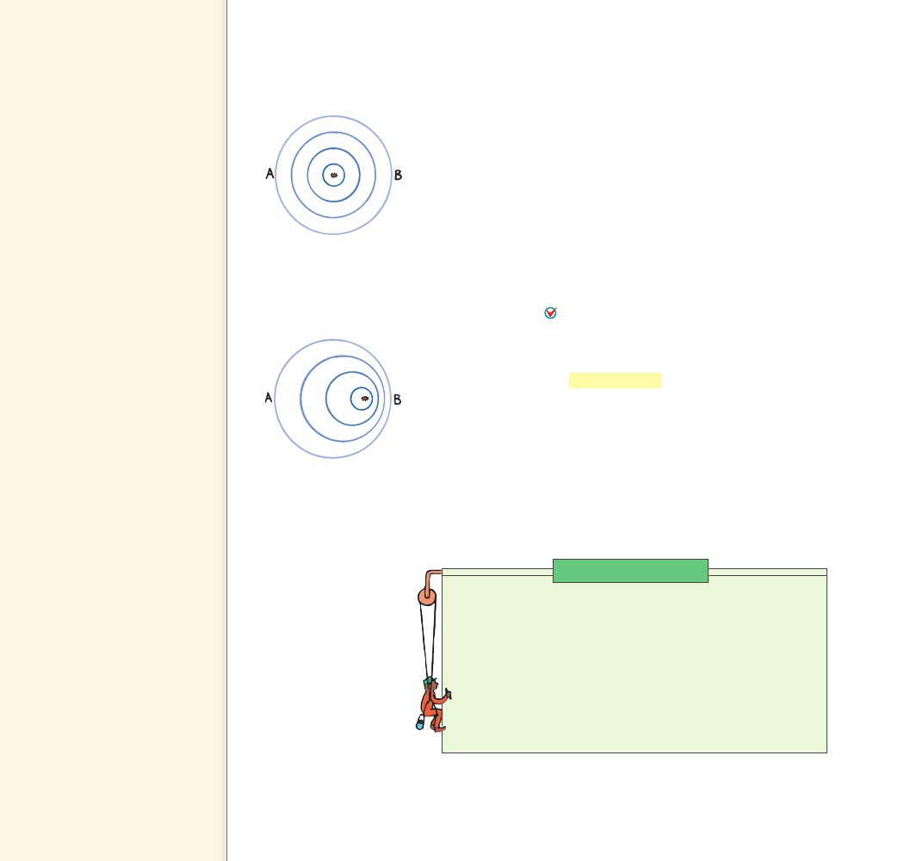
Teaching Tip Describe the
pattern that a stationary bug
jiggling in still water makes as
shown in Figure 25.15. Draw
circles to show the top view of
circular ripples made by a bug
bobbing in the water. Stress
that wave speed, wavelength,
and frequency are the same in
all directions, as shown by the
circular shape.
Teaching Tip Now consider
a moving bug and the pattern
it makes (Figure 25.16). Explain
how the frequency of waves is
increased in front of the bug;
waves would be encountered
more often (more frequently) by
your hand placed in the water in
front of the bug. (The observer
would also encounter a shorter
wavelength; since v is a constant
for a given medium, then as f
increases, l decreases.) Similarly
waves would be encountered less
often (less frequently) behind
the bug.
FIGURE 25.15
A stationary bug jiggling
in still water produces a
circular water wave.
FIGURE 25.16
A bug swimming in still
water produces a wave
pattern that is no longer
concentric.
Suppose the jiggling bug moves across the water at a speed less
than the wave speed. In effect, the bug chases part of the crests it has
produced. The wave pattern is distorted and is no longer concentric,
as shown in Figure 25.16. The center of the outer crest was made
when the bug was at the center of that circle. The center of the next
smaller crest was made when the bug was at the center of that circle,
and so forth. The centers of the circular crests move in the direction
of the swimming bug. Although the bug maintains the same bob-
bing frequency as before, an observer at B would encounter the crests
more often. The observer would encounter a higher frequency. This is
because each successive crest has a shorter distance to travel so they
arrive at B more frequently than if the bug were not moving toward B.
An observer at A, on the other hand, encounters a lower fre-
quency because of the longer time between wave-crest arrivals. To
reach A, each crest has to travel farther than the one ahead of it due
to the bug’s motion. As a wave source approaches, an observer
encounters waves with a higher frequency. As the wave source
moves away, an observer encounters waves with a lower frequency.
This apparent change in frequency due to the motion of the source
(or receiver) is called the Doppler effect (after the Austrian scientist
Christian Doppler, 1803–1853). The greater the speed of the source,
the greater will be the Doppler effect.
Water waves spread over the flat surface of the water. Sound and
light waves, on the other hand, travel in three-dimensional space in
all directions like an expanding balloon. Just as circular wave crests
are closer together in front of the swimming bug, spherical sound or
light wave crests ahead of a moving source are closer together than
those behind the source and encounter a receiver more frequently.
Physics on the Job
Police Ofﬁcer
Police officers are responsible for protecting people. While that
involves catching criminals and solving crimes, it also requires that
police officers prevent drivers from speeding. In this way, police
officers protect pedestrians and people in vehicles. One way that
police officers prevent speeding is by using radar equipment. Radar
equipment sends waves toward a moving vehicle and uses the
Doppler effect to determine the speed of the vehicle. By knowing
how to operate the device, police officers can determine when a
driver is not obeying the speed limit.
502
502

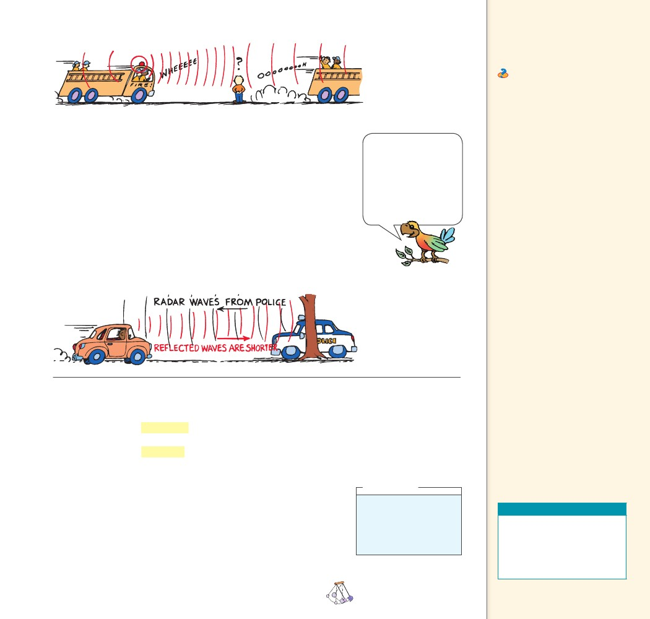
FIGURE 25.17
The pitch of sound
is higher when the
source moves toward
you, and lower when
the source moves
away.
Teaching Tip Relate the
concept of the moving bug to the
waves from the moving sources
in Figures 25.17 and 25.18.
Ask The waves are more
crowded in front of the
swimming bug and more spread
out behind. Is the wave speed
greater in front of the bug
(and less behind the bug)? No!
Frequency, not speed, is greater
in front of the bug and less
behind.
Teaching Tip Emphasize the
distinction between wave speed
and wave frequency.
Teaching Tip Swing a sound
source at the end of a string in
a horizontal circle. Relate this
to the siren of a fire engine
and the radar of the highway
patrol (Figures 25.17 and 25.18).
(Mention that sound requires a
medium; radar doesn’t.)
Teaching Tip Point out
that light, radar, TV, and radio
waves are all electromagnetic
in nature. The waves differ
only in frequency (and hence
wavelength) and energy per
photon.
Teaching Tip Relate the pitch
of sound to the color of light.
Both depend on frequency.
Sound The Doppler effect is evident when you hear the changing
pitch of a siren as a firetruck passes you. Look at Figure 25.17. When
the firetruck approaches, the pitch sounds higher than normal. This
occurs because the sound wave crests are encountering you more fre-
quently. When the firetruck passes and moves away, you hear a drop in
pitch because the wave crests are encountering you less frequently.
Police make use of the Doppler effect of radar waves in measur-
ing the speeds of cars on the highway. Radar waves are electromag-
netic waves, lower in frequency than light and higher in frequency
than radio waves. Police bounce them off moving cars as shown in
Figure 25.18. A computer built into the radar system calculates the
speed of the car relative to the radar unit by comparing the frequency
of the radar with the frequency of the reflected waves.
Bats hunt moths in
darkness by echo loca-
tion and the Doppler
effect. Some moths
are protected by a
thick covering of fuzzy
scales that deaden the
echoes.
FIGURE 25.18
The police calculate a
car’s speed by measur-
ing the Doppler effect
of radar waves.
Light The Doppler effect also occurs for light. When a light source
approaches, there is an increase in its measured frequency, and
when it recedes, there is a decrease in its frequency. An increase in
frequency is called a blue shift, because the increase is toward the
high-frequency, or blue, end of the color spectrum. A decrease in
frequency is called a red shift, referring to the low-frequency, or
red, end of the color spectrum. Distant galaxies, for example, show a
red shift in the light they emit. A measurement of this shift enables
astronomers to calculate their speeds of recession. A rapidly spinning
star shows a red shift on the side turning away from us and a blue
shift on the side turning toward us. This enables a calculation of the
star’s spin rate.
think!
When a source moves
toward you, do you
measure an increase or
decrease in wave speed?
Answer: 25.9
As a wave source
CHECK approaches, an
observer encounters waves with
a higher frequency. As the wave
source moves away, an observer
encounters waves with a
lower frequency.
CONCEPT
Teaching Resources
• Concept-Development
Practice Book 25-1
• Problem-Solving Exercises
in Physics 13-2
• Laboratory Manual 70
CHECK
......
CONCEPT How does the apparent frequency of waves change
as a wave source moves?
......
CHAPTER 25
VIBRATIONS AND WAVES
503
503

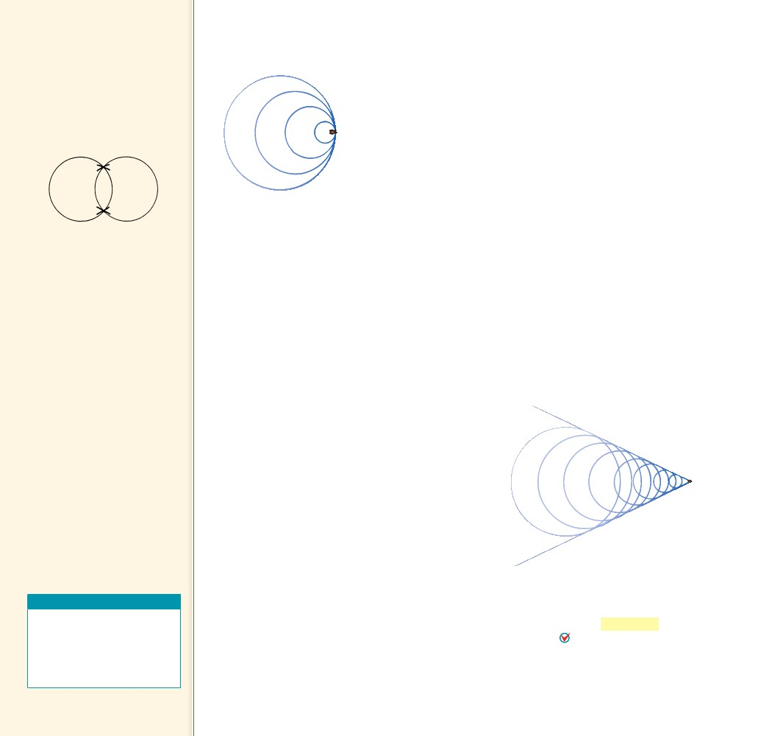
25.10 Bow Waves
Key Term
bow wave
Teaching Tip Ask the class
to consider the waves made by
two stones thrown in the water.
Sketch the overlapping waves as
shown below.
25.10 Bow Waves
When the speed of the source in a medium is as great as the speed
of the waves it produces, something interesting happens. The waves
pile up. Consider the bug in the previous example when it swims as
fast as the wave speed. Can you see that the bug will keep up with the
wave crests it produces? Instead of the crests getting ahead of the bug,
they pile up or superimpose on one another directly in front of the
bug, as suggested in Figure 25.19. The bug moves right along with the
leading edge of the waves it is producing.
The same thing happens when an aircraft travels at the speed of
sound. In the early days of jet aircraft, it was believed that this pileup
of sound waves in front of the airplane imposed a “sound barrier”
and that to go faster than the speed of sound, the plane would have
to “break the sound barrier.” What actually happens is that the
overlapping wave crests disrupt the flow of air over the wings, so that
it is harder to control the plane when it is flying close to the speed
of sound. But the barrier is not real. Just as a boat can easily travel
faster than the speed of water waves, an airplane with sufficient
power can easily travel faster than the speed of sound. Then we say
that it is supersonic—faster than sound. A supersonic airplane flies
into smooth, undisturbed air because no sound wave can propagate
out in front of it. Similarly, a bug swimming faster than the speed
of water waves finds itself always entering into water with a smooth,
unrippled surface.
FIGURE 25.19
A bug swimming at the
wave speed “keeps up”
with the wave crests it
produces.
Ask where the water is highest
above the normal water level,
and then indicate the two
places where the waves overlap
with X’s. This is constructive
interference. Extend the
swimming bug concept to speeds
greater than wave speeds and
show the regions of overlap that
produce the bow wave (sketching
Figures 25.15, 25.16, and 25.19).
Show how a series of overlaps
makes up the V-shaped envelope
shown in Figure 25.21.
Teaching Tip Explain that
the formation of the bow
wave in Figure 25.20 is another
example of constructive
interference, with an appreciable
resulting amplitude.
FIGURE 25.20
A bug swimming faster
than the wave speed
produces a wave pattern
in which the wave crests
overlap at the edges.
A bow wave occurs
CHECK when a wave source
moves faster than the waves
it produces.
CONCEPT
......
Teaching Resources
• Reading and Study
Workbook
• Transparency 53
• PresentationEXPRESS
• Interactive Textbook
When the bug swims faster than wave speed, ideally it produces
a wave pattern as shown in Figure 25.20. It outruns the wave crests
it produces. The crests overlap at the edges, and the pattern made
by these overlapping crests is a V shape, called a bow wave, which
appears to be dragging behind the bug. A bow wave occurs when
a wave source moves faster than the waves it produces. The familiar
bow wave generated by a speedboat knifing through the water is pro-
duced by the overlapping of many circular wave crests.
504
504

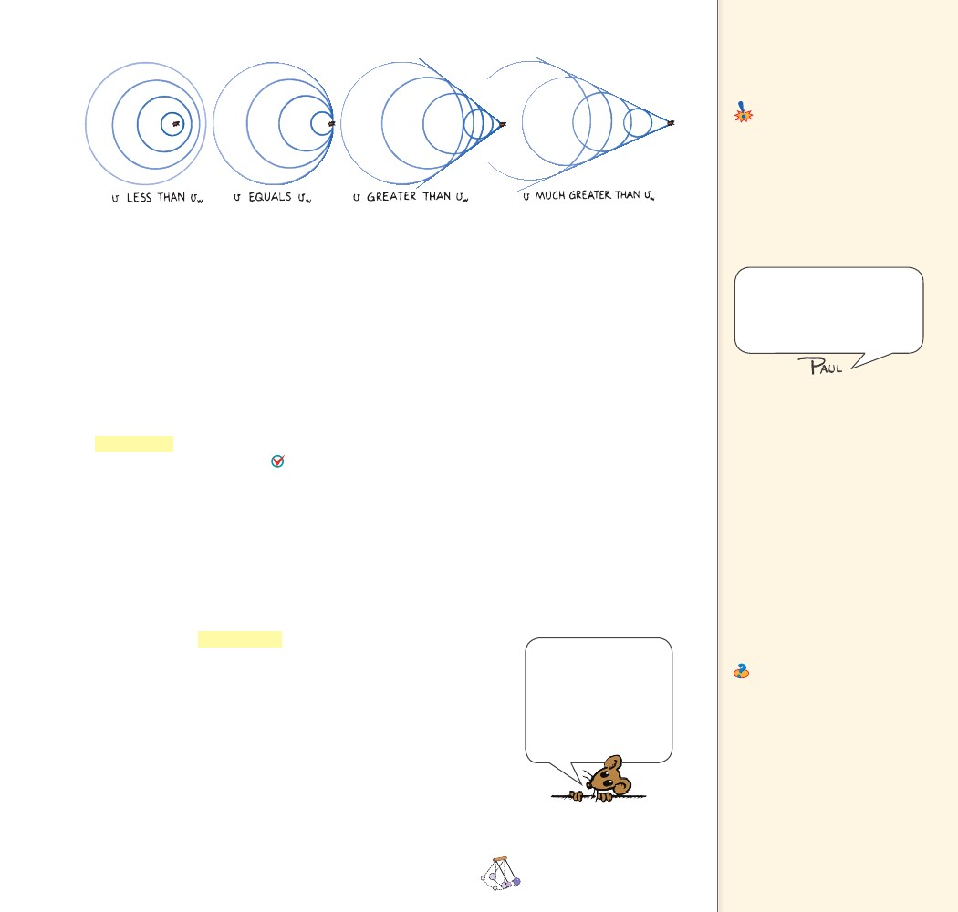
25.11 Shock Waves
Key Terms
shock wave, sonic boom
Common Misconception
A sonic boom is a momentary burst
of high pressure produced when
something exceeds the speed
of sound.
A sonic boom is actually a
continuous front of high pressure
generated by faster-than-sound
sources.
FACT
Figure 25.21 shows some wave patterns made by sources mov-
ing at various speeds. After the speed of the source exceeds the wave
speed, increased speed produces a bow wave with a narrower V shape.
CONCEPT
FIGURE 25.21
The wave patterns made
by a bug swimming at suc-
cessively greater speeds
change. Overlapping at
the edges occurs only
when the source travels
faster than wave speed.
The analogy between bow waves
in water and shock waves in
air is useful when discussing
the shock waves produced by
supersonic aircraft.
......
CHECK
What causes a bow wave?
25.11 Shock Waves
A speedboat knifing through the water generates a two-dimensional
bow wave. A supersonic aircraft similarly generates a shock wave.
A shock wave is a three-dimensional wave that consists of overlap-
ping spheres that form a cone. A shock wave occurs when an
object moves faster than the speed of sound. Just as the bow wave
of a speedboat spreads until it reaches the shore of a lake, the conical
shock wave generated by a supersonic craft spreads until it reaches
the ground, as shown in Figure 25.22.
The bow wave of a speedboat that passes by can splash and douse
you if you are at the water’s edge. In a sense, you can say that you are
hit by a “water boom.” In the same way, a conical shell of compressed
air sweeps behind a supersonic aircraft. The sharp crack heard when
the shock wave that sweeps behind a supersonic aircraft reaches the
listeners is called a sonic boom.
We don’t hear a sonic boom from a slower-than-sound, or sub-
sonic, aircraft, because the sound wave crests reach our ears one at
a time and are perceived as a continuous tone. Only when the craft
moves faster than sound do the crests overlap and encounter the lis-
tener in a single burst. The sudden increase in pressure has much the
same effect as the sudden expansion of air produced by an explosion.
Both processes direct a burst of high-pressure air to the listener. The
ear cannot distinguish between the high pressure from an explosion
and the high pressure from many overlapping wave crests.
Teaching Tip Questions
raised by students about shock
waves and the sonic boom can
be effectively answered by
substituting the example of an
aircraft in the air for the example
of a speedboat knifing through
the water. If you’re enjoying
a picnic lunch at the edge of a
river when a speedboat comes
by and drenches you, you won’t
attribute this to the idea that
the speedboat just exceeded the
speed of the water waves. You
know the boat is generating a
continuous bow wave so long
as it travels faster than waves in
water. Likewise for aircraft.
Ask Why can’t a subsonic
aircraft, no matter how loud it
may be, produce a shock wave
or sonic boom? There will be no
overlapping of spherical waves
to form a cone unless the aircraft
moves faster than the waves
it generates.
Don’t confuse super-
sonic with ultrasonic.
Supersonic has to do
with speed—faster
than sound. Ultrasonic
involves frequency—
higher than we can hear.
CHAPTER 25
VIBRATIONS AND WAVES
505
505

