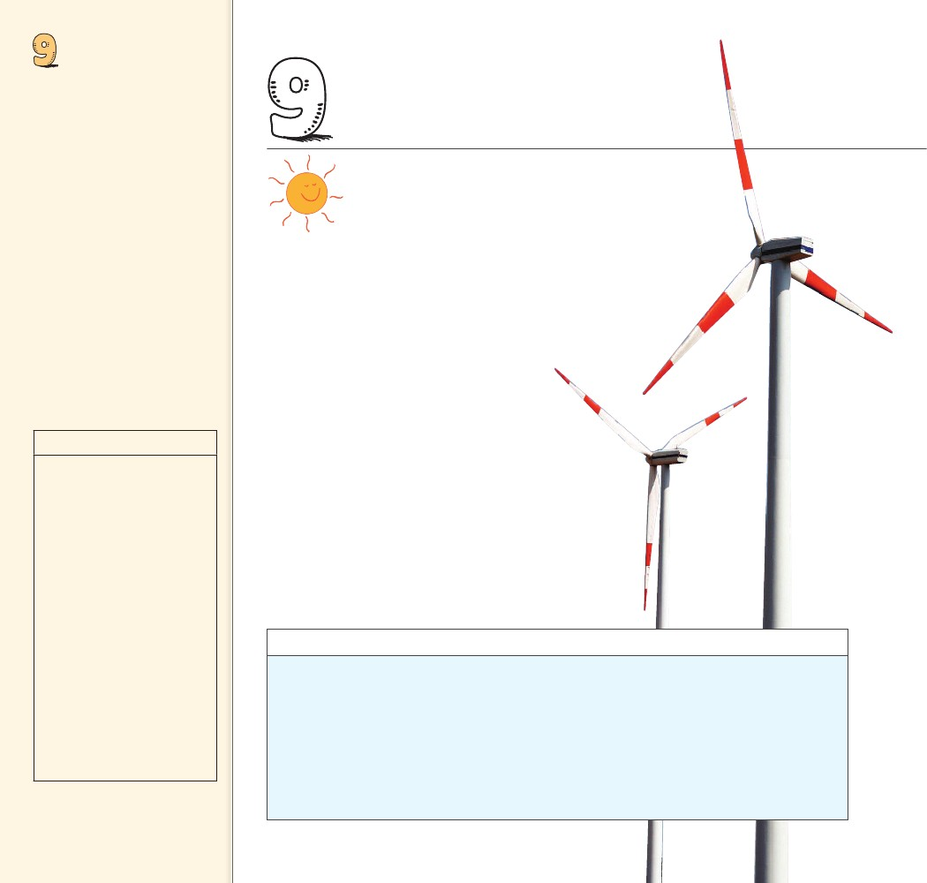
ENERGY
Objectives
• Define and describe work. (9.1)
• Define and describe power.
(9.2)
• State the two forms of
mechanical energy. (9.3)
• State three forms of potential
energy. (9.4)
• Describe how work and kinetic
energy are related. (9.5)
• State the work-energy
theorem. (9.6)
• State the law of conservation
of energy. (9.7)
• Describe how a machine uses
energy. (9.8)
• Explain why no machine can be
100% efficient. (9.9)
• Describe the role of energy in
living organisms. (9.10)
9 ENERGY
THE BIG
........
IDEA
Energy can change from one form
to another without a net loss or gain.
E
nergy is the most central concept underlying all
of science. Surprisingly, the idea of energy was
unknown to Isaac Newton, and its existence
was still being debated in the 1850s. Even though
the concept of energy is relatively new, today we
find it ingrained not only in all branches of science,
but in nearly every aspect of human
society. We are all quite familiar with
energy. Energy comes to us from the
sun in the form of sunlight, it is in the
food we eat, and it sustains life. Energy
may be the most familiar concept in science,
yet it is one of the most difficult to define.
Persons, places, and things have energy, but we observe
only the effects of energy when something is happen-
ing—only when energy is being transferred from one
place to another or transformed from one form to
another. We begin our study of energy by observing
a related concept, work.
discover!
Where Does a Popper Toy Get
Its Energy?
1. Turn a popper (slice of a hollow rubber ball)
inside out and place it on a table or floor.
Observe what happens to the popper toy.
2. Once again compress the popper and drop it
onto a table or floor. Observe what happens
to the popper.
Analyze and Conclude
1. Observing What propelled the popper into
the air?
2. Predicting Will dropping the popper from
greater heights make the popper jump
higher? Explain.
3. Making Generalizations Describe where the
popper got the energy to move upward and
downward through the air.
144
144

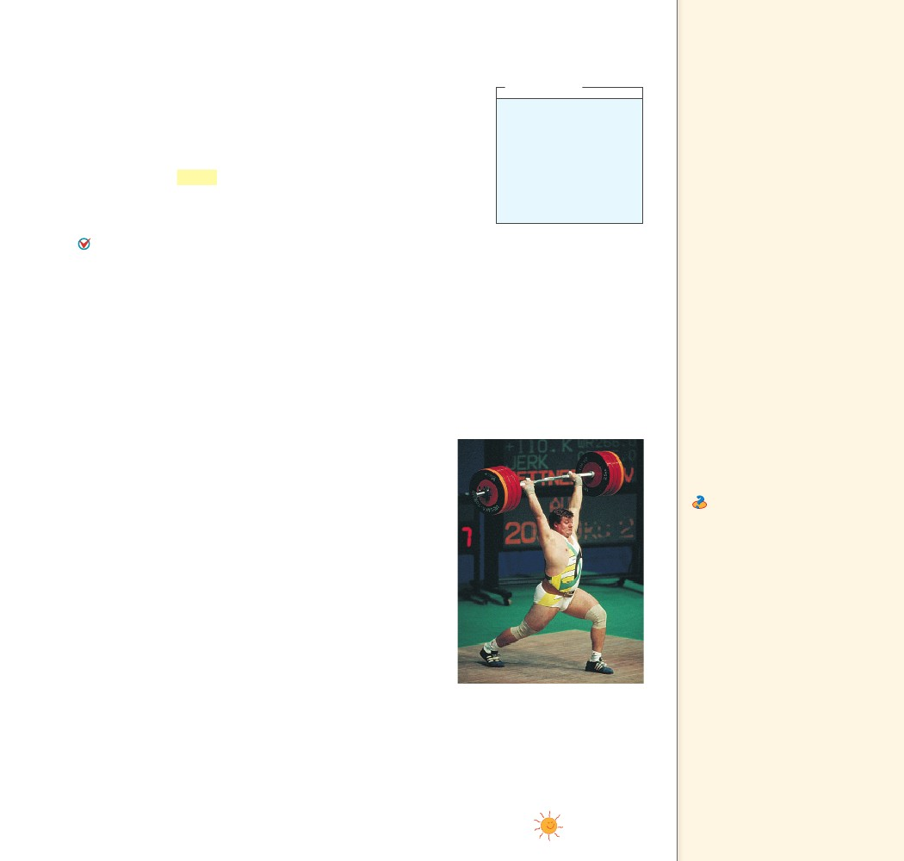
9.1 Work
9.1 Work
The previous chapter showed that the change in an object’s motion is
related to both force and how long the force acts. “How long” meant
time. Remember, the quantity force time is called impulse. But “how
long” need not always mean time. It can mean distance also. When
we consider the quantity force distance, we are talking about the
concept of work. Work is the product of the net force on an object
and the distance through which the object is moved.
We do work when we lift a load against Earth’s gravity. The
heavier the load or the higher we lift it, the more work we do.
Work is done when a force acts on an object and the object
moves in the direction of the force.
Let’s look at the simplest case, in which the force is constant and
the motion takes place in a straight line in the direction of the force.
Then the work done on an object by an applied force is the product
of the force and the distance through which the object is moved.9.1
work
In equation form,
W
Fd
net force
distance
think!
Suppose that you apply a
60-N horizontal force to
a 32-kg package, which
pushes it 4 meters across
a mailroom floor. How
much work do you do on
the package?
Answer: 9.1
Key Terms
work, joule
Teaching Tip When
describing work, specify on what
object the work is done. If you
push a wall, you do no work on
the wall unless it moves. The key
point here is that if work is done
on an object, then the energy of
that object changes.
Teaching Tip Define work
and relate it to the lifting of a
barbell, as shown in Figure 9.1.
When work is done on the
barbell, two things happen: (1) a
force is exerted on the barbell,
and (2) the barbell is moved by
that force. If the barbell is simply
held still, the weightlifter will get
tired, and feel like he is doing
work. With each contraction of
the weight lifter’s heart, a force
is exerted through a distance on
his blood and so does work on
the blood. He may well be doing
work on himself through tiny
movements in his body tissues,
but he is doing no work on the
barbell unless the force he exerts
moves the barbell.
Ask Work is done lifting a
barbell. How much more work
is done lifting a twice-as-heavy
barbell the same distance? Twice
as much How much more work
is done lifting a twice-as-heavy
barbell twice as far? Four times
as much
If we lift two loads up one story, we do twice as much work
as we would in lifting one load the same distance, because the
force needed to lift twice the weight is twice as great. Similarly,
if we lift one load two stories instead of one story, we do twice
as much work because the distance is twice as great.
Notice that the definition of work involves both a force and
a distance. The weight lifter in Figure 9.1 is holding a barbell
weighing 1000 N over his head. He may get really tired hold-
ing it, but if the barbell is not moved by the force he exerts, he
does no work on the barbell. Work may be done on the muscles
by stretching and squeezing them, which is force times distance
on a biological scale, but this work is not done on the barbell.
Lifting the barbell, however, is a different story. When the weight
lifter raises the barbell from the floor, he is doing work on it.
Work generally falls into two categories. One of these is the
work done against another force. When an archer stretches her
bowstring, she is doing work against the elastic forces of the
bow. Similarly, when the ram of a pile driver is raised, work is
required to raise the ram against the force of gravity. When you
do push-ups, you do work against your own weight. You do
work on something when you force it to move against the influ-
ence of an opposing force—often friction.
FIGURE 9.1
Work is done in lifting the barbell
but not in holding it steady. If the
barbell could be lifted twice as
high, the weight lifter would have
to do twice as much work.
CHAPTER 9
ENERGY
145
145

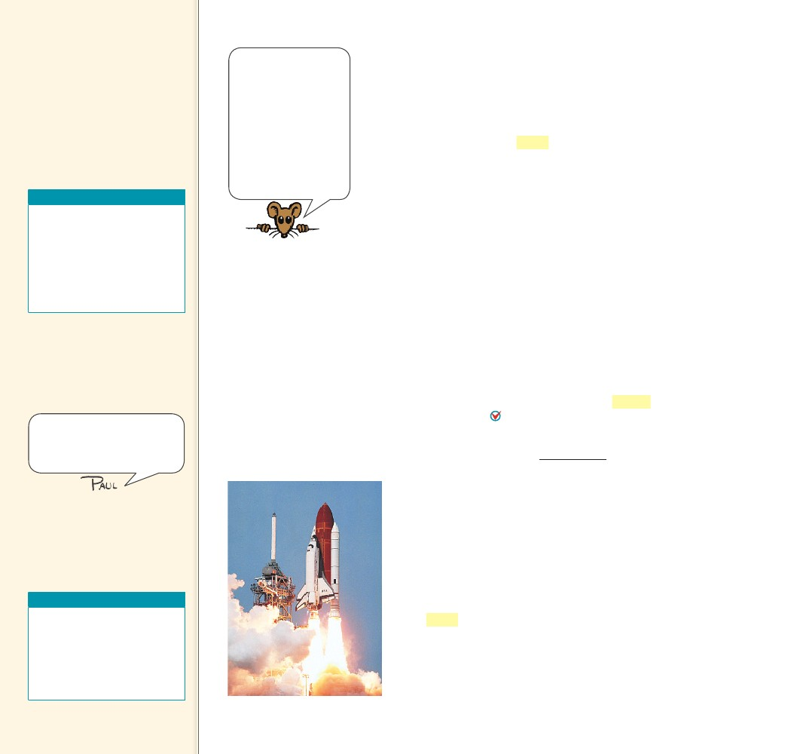
Teaching Tip Compare
work to impulse of the previous
chapter. In both concepts, a force
is exerted. For impulse, the force
is exerted over a certain time
interval; for work, it is exerted
over a certain distance.
Work is done when a
CHECK force acts on an
object and the object moves in
the direction of the force.
CONCEPT
The physics of a
weightlifter holding a
stationary barbell over-
head is no different
than the physics of a
table supporting a bar-
bell’s weight. No net
force acts on the bar-
bell, no work is done
on it, and no change in
its energy occurs.
Teaching Resources
• Reading and Study
Workbook
• PresentationEXPRESS
• Interactive Textbook
• Next-Time Question 9-1
• Conceptual Physics Alive!
DVDs Energy
The other category of work is work done to change the speed
of an object. This kind of work is done in bringing an automobile
up to speed or in slowing it down. In both categories, work involves
a transfer of energy between something and its surroundings.
The unit of measurement for work combines a unit of force, N,
with a unit of distance, m. The resulting unit of work is the newton-
meter (N·m), also called the joule (rhymes with cool) in honor
of James Joule. One joule (J) of work is done when a force of 1 N
is exerted over a distance of 1 m, as in lifting an apple over your
head. For larger values, we speak of kilojoules (kJ)—thousands of
joules—or megajoules (MJ)—millions of joules. The weight lifter
in Figure 9.1 does work on the order of kilojoules. To stop a loaded
truck going at 100 km/h takes megajoules of work.
CONCEPT
......
......
CHECK
When is work done on an object?
9.2 Power
The definition of work says nothing about how long it takes to do the
work. When carrying a load up some stairs, you do the same amount
of work whether you walk or run up the stairs. So why are you more
tired after running upstairs in a few seconds than after walking
upstairs in a few minutes? To understand this difference, we need to
talk about how fast the work is done, or power. Power is the rate
at which work is done. Power equals the amount of work done
divided by the time interval during which the work is done.
power
work done
time interval
9.2 Power
Key Terms
power, watt
FIGURE 9.2
The three main engines
of the space shuttle can
develop 33,000 MW of
power when fuel is burned
at the enormous rate of
3400 kg/s. This is like emp-
tying an average-size swim-
ming pool in 20 seconds!
Tell students that to vertically
lift a quarter-pound hamburger
with cheese 1 m in 1 s requires
one watt of power.
Power equals the
CHECK amount of work
done divided by the time interval
during which the work is done.
CONCEPT
Teaching Resources
• Reading and Study
Workbook
• Problem-Solving Exercises in
Physics 6-1
• PresentationEXPRESS
• Interactive Textbook
A high-power engine does work rapidly. An automobile
engine that delivers twice the power of another automobile
engine does not necessarily produce twice as much work or go
twice as fast as the less powerful engine. Twice the power means
the engine can do twice the work in the same amount of time
or the same amount of work in half the time. A powerful
engine can get an automobile up to a given speed in less time
than a less powerful engine can.
The unit of power is the joule per second, also known as
the watt, in honor of James Watt, the eighteenth-century
developer of the steam engine. One watt (W) of power is
expended when one joule of work is done in one second.
One kilowatt (kW) equals 1000 watts. One megawatt (MW)
equals one million watts. The space shuttle in Figure 9.2 uses
33,000 MW of power.
146
146
......

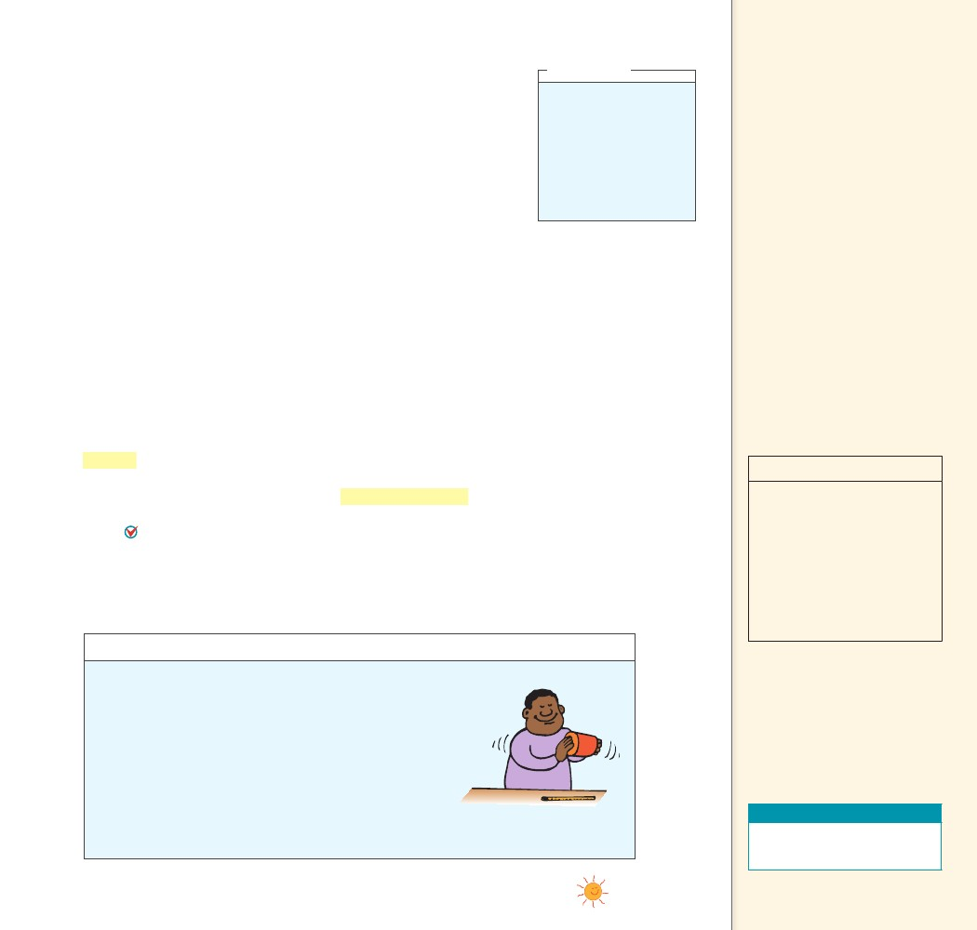
In the United States, we customarily rate engines in units of
horsepower and electricity in kilowatts, but either may be used. In the
metric system of units, automobiles are rated in kilowatts. One horse-
power (hp) is the same as 0.75 kW, so an engine rated at 134 hp is a
100-kW engine.
CONCEPT
think!
If a forklift is replaced
with a new forklift that
has twice the power, how
much greater a load can
it lift in the same amount
of time? If it lifts the same
load, how much faster can
it operate? Answer: 9.2
9.3 Mechanical
Energy
Key Terms
energy, mechanical energy
Teaching Tip Explain that
mechanical energy becomes
evident only when it changes
from one form to another, or
when there is motion.
Teaching Tip Point out that
mechanical energy is relative.
It depends on the location we
choose for our reference frame.
A 1-N apple held 1 m above the
floor has 1 J of PE, but when
held out the window 10 m above
the ground it has 10 J. The same
apple held in your lap has 0 KE,
but if your lap is on the seat of
a high-flying jet plane, it has
many joules of KE relative to
the ground below. PE and KE
are relative to a specified or an
implied frame of reference.
......
CHECK
How can you calculate power?
9.3 Mechanical Energy
When work is done by an archer in drawing back a bowstring, the
bent bow acquires the ability to do work on the arrow. When work is
done to stretch a rubber band, the rubber band acquires the ability to
do work on an object when it is released. When work is done to wind
a spring mechanism, the spring acquires the ability to do work on
various gears to run a clock, ring a bell, or sound an alarm.
In each case, something has been acquired that enables the object
to do work. It may be in the form of a compression of atoms in the
material of an object; a physical separation of attracting bodies; or
a rearrangement of electric charges in the molecules of a substance.
The property of an object or system that enables it to do work is
energy. 9.3 Like work, energy is measured in joules. It appears in
many forms that will be discussed in the following chapters. For
now we will focus on mechanical energy. Mechanical energy is the
energy due to the position of something or the movement of some-
thing. The two forms of mechanical energy are kinetic energy
and potential energy.
CONCEPT
discover!
MATERIALS
dry sand, can with
cover, thermometer
The
temperature of the sand rises
as a student shakes the can.
EXPECTED OUTCOME
THINK
......
CHECK
What are the two forms of mechanical energy?
The work that a person
does in shaking the can is
converted into the thermal
energy of the sand.
discover!
What Happens When You Do Work on Sand?
1.
2.
3.
4.
Pour a handful of dry sand into a can.
Measure the temperature of the sand with a thermometer.
Remove the thermometer and cover the can.
Shake the can vigorously for a minute or so. Now remove
the cover and measure the temperature of the sand again.
5. Describe what happened to the temperature of the sand
after you shook it.
6. Think How can you explain the change in temperature of
the sand in terms of work and energy?
The two forms of
CHECK mechanical energy
are kinetic energy and potential
energy.
CONCEPT
Teaching Resources
• Laboratory Manual 26
• Probeware Lab Manual 7
CHAPTER 9
ENERGY
......
147
147

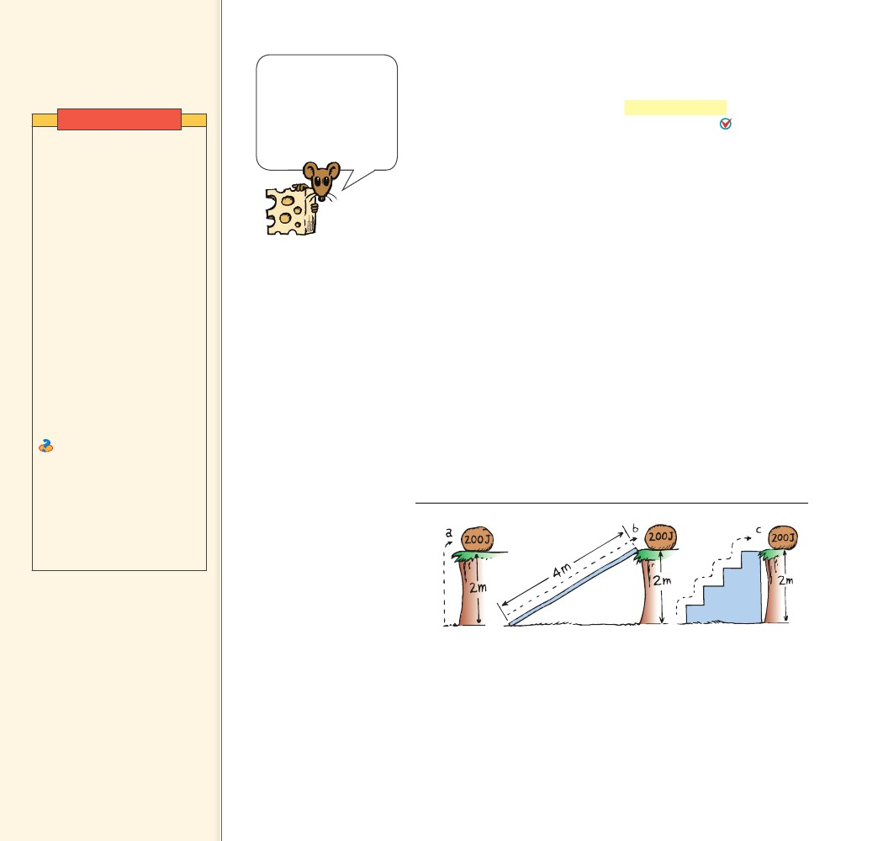
9.4 Potential Energy
Key Term
potential energy
Demonstration
Attach a spring scale to a
pendulum bob at its rest
position. Show that a small
force pulls it sideways from
its rest position. Compare this
force to the force that would
be necessary to lift it vertically
(its weight). Show that as
the bob is pulled farther up
the arc, the force required
to move it increases. This is
because it is being pulled
against gravity, which has
no vector component along
the pendulum path when
the pendulum is hanging at
its lowest point, but which
increases as the pendulum is
raised. More work is required
to move the pendulum equal
distances the farther the
pendulum is raised.
Ask Keeping the spring
scale perpendicular to the
string, predict what the force
will be if the string is pulled
through an angle of 90º and
is horizontal. The force will
be equal and opposite to the
force of gravity on the bob—
its weight.
What tells you whether
or not work is done
on something is a
change in its energy.
No change in energy
means that no net work
was done on it.
9.4 Potential Energy
An object may store energy by virtue of its position. Energy that is
stored and held in readiness is called potential energy (PE) because
in the stored state it has the potential for doing work. Three
examples of potential energy are elastic potential energy, chemical
energy, and gravitational potential energy.
Elastic Potential Energy A stretched or compressed spring, for
example, has a potential for doing work. This type of potential energy
is elastic potential energy. When a bow is drawn back, energy is stored
in the bow. The bow can do work on the arrow. A stretched rubber
band has potential energy because of its position. If the rubber band
is part of a slingshot, it is also capable of doing work.
Chemical Energy The chemical energy in fuels is also potential
energy. It is actually energy of position at the submicroscopic level.
This energy is available when the positions of electric charges within
and between molecules are altered, that is, when a chemical change
takes place. Any substance that can do work through chemical reac-
tions possesses chemical energy. Potential energy is found in fossil
fuels, electric batteries, and the food we eat.
Gravitational Potential Energy Work is required to elevate
objects against Earth’s gravity. The potential energy due to elevated
positions is gravitational potential energy. Water in an elevated
reservoir and the raised ram of a pile driver have gravitational poten-
tial energy.
Teaching Tip Discuss the
elevated boulder in Figure 9.3.
Point out that the resulting PE of
the boulder is the same in each
case.
Teaching Tip An average
apple weighs 1 N. When it is
held 1 m above the ground, then
relative to the ground it has a PE
of 1 J.
FIGURE 9.3
The potential energy of the 100-N boulder with respect
to the ground below is 200 J in each case because the
work done in elevating it 2 m is the same whether the
boulder is a. lifted with 100 N of force, b. pushed up
the 4-m incline with 50 N of force, or c. lifted with 100 N
of force up each 0.5-m stair. No work is done in moving
it horizontally, neglecting friction.
148
148

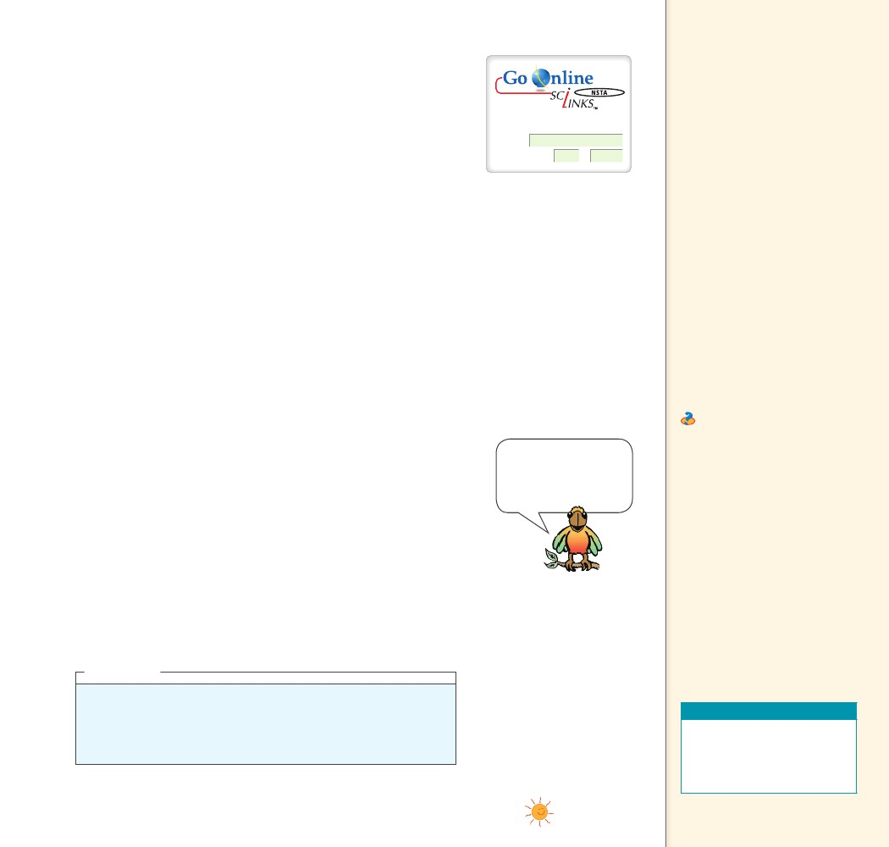
The amount of gravitational potential energy possessed by an
elevated object is equal to the work done against gravity in lifting it.
The work done equals the force required to move it upward times the
vertical distance it is moved (remember W = Fd). The upward force
required while moving at constant velocity is equal to the weight, mg,
of the object, so the work done in lifting it through a height h is the
product mgh.
gravitational potential energy
PE
mgh
weight
height
For: Links on potential energy
Visit: www.SciLinks.org
Web Code: csn – 0904
Note that the height is the distance above some arbitrarily
chosen reference level, such as the ground or the floor of a building.
The gravitational potential energy, mgh, is relative to that level and
depends only on mg and h. For example, if you’re in a third-story
classroom and a ball rests on the floor, you can say the ball is at
height 0. Lift it and it has positive PE relative to the floor. Toss it out
the window and it has negative PE relative to the floor. We can see in
Figure 9.3 that the potential energy of the boulder at the top of the
ledge does not depend on the path taken to get it there.
Hydroelectric power stations make use of gravitational potential
energy. When a need for power exists, water from an upper reservoir
flows through a long tunnel to an electric generator. Gravitational
potential energy of the water is converted to electrical energy. Most
of this energy is delivered to consumers during daylight hours. A
few power stations buy electricity at night, when there is much less
demand. They use this electricity to pump water from a lower res-
ervoir back up to the upper reservoir. This process, called pumped
storage, is practical when the cost of electricity is less at night. Then
electrical energy is transformed to gravitational potential energy.
Although the pumped storage system doesn’t generate any overall net
energy, it helps to smooth out differences between energy demand
and supply.
CONCEPT
Teaching Tip Point out that
the arc path to any elevation is
longer than the vertical path. The
computation of the work done
along the arc path is complicated
because the force continually
varies with distance. However,
the answer is also obtained by
multiplying the weight of the
bob by the vertical distance
it is raised! The work done in
elevating the bob is the same
along either path, straight up
or along the arc. Gravitational
PE depends only on weight and
height—not the path taken to
get it there.
Teaching Tip Use the
example of dropping a bowling
ball on your toe—first from a
distance of 1 mm above your toe
and then from distances up to
1 m above your toe. Each time,
the bowling ball would do more
work on your toe, because it
would possess more gravitational
PE when released.
Ask Does a car hoisted for
lubrication in a service station
have PE? Yes, any elevated
body has PE with respect to any
chosen reference level—usually
the “ground level.” How much
work will raise the car twice as
high? Twice as much How much
work is required to raise it three
times as high, and how much PE
will it have? Three times as much
of each
When h is below a
reference point, PE is
negative relative to
that reference point.
......
CHECK
Name three examples of potential energy.
think!
You lift a 100-N boulder 1 m.
a. How much work is done on the boulder?
b. What power is expended if you lift the boulder in a time of 2 s?
c. What is the gravitational potential energy of the boulder in the lifted
position? Answer: 9.4
Three examples of
CHECK potential energy are
elastic potential energy, chemical
energy, and gravitational
potential energy.
CONCEPT
Teaching Resources
• Reading and Study
Workbook
• PresentationEXPRESS
• Interactive Textbook
CHAPTER 9
ENERGY
......
149
149

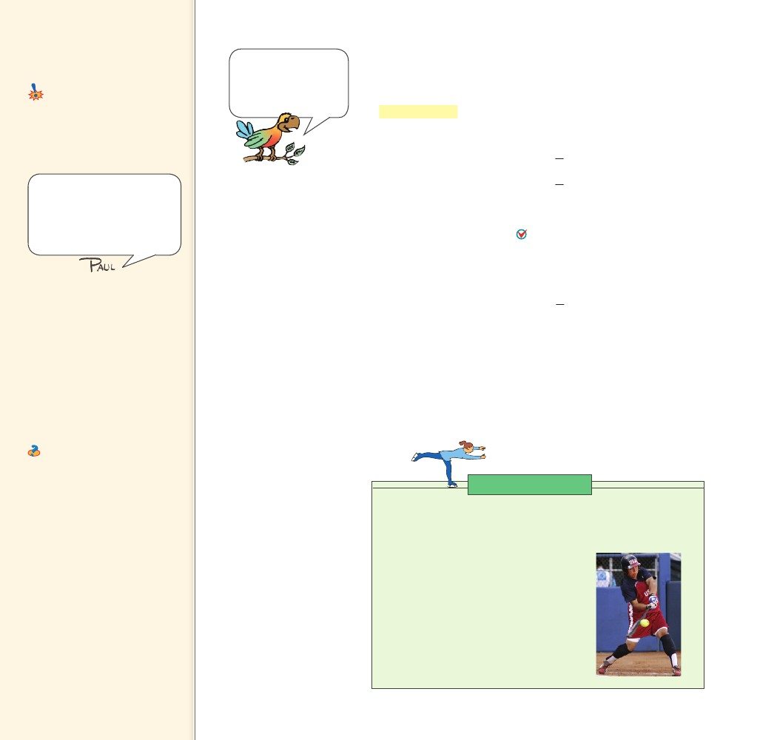
9.5 Kinetic Energy
Key Term
kinetic energy
Common Misconception
Momentum and KE are the same
concept.
FACT
Refer to Note 9.5 in
Appendix G for the
derivation of the
equation WKE .
9.5 Kinetic Energy
Push on an object and you can set it in motion. If an object is
moving, then it is capable of doing work. It has energy of motion,
or kinetic energy (KE). The kinetic energy of an object depends on
the mass of the object as well as its speed. It is equal to half the mass
multiplied by the square of the speed.
kinetic energy
1
2 mass
122 mv
Momentum is mv; KE is
1/2mv2.
speed2
Failure to distinguish between
momentum and KE gave rise to
much controversy in Europe
after the time of Newton. (The
concept of KE was developed
after Newton’s time.)
KE
When you throw a ball, you do work on it to give it speed as it
leaves your hand. The moving ball can then hit something and push
it, doing work on what it hits. The kinetic energy of a moving
object is equal to the work required to bring it to its speed from
rest, or the work the object can do while being brought to rest. 9.5
net force distancekinetic energy
Fd
122 mv
Teaching Tip Explain that a
moving body has motion energy,
or kinetic energy, and can do
work because of its motion.
Relate KE to force 3 distance.
Teaching Tip Mention that
KE comprises thermal energy
(haphazard motion of molecules),
sound (vibratory motion of
molecules), and light (emitted by
the vibratory motion of electrons
in an atom).
Ask Does a car moving along
a road have KE? Any moving
object has KE, which is a relative
quantity, as is speed. The cup
of tea you hold in a high-flying
jet has KE with respect to the
ground, but no KE with respect
to the saucer on which it sits. If
the speed of the car doubles, by
how much does the KE increase?
It’s multiplied by 4. If the speed
triples? It’s multiplied by 9.
The kinetic energy of
CHECK a moving object is
equal to the work required to
bring it to its speed from rest, or
the work the object can do while
being brought to rest.
CONCEPT
Note that the speed is squared, so if the speed of an object is
doubled, its kinetic energy is quadrupled (22 4). Consequently, it
takes four times the work to double the speed. Also, an object moving
twice as fast takes four times as much work to stop. Whenever work is
done, energy changes.
CHECK
......
CONCEPT How are work and the kinetic energy of a moving
object related?
Physics of Sports
The Sweet Spot
The sweet spot of a softball bat or a tennis racquet is the place where
the ball’s impact produces minimum vibrations in the racquet or bat.
Strike a ball at the sweet spot and it goes
faster and farther. Strike a ball in another
part of the bat or racquet, and vibrations
can occur that sting your hand! From an
energy point of view, there is energy in the
vibrations of the bat or racquet. There is
energy in the ball after being struck. Energy
that is not in vibrations is energy available to
the ball. Do you see why a ball will go faster
and farther when struck at the sweet spot?
150
......
150

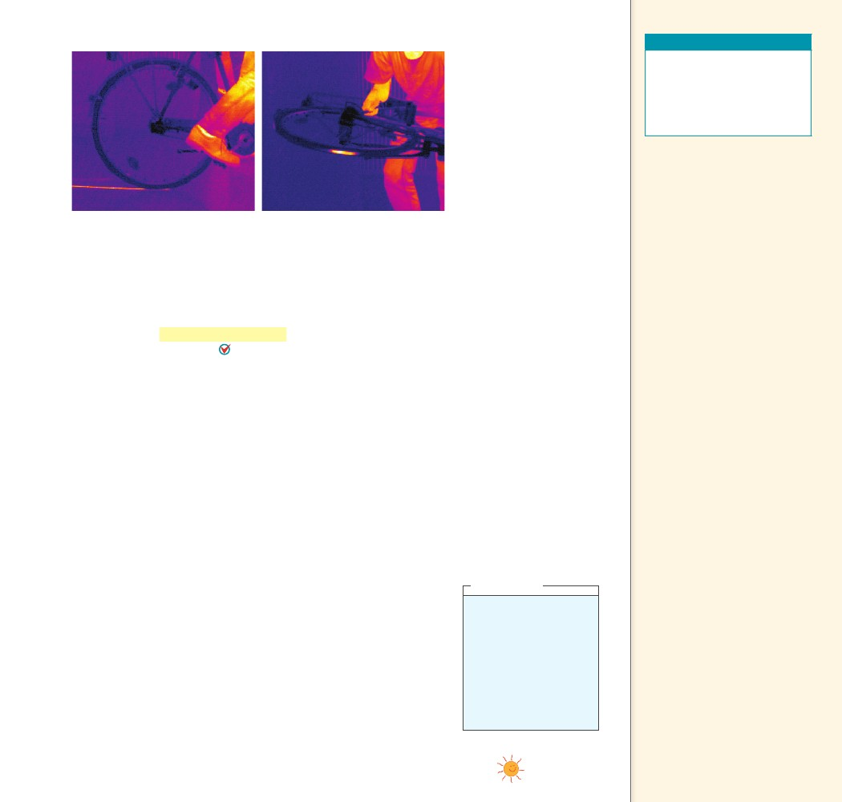
Teaching Resources
FIGURE 9.4
Due to friction, energy
is transferred both into
the floor and into the tire
when the bicycle skids to
a stop. a. An infrared cam-
era reveals the heated tire
track on the floor. b. The
warmth of the tire is also
revealed.
• Reading and Study
Workbook
• Laboratory Manual 30
• PresentationEXPRESS
• Interactive Textbook
9.6 Work-Energy
Theorem
Key Term
work-energy theorem
Teaching Tip Note the pair
of photos in Figure 9.4 that
nicely show the heat generated
by friction on a skidding bicycle
tire. How interesting it would
be to see infrared photos of the
heat generated when a couple
of cars collide. Recall that half
the KE for a collision of identical
cars goes into heat. Seeing that
via an infrared photo would be
interesting.
Teaching Tip To a close
approximation, skidding force
is independent of speed. Hence,
change in KE is approximately
equal to change in skidding
distance.
Teaching Tip Point out
that when a car’s brakes are
applied, the car’s KE is changed
into internal energy in the brake
pads, tires, and road as they all
become warmer.
a
b
9.6 Work-Energy Theorem
So we see that to increase the kinetic energy of an object, work must
be done on it. Or if an object is moving, work is required to bring it
to rest. In either case, the change in kinetic energy is equal to the net
work done. The work-energy theorem describes the relationship
The work-energy theorem states thatbetween work and energy.
whenever work is done, energy changes. We abbreviate “change in”
with the delta symbol, , and say
Work
KE
Work equals change in kinetic energy. The work in this equation is the
net work—that is, the work based on the net force.
The work-energy theorem emphasizes the role of change. If there
is no change in an object’s kinetic energy, then we know no net work
was done on it. Push against a box on a floor. If it doesn’t slide, then
you are not doing work on the box. Put the box on a very slippery
floor and push again. If there is no friction at all, the work of your
push times the distance of your push appears as kinetic energy of the
box. If there is some friction, it is the net force of your push minus
the frictional force that is multiplied by distance to give the gain in
kinetic energy. If the box moves at a constant speed, you are pushing
just hard enough to overcome friction. Then the net force and net
work are zero, and, according to the work-energy theorem, KE = 0.
The kinetic energy doesn’t change.
The work-energy theorem applies to decreasing speed as well.
The more kinetic energy something has, the more work is required
to stop it. Twice as much kinetic energy means twice as much work.
When we apply the brakes to slow a car, or the bike in Figure 9.4, we
do work on it. This work is the friction force supplied by the brakes
multiplied by the distance over which the friction force acts.
think!
A friend says that if you
do 100 J of work on a
moving cart, the cart
will gain 100 J of KE.
Another friend says this
depends on whether or
not there is friction. What
is your opinion of these
statements? Answer: 9.6.1
Teaching Tidbit The work-
energy theorem can be further
stated as DE 5 W 1 Q, where Q
is the energy transfer due to a
temperature difference.
CHAPTER 9
ENERGY
151
151

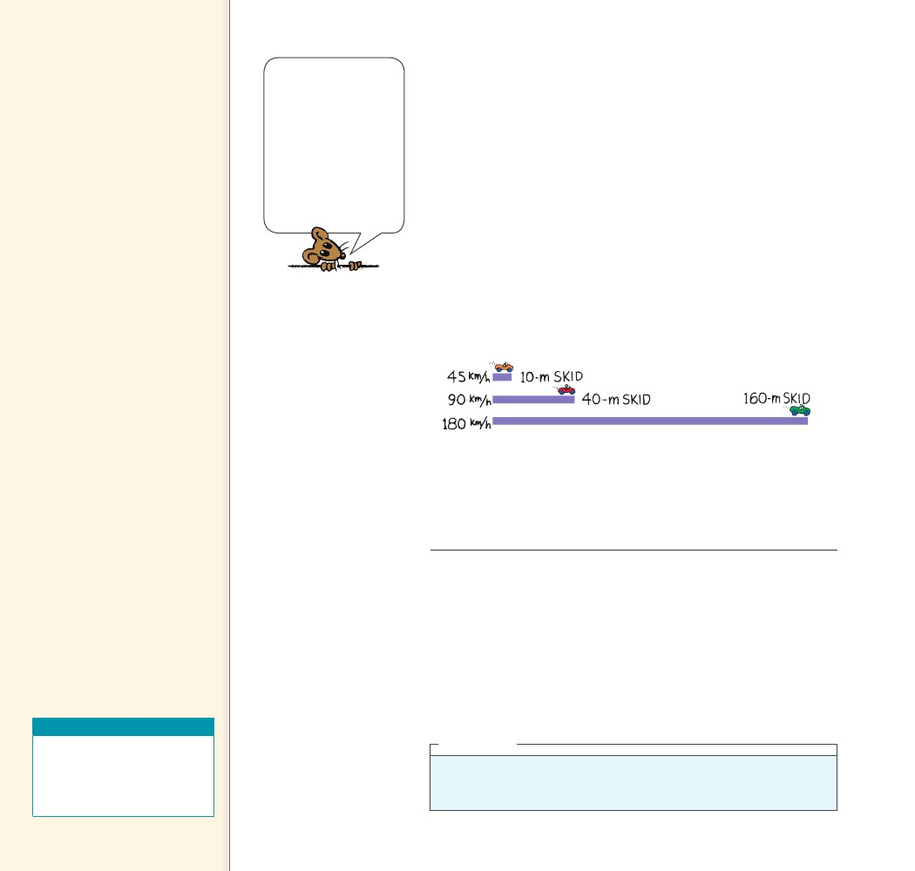
Teaching Tip Revisit the
demonstration on page 131 and
ask why lifting and dropping two
balls doesn’t result in one ball
popping out at twice the speed.
If that were to occur, momentum
would be conserved (2mv 5
m2v). But this doesn’t occur
because the KE of the twice-
as-fast ball would exceed (be
twice) the KE of the two incident
balls! [1/2 (2mv2) ? 1/2m(2v)2,
a conservation of energy no
no!] This is a stumper for most
students.
Automobile brakes
convert KE to heat.
Professional drivers are
familiar with another
way to brake—shift to
low gear and let the
engine slow the vehicle.
Hybrid cars similarly
divert braking energy
to stored energy in
batteries.
Interestingly, the maximum friction that the brakes can supply is
nearly the same whether the car moves slowly or quickly. In a panic
stop with antilock brakes, the only way for the brakes to do more
work is to act over a longer distance. A car moving at twice the speed
of another has four times (22 4) as much kinetic energy, and will
require four times as much work to stop. Since the frictional force is
nearly the same for both cars, the faster one takes four times as much
distance to stop. The same rule applies to older-model brakes that can
lock the wheels. The force of friction on a skidding tire is also nearly
independent of speed. So, as accident investigators are well aware, an
automobile going 100 kilometers per hour, with four times the kinetic
energy it would have at 50 kilometers per hour, skids four times as far
with its wheels locked as it would with a speed of 50 kilometers per
hour. Figure 9.5 shows the skid distances for a car moving at 45 km/h,
90 km/h, and 180 km/h. The distances would be even greater if the
driver’s reaction time were taken into account. Kinetic energy depends
on speed squared.
FIGURE 9.5
Typical stopping distances for cars
equipped with antilock brakes traveling
at various speeds. The work done to
stop the car is friction force distance
of slide.
CONCEPT
......
The work-energy
CHECK theorem states that
whenever work is done, energy
changes.
CONCEPT
Kinetic energy often appears hidden in different forms of energy,
such as heat, sound, light, and electricity. Random molecular motion
is sensed as heat. Sound consists of molecules vibrating in rhythmic
patterns. Even light energy originates in the motion of electrons
within atoms. Electrons in motion make electric currents. We see that
kinetic energy plays a role in other energy forms.
......
CHECK
Teaching Resources
• Reading and Study
Workbook
• PresentationEXPRESS
• Interactive Textbook
What is the work-energy theorem?
think!
When the brakes of a car are locked, the car skids to a stop. How much farther
will the car skid if it’s moving 3 times as fast?
Answer: 9.6.2
152
152

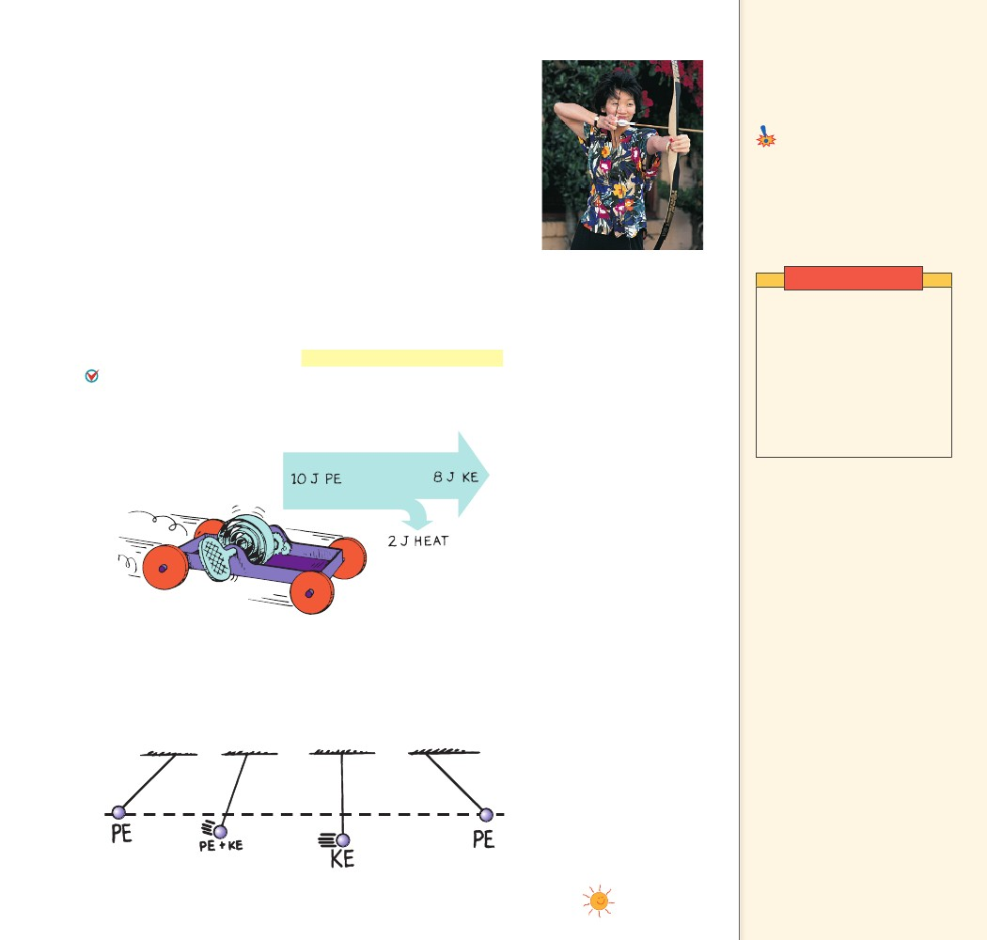
9.7 Conservation
9.7 Conservation of Energy
More important than knowing what energy is, is understanding how
it behaves—how it transforms. We can understand nearly every pro-
cess that occurs in nature if we analyze it in terms of a transforma-
tion of energy from one form to another.
As you draw back the arrow in a bow, as shown in Figure 9.6,
you do work stretching the bow. The bow then has potential energy.
When released, the arrow has kinetic energy equal to this potential
energy. It delivers this energy to its target. The small distance the
arrow moves multiplied by the average force of impact doesn’t quite
match the kinetic energy of the target. But if you investigate further,
you’ll find that both the arrow and target are a bit warmer. By how
much? By the energy difference. Energy changes from one form to
another without a net loss or a net gain.
The study of the various forms of energy and the transformations
from one form into another is the law of conservation of energy.
The law of conservation of energy states that energy cannot be
created or destroyed. It can be transformed from one form into
another, but the total amount of energy never changes.
of Energy
Key Term
law of conservation of energy
Common Misconception
Energy is conserved only under
certain conditions.
When energy changes from
one form to another, it always
transforms without net loss or
gain.
FACT
FIGURE 9.6
When released, potential
energy will become the
kinetic energy of the arrow.
Demonstration
Attach a small weight to
the end of a 1-m length of
string. Swing the pendulum
to and fro, and describe the
transformations from PE to
KE to PE. Discuss the role
of friction in damping the
pendulum motion (and the
subsequent warming of the
room!).
FIGURE 9.7
Part of the PE of the wound
spring changes into KE.
The remaining PE goes into
heating the machinery and
the surroundings due to fric-
tion. No energy is lost.
Teaching Tip Tell students
that when gasoline combines
with oxygen in a car’s engine, the
chemical potential energy stored
in the fuel is converted mainly
into molecular KE, or thermal
energy. Some of this energy is
transferred to the piston and
some of this energy in turn causes
motion of the car.
Teaching Tip Tell students
that when you rub two sticks
together to start a fire, you
transform mechanical energy into
heat. When you do work to wind
up a spring in a toy cart, you
give it PE which then transforms
to KE when the cart speeds up
on the floor. When the speed
becomes constant, continued
transformation of PE does work
against friction and produces
heat. (Without friction, KE
would keep increasing with
decreasing PE.)
Figures 9.7 and 9.8 demonstrate conservation of energy in two dif-
ferent systems. When you consider any system in its entirety, whether
it is as simple as the swinging pendulum or as complex as an explod-
ing galaxy, there is one quantity that does not change: energy. Energy
may change form, but the total energy score stays the same.
FIGURE 9.8
Everywhere along the path
of the pendulum bob, the
sum of PE and KE is the
same. Because of the work
done against friction, this
energy will eventually be
transformed into heat.
CHAPTER 9
ENERGY
153
153

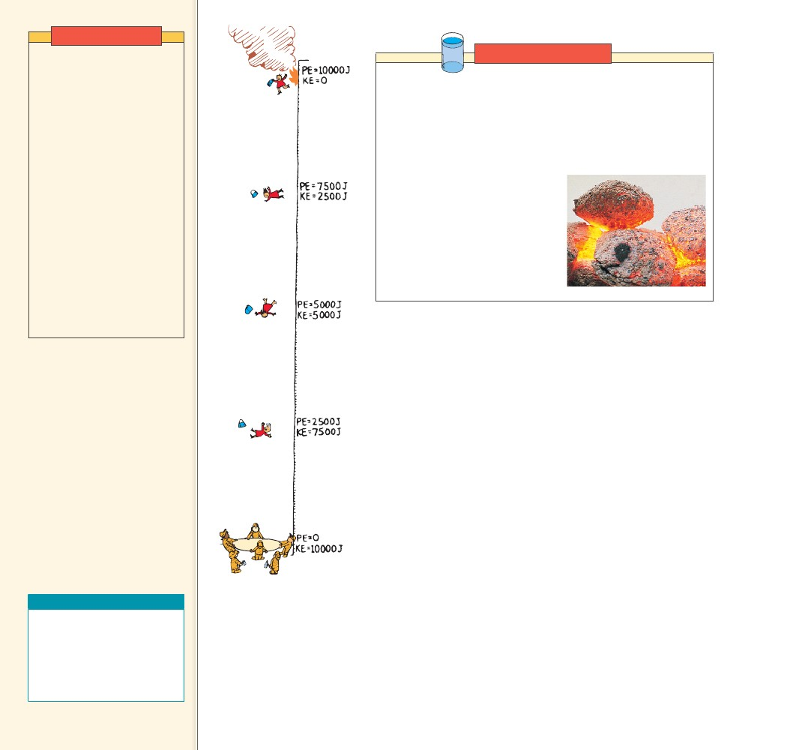
Demonstrations
Make a long pendulum that
extends from the ceiling 2 or
3 m away from a wall. Stand
on a chair against the wall
with the extended heavy
pendulum bob held at the tip
of your nose, or against your
teeth. Release the bob and let
it swing out, and then back
to your face. Don’t flinch.
Comment on your confidence
in one of the most central
of the physical laws—the
conservation of energy.
Preview electricity and
magnetism and bring out
the hand-cranked horseshoe-
magnet generator that lights
up a lamp. Have student
volunteers note that more
work is needed to turn the
crank when the lamp is
connected than when it is not.
Link to CHEMISTRY
Reactions What process provides energy for rockets that lift the
space shuttle into orbit? What process releases energy from the food
we eat? The answer is chemical reactions. During a chemical reaction
the bonds between atoms break and then reform. Breaking bonds
requires energy, and forming bonds releases it. Pulling atoms apart
is like pulling apart two magnets stuck together; it takes energy to
do it. And when atoms join, it is like two separated magnets that slam
together; energy is released. Rapid
energy release can produce flames.
Slow energy release occurs during
the digestion of food. The conser-
vation of energy rules chemical
reactions. The amount of energy
required to break a chemical bond
is the same amount released when
that bond is formed.
The law of
CHECK conservation of
energy states that energy cannot
be created or destroyed. It can be
transformed from one form into
another, but the total amount of
energy never changes.
CONCEPT
Teaching Resources
• Concept-Development
Practice Book 9-1
• Problem-Solving Exercises in
Physics 6-2
• Laboratory Manual 28, 29, 32
• Next-Time Questions 9-2, 9-3
FIGURE 9.9
When the woman in dis-
tress leaps from the burning
building, note that the sum
of her PE and KE remains
constant at each successive
position all the way down to
the ground.
This energy score takes into account the fact that each atom that
makes up matter is a concentrated bundle of energy. When the nuclei
(cores) of atoms rearrange themselves, enormous amounts of energy
can be released. The sun shines because some of its nuclear energy is
transformed into radiant energy. In nuclear reactors, nuclear energy
is transformed into heat.
Enormous compression due to gravity in the deep hot interior
of the sun causes hydrogen nuclei to fuse and become helium nuclei.
This high-temperature welding of atomic nuclei is called thermo-
nuclear fusion and will be covered later, in Chapter 40. This process
releases radiant energy, some of which reaches Earth. Part of this
energy falls on plants, and some of the plants later become coal.
Another part supports life in the food chain that begins with micro-
scopic marine animals and plants, and later gets stored in oil. Part
of the sun’s energy is used to evaporate water from the ocean. Some
water returns to Earth as rain that is trapped behind a dam. By virtue
of its elevated position, the water behind the dam has potential energy
that is used to power a generating plant below the dam. The generat-
ing plant transforms the energy of falling water into electrical energy.
Electrical energy travels through wires to homes where it is used for
lighting, heating, cooking, and operating electric toothbrushes. How
nice that energy is transformed from one form to another!
CONCEPT
......
......
CHECK
What does the law of conservation of energy state?
154
154

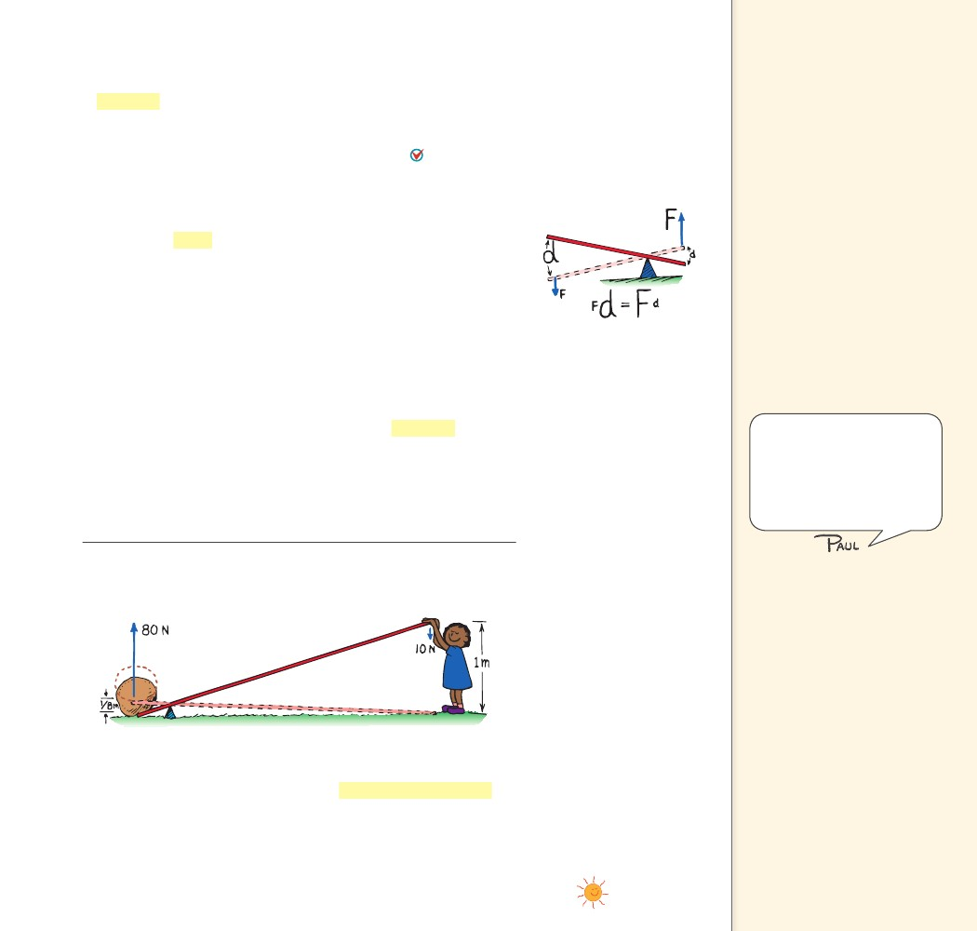
9.8 Machines
9.8 Machines
A machine is a device used to multiply forces or simply to change
the direction of forces. The concept that underlies every machine is
the conservation of energy. A machine cannot put out more energy
A machinethan is put into it. A machine cannot create energy.
transfers energy from one place to another or transforms it from
one form to another.
Levers Consider one of the simplest machines, the lever, shown in
Figure 9.10. A lever is a simple machine made of a bar that turns
about a fixed point. At the same time we do work on one end of the
lever, the other end does work on the load. We see that the direction
of force is changed. If we push down, the load is lifted up. If the heat
from friction is small enough to neglect, the work input will be equal
to the work output.
FIGURE 9.10
In the lever, the work
(force distance)
done at one end is
equal to the work
done on the load at
the other end.
Key Terms
machine, lever, fulcrum,
mechanical advantage, pulley
Teaching Tip Apply energy
conservation to the lever
(Figure 9.10). [Be careful not
to confuse the distances moved
with the lever-arm distances of
torque (Chapter 11)—Fd here
refers to the force multiplied by
the distance the “force moves”
(parallel to the force), whereas
in the case of torque, d refers
to the leverage distance that
is perpendicular to the applied
force.] Show how varying the
position of the fulcrum changes
the relative values of output
force and distance moved. Stress
that this is in accord with the rule
“work input 5 work output.”
Good resource material is found
at the beginning of Chapter 4
in the first volume of The
Feynman Lectures on Physics.
Feynman compares the idea of
energy conservation with a
child’s misplaced blocks.
work input
(force
distance)input
work output
(force
distance)output
Since work equals force times distance, we can say
A little thought will show that the pivot point, or fulcrum, of the
lever can be relatively close to the load. Then a small input force
exerted through a large distance will produce a large output force
over a correspondingly short distance. In this way, a lever can multi-
ply forces. However, no machine can multiply work or energy. That’s
a conservation of energy no-no!
FIGURE 9.11
The output force (80 N) is eight times
the input force (10 N), while the output
distance (1/8 m) is one-eighth of the
input distance (1 m).
Consider the ideal weightless lever in Figure 9.11. The child
pushes down 10 N and lifts an 80-N load. The ratio of output force
to input force for a machine is called the mechanical advantage.
Here the mechanical advantage is (80 N)/(10 N), or 8. Notice that the
load moves only one-eighth of the distance the input force moves.
Neglecting friction, the mechanical advantage can also be determined
by the ratio of input distance to output distance.
CHAPTER 9
ENERGY
155
155

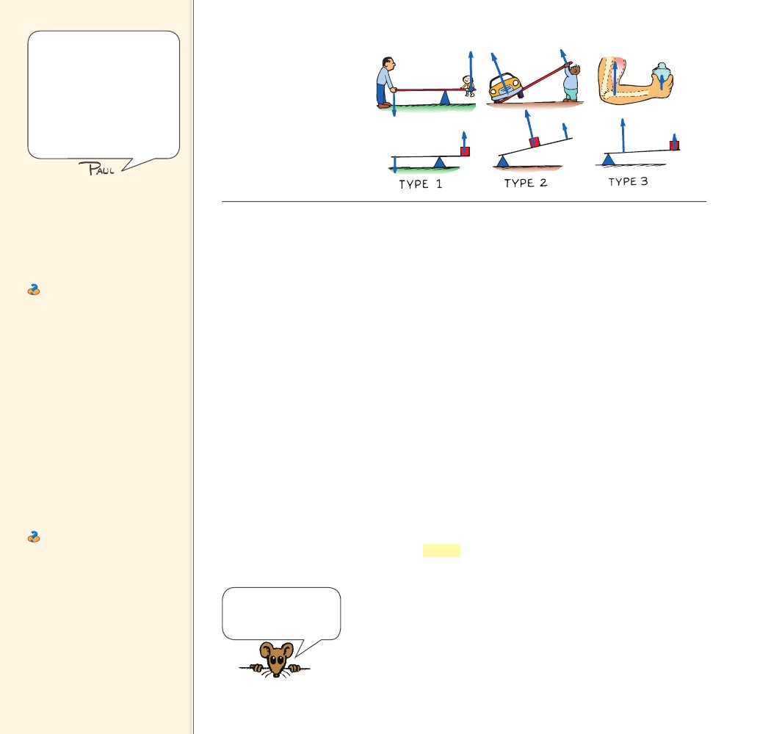
A perpetual-motion machine (a
device that can do work without
energy input) is a no no. But
perpetual motion itself, is a yes
yes. Atoms and their electrons,
and stars and their planets,
for example, are in a state of
perpetual motion. Perpetual
motion is the natural order of
things.
FIGURE 9.12
The three basic types of levers
are shown here. Notice that
the direction of the force is
changed in type 1.
Teaching Tip Acknowledge
the three different types of levers
shown in Figure 9.12, without
overstating the distinction
between the three types. Stress
the relationship fD 5 Fd, energy
conservation.
Ask Archimedes, the most
famous scientist in ancient
Greece, stated that given a long-
enough lever and a place to
stand, he could move the world.
What does this mean? In accord
with the lever equation fD 5 Fd,
a force as great as the weight of
the world could be lifted with
the force he could muster—as
long as there was a place for
him to stand and a place for the
fulcrum!
Teaching Tip Give some
other examples of levers:
Type 1: crowbar opening a
window
Type 2: a hand bottle cap
opener
Type 3: a construction crane
Ask In which type of lever is
work output greater than work
input? NONE! In no system can
work output exceed work input!
Be clear about the difference
between work and force.
Three common ways to set up a lever are shown in Figure 9.12.
A type 1 lever has the fulcrum between the force and the load, or
between input and output. This kind of lever is commonly seen in a
playground seesaw with children sitting on each end of it. Push down
on one end and you lift a load at the other. You can increase force at
the expense of distance. Note that the directions of input and output
are opposite.
For a type 2 lever, the load is between the fulcrum and the input
force. To lift a load, you lift the end of the lever. One example is plac-
ing one end of a long steel bar under an automobile frame and lift-
ing on the free end to raise the automobile. Again, force on the load
is increased at the expense of distance. Since the input and output
forces are on the same side of the fulcrum, the forces have the same
direction.
In the type 3 lever, the fulcrum is at one end and the load is at the
other. The input force is applied between them. Your biceps muscles
are connected to the bones in your forearm in this way. The fulcrum
is your elbow and the load is in your hand. The type 3 lever increases
distance at the expense of force. When you move your biceps muscles
a short distance, your hand moves a much greater distance. The input
and output forces are on the same side of the fulcrum and therefore
they have the same direction.
Pulleys A pulley is basically a kind of lever that can be used to
change the direction of a force. Properly used, a pulley or system of
pulleys can multiply forces.
The single pulley in Figure 9.13a behaves like a type 1 lever. The
axis of the pulley acts as the fulcrum, and both lever distances (the
radius of the pulley) are equal so the pulley does not multiply force.
It simply changes the direction of the applied force. In this case, the
mechanical advantage equals 1. Notice that the input distance equals
the output distance the load moves.
A machine can multiply
force, but never energy.
No way!
156
156

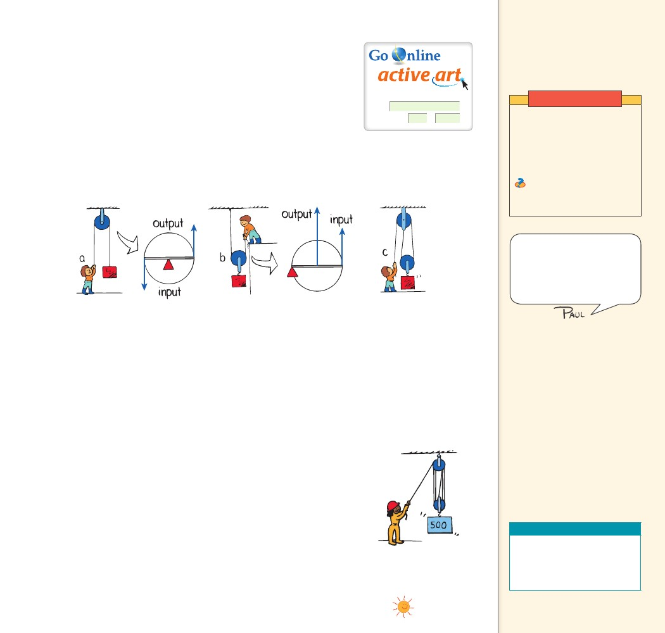
In Figure 9.13b, the single pulley acts as a type 2 lever. Careful
thought will show that the fulcrum is at the left end of the “lever”
where the supporting rope makes contact with the pulley. The load
is suspended halfway between the fulcrum and the input end of the
lever, which is on the right end of the “lever.” Each newton of input
will support two newtons of load, so the mechanical advantage is 2.
This number checks with the distances moved. To raise the load
1 m, the woman will have to pull the rope up 2 m. We can say the
mechanical advantage is 2 for another reason: the load is now sup-
ported by two strands of rope. This means each strand supports half
the load. The force the woman applies to support the load is there-
fore only half of the weight of the load.
Teaching Tip Explain that
a pulley is simply a lever in
disguise, as shown in Figure 9.13.
Show also that for a pulley,
fD 5 Fd.
For: Pulley activity
Visit: PHSchool.com
Web Code: csp – 1097
Demonstration
Use a spring scale and model
pulleys to show the pulley
arrangements in Figure 9.13.
The spring scale will show
the relative forces needed to
support the same load.
Ask In which pulley
arrangement can work output
exceed work input? NONE!
Cite the cases of charlatans
who devise complicated
arrangements of levers, pulleys,
and other gadgets to design a
machine that will have a greater
work output than work input.
The mechanical advantage for simple pulley systems is the same
as the number of strands of rope that actually support the load. In
Figure 9.13a, the load is supported by one strand and the mechanical
advantage is 1. In Figure 9.13b, the load is supported by two strands
and the mechanical advantage is 2. Can you use this rule to state the
mechanical advantage of the pulley system in Figure 9.13c?9.8
The mechanical advantage of the simple system in Figure 9.13c
is 2. Notice that although three strands of rope are shown, only two
strands actually support the load. The upper pulley serves only to
change the direction of the force. Actually experimenting with a
variety of pulley systems is much more beneficial than reading about
them in a textbook, so try to get your hands on some pulleys, in or
out of class. They’re fun.
The pulley system shown in Figure 9.14 is a bit more complex, but
the principles of energy conservation are the same. When the rope
is pulled 5 m with a force of 100 N, a 500-N load is lifted 1 m. The
mechanical advantage is (500 N)/(100 N), or 5. Force is multiplied at
the expense of distance. The mechanical advantage can also be found
from the ratio of distances: (input distance)/(output distance) 5.
CONCEPT
FIGURE 9.13
A pulley is useful.
a. A pulley can change
the direction of a force.
b. A pulley multiplies
force. c. Two pulleys can
change the direction and
multiply force.
Teaching Tip Some of your
students may have seen a chain
hoist being used to remove an
automobile engine from a car.
If so, they’ll have noticed that
the mechanic must pull meters
of chain to lift the engine only a
few centimeters.
A machine transfers
CHECK energy from one
place to another or transforms it
from one form to another.
CONCEPT
Teaching Resources
......
FIGURE 9.14
• Concept-Development
Practice Book 9-2, 9-3
• Transparencies 13, 14
• Laboratory Manual 27
CHECK
How does a machine use energy?
A complex pulley system is
shown here.
......
CHAPTER 9
ENERGY
157
157

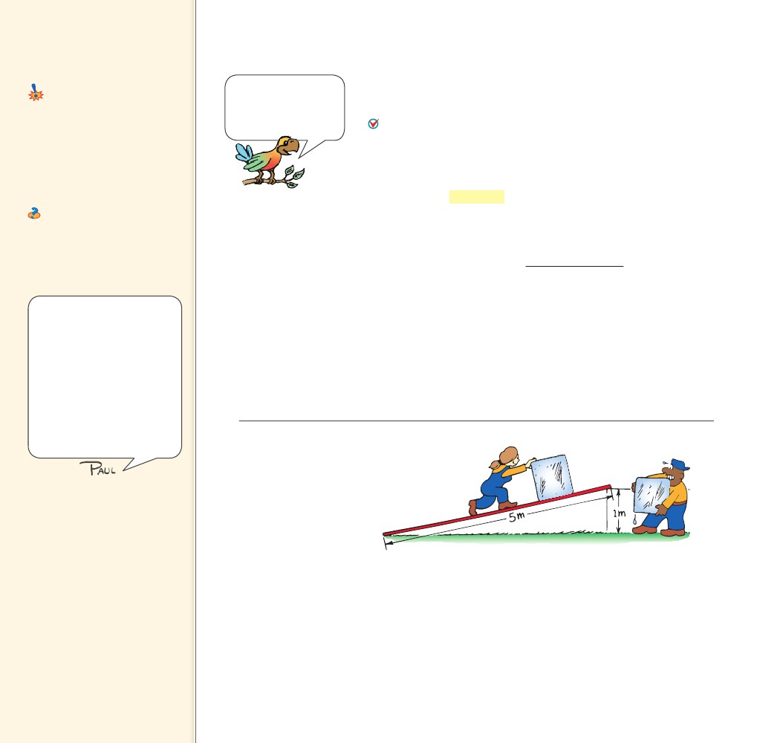
9.9 Efficiency
Key Term
efficiency
Common Misconceptions
It is possible to get more energy out
of a machine than is put in.
In practice, some energy is
always dissipated as heat and so
no machine can ever be 100%
efficient, and certainly cannot
generate more energy than is put
into it.
FACT
9.9 Efficiency
When it comes to
energy, you can never
get something for
nothing.
Ask What does it mean to
say a certain machine is 30%
efficient? It means the machine
will convert 30% of the energy
input to useful work—70% of the
energy input will be wasted.
The previous examples of machines were considered to be ideal. All
the work input was transferred to work output. An ideal machine
would have 100% efficiency. No real machine can be 100% efficient.
In any machine, some energy is transformed into atomic or
molecular kinetic energy—making the machine warmer. We say
this wasted energy is dissipated as heat.9.9.1
When a simple lever rocks about its fulcrum, or a pulley turns
about its axis, a small fraction of input energy is converted into ther-
mal energy. The efficiency of a machine is the ratio of useful energy
output to total energy input, or the percentage of the work input that
is converted to work output. Efficiency can be expressed as the ratio
of useful work output to total work input.
efficiency
useful work output
total work input
It should be enough that
your students are acquainted
with the ideas of efficiency
and actual and theoretical
mechanical advantage. It is
easy to let the plow blade sink
deeper in this section, and
turn this chapter toward the
burdensome side of study. I
therefore recommend this
section be treated lightly, and
not used as primary examination
fodder.
We may put in 100 J of work on a lever and get out 98 J of work.
The lever is then 98% efficient and we lose only 2 J of work input as
heat. In a pulley system, a larger fraction of input energy is lost as
heat. For example, if we do 100 J of work, the friction on the pulleys
as they turn and rub on their axle can dissipate 40 J of heat energy.
So the work output is only 60 J and the pulley system has an effi-
ciency of 60%. The lower the efficiency of a machine, the greater is
the amount of energy wasted as heat.
FIGURE 9.15
Pushing the block of ice
5 times farther up the
incline than the vertical
distance it’s lifted requires
a force of only one-fifth its
weight. Whether pushed up
the plane or simply lifted,
the ice gains the same
amount of PE.
Teaching Tip Discuss
Figure 9.15. As the load is
pushed, the load pushes on
molecules of the ramp (due to
friction), causing them to move
too. So some of the work done is
lost to the ramp through friction.
Inclined Planes An inclined plane is a machine. Sliding a load up
an incline requires less force than lifting it vertically. Figure 9.15 shows
a 5-m inclined plane with its high end elevated by 1 m. Using the
plane to elevate a heavy load, we push the load five times farther than
we lift it vertically. If friction is negligible, we need apply only one-
fifth of the force required to lift the load vertically. The inclined plane
shown has a theoretical mechanical advantage of 5.
158
158

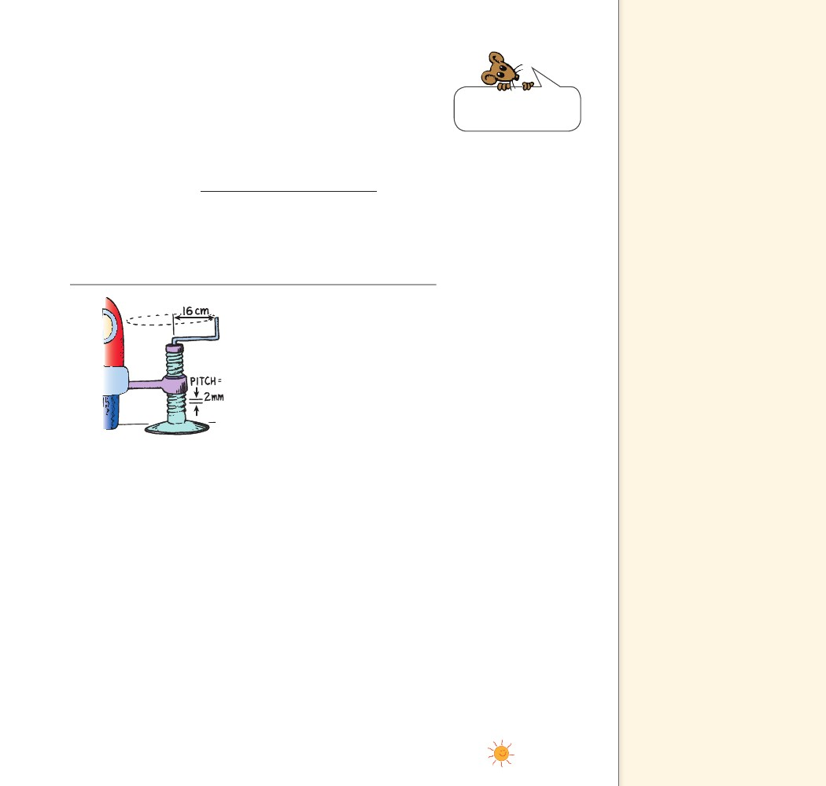
An icy plank used to slide a block of ice up to some height might
have an efficiency of almost 100%. However, when the load is a
wooden crate sliding on a wooden plank, both the actual mechanical
advantage and the efficiency will be considerably less. Friction will
require you to exert more force (a greater work input) without any
increase in work output.
Efficiency can also be expressed as the ratio of actual mechanical
advantage to theoretical mechanical advantage.
efficiency
actual mechanical advantage
theoretical mechanical advantage
Energy is nature’s way
of keeping score.
Efficiency will always be a fraction less than 1. To convert effi-
ciency to percent, we simply express it as a decimal and multiply
by 100%. For example, an efficiency of 0.25 expressed in percent is
0.25 100%, or 25%.
Teaching Tip The efficiency
of a light bulb underscores the
idea of useful energy. To say
an incandescent lamp is 10%
efficient is to say that only 10%
of the energy input is converted
to the useful form of energy,
light. All the rest goes to heat.
However, even the energy of
light converts to heat upon
absorption, so all the energy
input to an incandescent lamp
is converted to heat. This means
it is a 100%-efficient device as a
heater (but not as a device for
emitting light)!
FIGURE 9.16
The auto jack is like an
inclined plane wrapped
around a cylinder. Every
time the handle is turned
one revolution, the load
is raised a distance of
one pitch.
Complex Machines The auto jack shown in Figure 9.16 is actu-
ally an inclined plane wrapped around a cylinder. You can see that
a single turn of the handle raises the load a relatively small distance.
If the circular distance the handle is moved is 500 times greater than
the pitch, which is the distance between ridges, then the theoretical
mechanical advantage of the jack is 500.9.9.2 No wonder a child can
raise a loaded moving van with one of these devices! In practice there
is a great deal of friction in this type of jack, so the efficiency might
be about 20%. Thus the jack actually multiplies force by about 100
times, so the actual mechanical advantage approximates an impres-
sive 100. Imagine the value of one of these devices if it had been
available when the great pyramids were being built!
An automobile engine is a machine that transforms chemical
energy stored in fuel into mechanical energy. The molecules of the
gasoline break up as the fuel burns. Burning is a chemical reaction in
which atoms combine with the oxygen in the air. Carbon atoms from
the gasoline combine with oxygen atoms to form carbon dioxide,
hydrogen atoms combine with oxygen, and energy is released. The
converted energy is used to run the engine.
CHAPTER 9
ENERGY
159
159

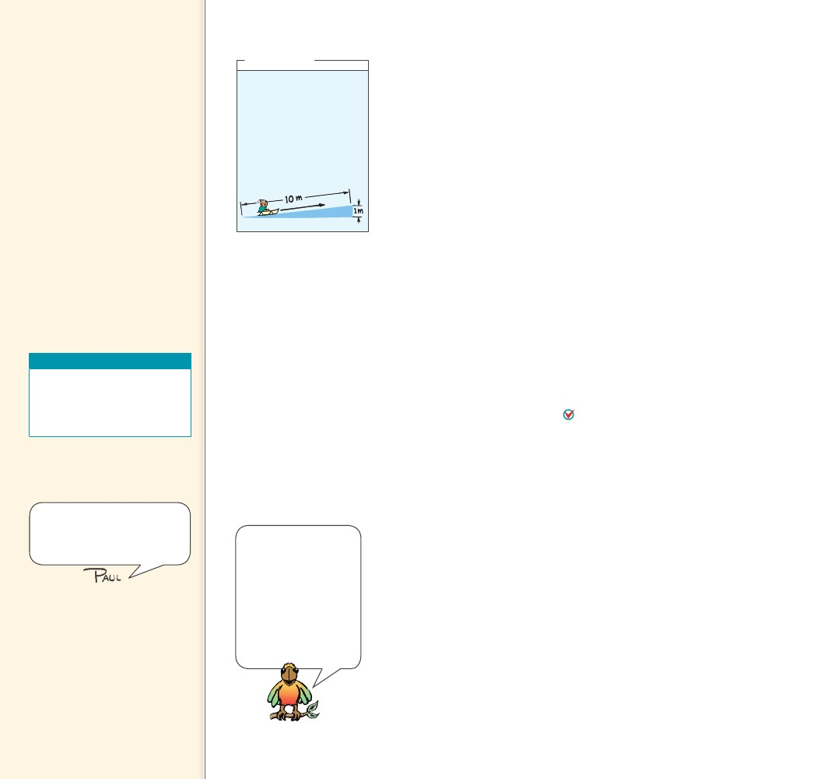
Teaching Tip Fuels such as
oil, gas, and wood are forms of
concentrated energy. When they
are used to do work, their energy
is degraded. If all concentrations
of energy are degraded, no more
work can be done. Heat is the
destiny of useful energy.
Teaching Tip Explain that the
degradation of energy is much
like one of your students sharing
his or her lunch (energy) with 100
other students. Rather than one
student with a lot of energy, now
there are many students, each
with a little energy. The energy
has been spread out.
In any machine, some
CHECK energy is transformed
into atomic or molecular kinetic
energy—making the machine
warmer.
CONCEPT
think!
A child on a sled (total
weight 500 N) is pulled up
a 10-m slope that elevates
her a vertical distance of
1 m. What is the theoreti-
cal mechanical advantage
of the slope?
Answer: 9.9
As physicists learned in the nineteenth century, transforming
100% of thermal energy into mechanical energy is not possible. Some
heat must flow from the engine. Friction adds more to the energy
loss. Even the best-designed gasoline-powered automobile engines are
unlikely to be more than 35% efficient. Some of the heat energy goes
into the cooling system and is released through the radiator to the air.
Some of it goes out the tailpipe with the exhaust gases, and almost
half goes into heating engine parts as a result of friction.
On top of these contributors to inefficiency, the fuel does not
burn completely. A certain amount of it goes unused. We can look at
inefficiency in this way: In any transformation there is a dilution of
the amount of useful energy. Useful energy ultimately becomes ther-
mal energy. Energy is not destroyed, it is simply degraded. Through
heat transfer, thermal energy is the graveyard of useful energy.
CONCEPT
......
......
......
CHECK
Why can’t a machine be 100% efficient?
9.10 Energy for Life
Every living cell in every organism is a machine. Like any machine, liv-
ing cells need an energy supply. Most living organisms on this planet
feed on various hydrocarbon compounds that release energy when
they react with oxygen. There is more energy stored in gasoline than
in the products of its combustion. There is more energy stored in
the molecules in food than there is in the reaction products after the
food is metabolized. This energy difference sustains life.9.10
The same principle of combustion occurs in the metabolism
of food in the body and the burning of fossil fuels in mechanical
engines. The main difference is the rate at which the reactions take
place. During metabolism, the reaction rate is much slower and
energy is released as it is needed by the body. Like the burning of fos-
sil fuels, the reaction is self-sustaining once it starts. In metabolism,
carbon combines with oxygen to form carbon dioxide.
The reverse process is more difficult. Only green plants and cer-
tain one-celled organisms can make carbon dioxide combine with
water to produce hydrocarbon compounds such as sugar. This pro-
cess is photosynthesis and requires an energy input, which normally
comes from sunlight. Sugar is the simplest food. All other foods, such
as carbohydrates, proteins, and fats, are also synthesized compounds
containing carbon, hydrogen, oxygen, and other elements. Because
green plants are able to use the energy of sunlight to make food that
gives us and all other organisms energy, there is life.
CONCEPT
Teaching Resources
• Problem-Solving Exercises in
Physics 6-3
• Laboratory Manual 31
• Probeware Lab Manual 8
9.10 Energy for Life
This section can be skimmed or
can be the topic of a class on
how the conservation of energy
underlies all biology.
There is more energy
CHECK stored in the
molecules in food than there is in
the reaction products after food
is metabolized. This energy
difference sustains life.
CONCEPT
......
In biology, you’ll learn
how the body takes
energy from the food
you eat to build mol-
ecules of adenosine
triphosphate, or ATP,
and how this supply of
ATP is used to run all
the chemical reactions
that sustain life.
CHECK
160
What role does energy play in sustaining life?
160

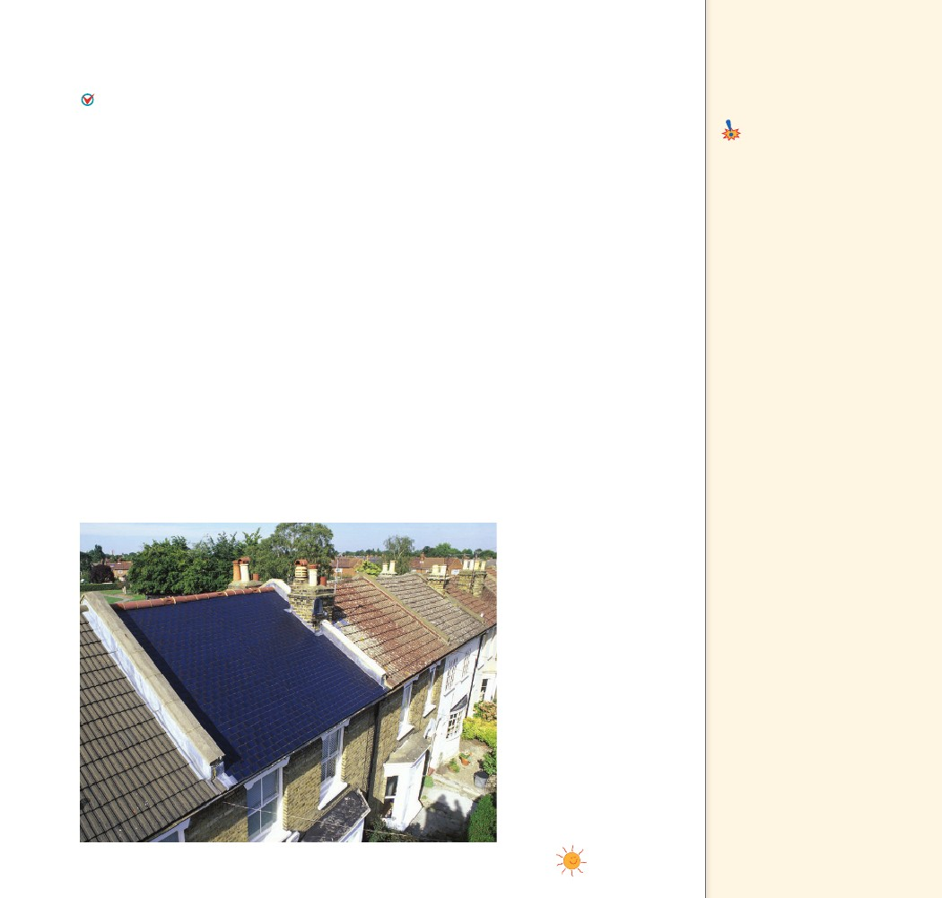
9.11 Sources of
9.11 Sources of Energy
The sun is the source of practically all our energy on Earth.
(Exceptions are nuclear and geothermal energy.) The energy from
burning wood comes from the sun. Even the energy we obtain from
Earth’s compost of the past—fossil fuels such as petroleum, coal, and
natural gas—comes from the sun. These fuels are created by photosyn-
thesis, the process by which plants trap solar energy and store it
as plant tissue.
Solar Power Sunlight is directly transformed into electricity by
photovoltaic cells, like those found in solar-powered calculators, or
more recently, in the flexible solar shingles on the roof of the build-
ing in Figure 9.17. We use the energy in sunlight to generate electric-
ity indirectly as well. Sunlight evaporates water, which later falls as
rain; rainwater flows into rivers and turns water wheels, or it flows
into modern generator turbines as it returns to the sea.
Wind, caused by unequal warming of Earth’s surface, is another
form of solar power. The energy of wind can be used to turn gen-
erator turbines within specially equipped windmills. Because wind
is not steady, wind power cannot by itself provide all of our energy
needs. But because the wind is always blowing somewhere, windmills
spread out over a large geographical area and integrated into a power
grid can make a substantial contribution to the overall energy mix.
Harnessing the wind is very practical when the energy it produces is
stored for future use, such as in the form of hydrogen.
FIGURE 9.17
Solar shingles look like
traditional asphalt shingles
but they are hooked into
a home’s electrical system.
Energy
Key Term
fuel cell
Common Misconception
Electricity, steam, and other
transporters of energy are energy
sources.
Sources of energy include
solar, geothermal, and nuclear
energy.
FACT
Teaching Tip When
hydrogen is burned in vehicles,
as is presently being done with
commercial vehicles in Iceland,
only water vapor is ejected by the
exhaust. This makes it seem like
a dream fuel. The big problem is
that there is no free hydrogen to
burn. It must be removed from
molecules where it is abundant,
which takes energy that must
come from some energy source.
If gasoline is the source, then
it might as well be used in the
vehicles to begin with, for even
more pollutants would result at
the conversion site. Proponents
of a hydrogen economy usually
sidestep this basic physics. Saying
cars should be powered with
hydrogen is akin to saying
they should be powered with
electricity. Both are not sources
of energy—but carriers of
energy.
CHAPTER 9
ENERGY
161
161

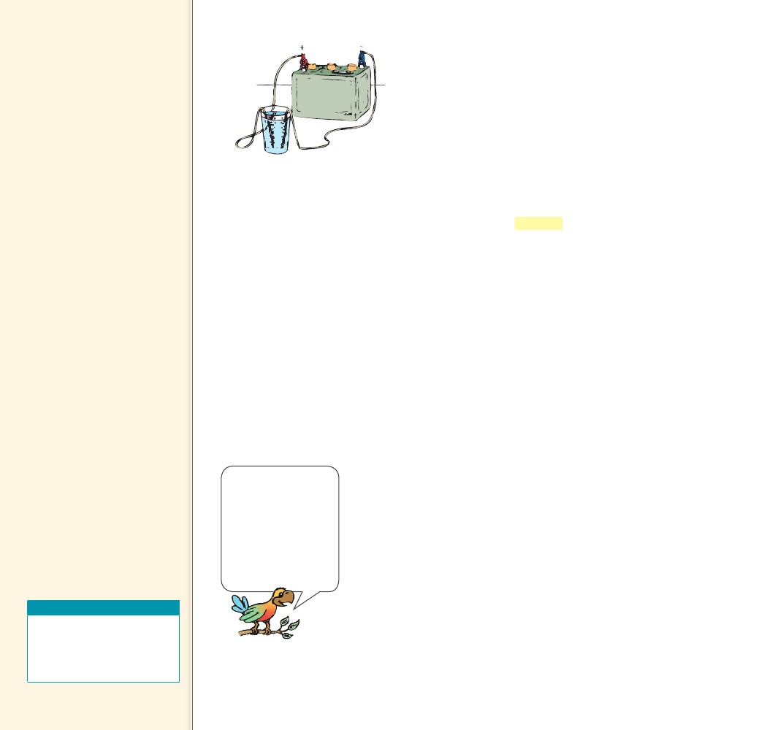
Teaching Tip Sooner or
later, all the sunlight that falls
on an ecosystem will be radiated
back into space. Energy in an
ecosystem is always in transit—
you can rent it, but you can’t
own it.
Teaching Tip When biologists
talk of energy in living systems,
they’re talking about the same
energy discussed in this chapter.
Our bodies obey the same
principles that levers and other
machines obey.
Teaching Tip When chemical
energy in gunpowder is suddenly
turned into thermal energy,
exiting gases expand rapidly and
push the bullet out of the gun.
In doing so, the gases lose some
of their energy and cool off.
This energy goes into the kinetic
energy of the bullet. Remarkably,
if you add up all this energy,
the total energy is the same.
Chemical energy is converted
into thermal energy and kinetic
energy, and the number of
Calories (or Joules) after firing is
exactly the same as was stored
in the gunpowder. Energy is
conserved.
FIGURE 9.18
When electric current passes
through water, bubbles of
hydrogen form at one wire and
bubbles of oxygen form at the
other. In a fuel cell, the reverse
process occurs: hydrogen and
oxygen combine to produce
water and electricity.
Fuel Cells Hydrogen, the least polluting of all fuels,
holds much promise for the future. Because it takes energy
to make hydrogen (to extract it from water and carbon
compounds), it is not a source of energy. A simple method
to extract hydrogen from water is shown in Figure 9.18.
Place two platinum wires that are connected to the ter-
minals of an ordinary battery into a glass of water (with
an electrolyte dissolved in the water for conductivity). Be
sure the wires don’t touch each other. Bubbles of hydro-
gen form on one wire, and bubbles of oxygen form on the
other. Electricity splits water into its constituent parts.
If you make the electrolysis process run backward, you
have a fuel cell. In a fuel cell, hydrogen and oxygen gas
are compressed at electrodes to produce water and electric
current. The space shuttle uses fuel cells to meet its elec-
trical needs while producing drinking water for the astro-
nauts. Here on Earth, fuel-cell researchers are developing
fuel cells for buses, automobiles, and trains.
The sun is the source
CHECK of practically all our
energy on Earth.
CONCEPT
Watch for the growth
of fuel-cell technology.
The major hurdle for
this technology is not
the device itself, but
with acquiring hydro-
gen fuel economically.
One way is via solar
cells.
Nuclear and Geothermal Energy The most concentrated
form of usable energy is stored in uranium and plutonium, which are
nuclear fuels. Interestingly, Earth’s interior is kept hot by producing
a form of nuclear power, radioactivity, which has been with us since
the Earth was formed.
A byproduct of radioactivity in Earth’s interior is geothermal
energy. Geothermal energy is held in underground reservoirs of hot
water. Geothermal energy is a practical energy source in areas of vol-
canic activity, such as Iceland, New Zealand, Japan, and Hawaii. In
these places, heated water near Earth’s surface is tapped to provide
steam for running turbogenerators.
Energy sources such as nuclear, geothermal, wind, solar, and
water power are environmentally friendly. The combustion of fossil
fuels, on the other hand, leads to increased atmospheric concentra-
tions of carbon dioxide, sulfur dioxide, and other pollutants.
As the world population increases, so does our need for energy.
With the rules of physics to guide them, technologists are now
researching newer and cleaner energy sources. But they race to keep
up with world population and greater demand in the developing
world.
......
Teaching Resources
• Reading and Study
Workbook
• PresentationEXPRESS
• Interactive Textbook
CHECK
......
CONCEPT What is the source of practically all of our
energy on Earth?
162
162

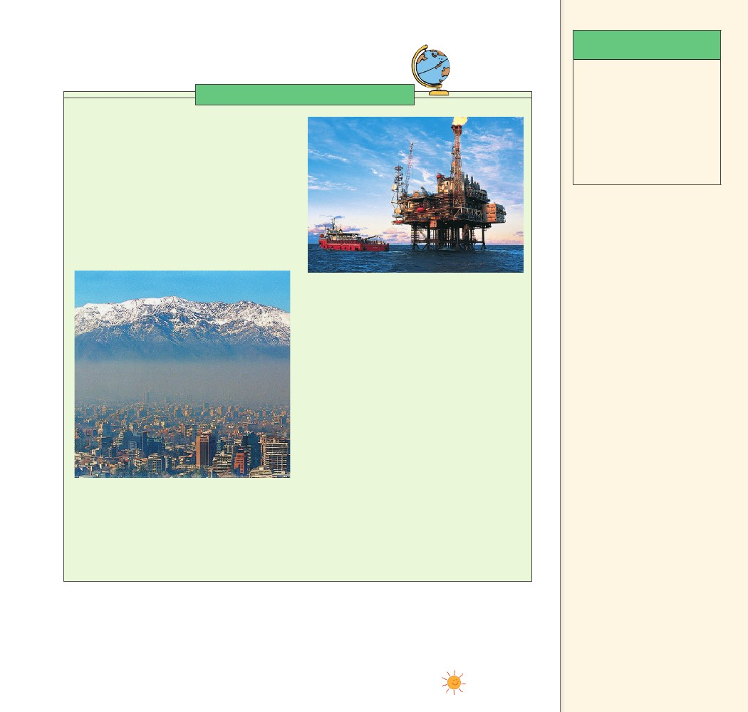
Science, Technology,
and Society
Discuss with students your local
and regional energy sources.
Note the environmental impact
in your area and ways it is being
reduced.
CRITICAL THINKING
Science, Technology, and Society
Energy Conservation Most energy consumed
in America comes from fossil fuels. Oil, natural
gas, and coal supply the energy for almost all
our industry and technology. About 70% of
electrical power in the United States comes from
fossil fuels, with about 21% from nuclear power.
Worldwide, fossil fuels also account for most
energy consumption. We have grown to depend
on fossil fuels because they have been plentiful
and inexpensive. Until recently, our consumption
was small enough that we could ignore their
environmental impact.
to be as inexhaustible as the sun’s glow and as
acceptable as Mom’s apple pie, because these
fuels lasted and nurtured us through the 1900s.
Financially, fossil fuels are still a bargain, but this
is destined to change. Environmentally, the costs
are already dramatic. Some other fuel must take
the place of fossil fuels if we are to maintain
the industry and technology to which we are
accustomed. The French have chosen nuclear, with
about 74% of their electricity coming from nuclear
power plants. What energy source would you
choose as an alternative?
In the meantime, we shouldn’t waste energy.
As individuals, we should limit the consumption
of useful energy by such measures as turning off
unused electrical appliances, using less hot water,
going easy on heating and air conditioning, and
driving energy-efficient automobiles. By doing
these things, we are conserving useful energy.
Critical Thinking In how many reasonable ways
can we reduce energy consumption?
Accept any
reasonable answer as long
as students support their
suggestions with pros and cons.
Teaching Tidbits In Iceland
93% of homes are heated by
geothermal power. In China
30 million households use solar
water heating. In the Philippines
27% of electricity is generated
from geothermal power. In
Denmark 20% of its electricity
is provided by wind turbines. As
of 2007, the state of Texas is the
leading wind-energy producer in
the US.
But things have changed. Fossil fuels are being
consumed at a rate that threatens to deplete the
entire world supply. Locally and globally, our fossil
fuel consumption is measurably polluting the air
we breathe and the water we drink. Yet, despite
these problems, many people consider fossil fuels
CHAPTER 9
ENERGY
163
163

